Team One- American Eagles
Columbia County, NY

Though many changes have taken place in Columbia County since its initial formation, the region still remains highly tied to its historical roots, making a comprehensive understanding of the region, its origins, and its contributions to the Hudson River Valley at large essential. An examination of its most prominent characters, numerous historical, cultural and industrial sites, and an analysis of early industrial demographics provides a rich understanding of all Columbia County has to offer.
Columbia County was first discovered in 1609 by Henry Hudson. Upon arriving to this land, he was greeting by the natives; the Mohican Indians. It wasn’t until an agreement in 1612 where the land began to grow and become colonized. Columbia Country is most often recognized for its historical contributions and key characters like Robert Livingston, Jan Frans Van Hoesen and Abraham Staats.
Based on its deep historical foundations, Columbia County offers a rich variety of historical sites, most notably including the home of Martin Van Buren, the Livingston family estate at Clermont, the federal mansion of Judge James Vanderpoel, and the Harlem Valley Rail trail. A wide variety of cultural and industrial sites and attractions are also present in Columbia County, such as the American Museum of Firefighting, the Shaker Museum and Library, Olana (home of Hudson River School painter Frederic Church), the Hudson-Athens Lighthouse, and the Stuyvesant Falls Mills District. (Hannah’s Olana chart)

The 1860 population, race, and occupations in Columbia County are all in some way correlated to the demographics found in Columbia County today. Many of the trends that were present in the census from 1860 can be found, or closely associated, to those in the census from 2000. Although hundreds of years have passed since 1860, the demographics are highly linked to Columbia County’s roots and will mostly likely continue to have a strong impact in shaping the tcounty’s demographic future.
Upon closer examination of Columbia County’s historical roots and influences, it is evident that these roots have had a strong impact on the development of the region as we know it today With such a wide array of history, culture and industry, Columbia County has something in store to offer just about everyone.

History- Jaimie Ehardt

The first exploration of Columbia County was said to be from Henry Hudson in 1609 while sailing across the Atlantic Ocean and up the Hudson River. Henry arrived at what is now known today as Columbia County on “accident” as his boat forced him to stop and come ashore to visit the area when he saw the land. Hudson described the surrounding land as “…the finest for cultivation that I ever in my life set foot upon, and it also abounds in trees of every description.” Other accounts of his journal include his description of the first people he met on the land, “we found very loving people and very old men, and the natives also brought on board Indian corn, pumpkins and tobacco.” At Stockpork Creek (the Mohican village), Hudson exclaimed the area “consisted of forty men and seventeen women,” a well as canoes and, to his astonishment, “a great quantity of Indian corn and beans… enough to load three ships.” If Indian corn wasn’t a dead give-away in itself, De Laet later gave the coordinates 42,18’ as the latitude of the place where Hudson’s visit was made which helped to further confirm the belief that they were in the present town of Stockport and Hudson was the first white man to step foot on the territory (Columbia County, NY.)
The native’s of the land were the Mohican Indians and in 1612 a trade was made as early settlers began to colonize the regions A man by the name of Jan Frans Van Hoesen purchased the land grant from the Mohicans who previously battled the Mohawks for river rights. Then, in 1624, New Amsterdam and Fort Orange were established which allowed travelers to stop along the shores of Columbia and the surrounding settlements as they would supply goods to the ships passing by. In 1657, a man by the name of Major Abraham Staats constructed a fur-trading post and farm on the North side of the Stockport Creek. Staat docked his ship the “Claverack” to take furs and grain which is to be considered the first European port in the area of Columbia County. (Columbia County. History and Heritage. Volume 2, Number 1. Summer 2003)

The most important port to emerge in pre-Revolutionary Columbia County was Claverack Landing. It contained a North Bay, South Bay and a peninsula in between. At that time, Clavarack Landing contained a dozen houses, two stores, two docks, a grist mill, and a ferry to Athens while serving as the port for nearly 800 houses that were 160 square miles along the east side of the Hudson. Early settlers in “Claverrack Landing” were mostly farmers, alongside a few fishermen. In 1783, four men that represented families from Newport, Nantucket, Edgartown and Providence were looking to move their enterprises (whaling) to a “more sheltered location” while naming themselves “The Proprietors.” They changed the name Claverrack Landing to “Hudson” on November 14, 1784 and took immediate action on the land. The Proprietors made this area flourish as it grew from a small settlement to a city in no time at all. In as little as two years there already emerged “two shipyards, ship-carpenters, caulkers, riggers, ship-smiths, sail-makers, numerous water lots for sloops from Europe and South America, and goods.” There was also a wide variety of new businesses, such as: West Indian and New England Rum, Iron, Salt, and Dry Good etc.
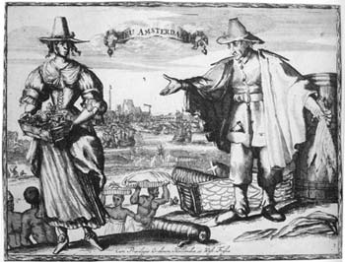
There were also prominent historic characters associated with Columbia County. Back tracking, in 1683 “two hundred acres of good land and eighteen hundred acres of woods” on the Roeliff Jansen’s Kill was granted to Robert Livingston and the following year was confirmed by patent as the Manor of Livingston. By 1695 the manor had expanded to one hundred and sixty thousand two hundred and forty acres. Livingston established his manor house and port at the mouth of Roeliff Jansen’s Kill and by the mid-eighteenth century this was a thriving port due to the Livingston family’s development of industrial works. “Manor lords” such as the Livingston’s and wealthy merchants such as Abraham Staats owned their own vessels for transporting lumber, agricultural products, and livestock. Despite the Livingston’s owning large sailing ships, the transportation that was most commonly used in Columbia County at the time were yachts and “sloops”, seeing as docking back then was complex. The craft most frequently used were yachts and “sloops” which continued to advance throughout the seventeenth century (Columbia County, History and Heritage. Volume 4, Number 2. Spring 2005.)

The history of Columbia County, geographically speaking dates back to April 1, 1786 when Columbia County was given its name through an act passed by the legislature. Seven original towns consisting of Kinderhook, Canaan, Claverack, Hillsdale, Clermont, Germantown and Livingston were erect by an act passed March 7, 1788 and as new towns formed during the late 1700’s and early 1800’s there became a total of 18. Columbia County’s land is diversified with hills, plains, and valleys. Columbia County is “farmed from the quantity and quality of its Indian corn, lead and iron.” It is now currently also divided into 19 towns now; Ancram, Austerlitz, Canaan, Chatham, Claverack, Clermont, Copake, Gallatin, Hudson City, Ghent, Greenport, Hillsdale, Germantown, Kinderhook, Livingston, New Lebanon, Stockport, Stuyvesant and Taghkanic (Columbia County, NY).

(Picture 2- “Robert Livingston Cartoon”- (Columbia County. History and Heritage. Volume 2, Number 1. Summer 2003)
(Picture 1- “A History Not Quite Visible” By Dorothy Dow Crane)

Key Historic/Cultural/Industrial Sites- Samantha Higgins

Based on its deep historical foundations, Columbia County offers a rich variety of historical sites, ranging from the home of Martin Van Buren and the Livingston family estate at Clermont to the Harlem Valley Rail trail. However, a wide variety of cultural and industrial sites and attractions are also present in Columbia County, each of which possesses a unique reflection of the county’s roots.
The region we now know to be Columbia County was first explored, accidentally, by Henry Hudson on his voyage up the Hudson River in 1609. The most significant exploration and development to take place in the county, however, took place in 1710 when German indentured servants were brought to Livingston Manor, in what is now Germantown. The grounds and historical gardens of this estate can still be visited at the Clermont State Historic site. Similarly, the Austerlitz Historical Society Museum Complex houses artifacts, photos and memorabilia relating to the town, as well as a collection of buildings from the same time period. Columbia County is also home to the Martin Van Buren National historic site, the Georgian-style home and farm property of the eighth president of the United States (National Park Service). This mansion is also where Van Buren managed two presidential campaigns and entertained politicians and celebrities during the mid-1800s. Yet another popular historical site to see in Columbia County is the mansion of Judge James Vanderpoel, now owned by the Columbia County Historical Society, a distinguished example of Federal period architecture featuring various exhibits and events throughout the year. Lastly, there is the Harlem Valley Rail trail, the old railroad bed that connected New York City, the Harlem Valley and Chatham, NY, which has now been converted to a bicycle/pedestrian path for all to experience.
Although Columbia Country is widely known for its rich historical background, this is not all the region has to offer. There are also a number of popular local museums and cultural sites providing a more comprehensive picture of all the country has to offer. For example, the 250 acre grounds surrounding the home and estate of Hudson River School painter Frederic Church, known as Olana, offers tours and encourages visitors to try their hand at painting the picturesque landscape (Columbia County Tourism). Columbia County is also home to the American Museum of Firefighting, which is the home of the premiere collection of American firefighting artifacts in the world, featuring over 90 pieces of apparatus on display. Along the same lines, there is the Shaker Museum and library, Visitors will learn to appreciate the simplistic way of life, as well as the history and culture of the Shakers at Mount Lebanon.
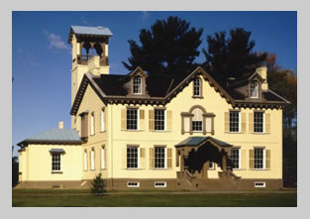
Finally, there are a number of unique industrial sites in Columbia County, such as the Hudson-Athens Lighthouse. The lighthouse is important because it is the northern-most lighthouse on the Hudson River. Perhaps one of the most prominent industrial sites in all of Columbia County, however, is Stuyvesant Falls Mill District, which is compromised of the industrial
(Martin Van Buren National Historic Site)
www.nps.gov/mava/

sites and power sources from which the adjoining village of Stuyvesant falls derived its livelihood. It includes the Upper and Lower Falls and mill dams on the east bank of Kinderhook Creek, the sites of a grist mill and paper mill, cotton mill, woolen mill complex and extant hydroelectric plant. Also included is an iron truss bridge erected in 1899.
Despite the fact that Columbia Country is most often recognized for its historical contributions, this region offers a great deal in the way of cultural and industrial contributions to society, which must also be taken into account. There is a wide variety of sites available to all types of inquiring minds, with something to see for just about everyone in Columbia County.

Chart Demographics- Abby D’Annolfo

One aspect that remained constant when looking at the population in 1860 to 2000 was the very small African American population in comparison to the White population. In 1860, there were 1,201 free African Americans compared to 45,792 White. And in 2003, there were 2,850 African Americans compared to 58,105 White (“1860 Census of Population and Housing”). Even as the overall population increased from 1860 to 2000, the African American to White ratio seems to remain fairly constant. One thing that did drastically change was the number of people in the “other” category of population. This category could consist of people with races such as Indian, Hispanic, Asian, etc. While this number was very small with only 179 people in 1860, it has greatly increased since then. In 2000, there were 2,136 people in this category, which is now very close to the African American population (“1860 Census of Population and Housing”). This number of people in this category has been consistently increasing over time, not just in Columbia County but all over the United States. This population will most likely continue to grow as more and more people migrate over and find jobs within the United States.
Population in Columbia County
 | Year
Color | 1860 | 2000
White | 45,792 | 58,105
Black/African American  (free colored) | 1,201 | 2,850
Other | 179 | 2,136
Total | 47,172 | 63,094
One detail that really stood out when examining the individual towns in Columbia County from 1860 to 2000 was how extremely high the population was in the town of Hudson in 1860. In 1860 the population was 7,187 in this town, which was the highest from any other town in the 1860’s and even exceeds the population there in 2000 (Columbia County, New York - Wolfram|Alpha). One reason for this high population could be due to the fact that Hudson can be found right along the Hudson River. This would have allowed easy access for people in the 1860’s to go out and fish for their food. The Hudson River Valley provides a plentiful supply of fish and other animals that could have easily been used for food and other products as well. Kinderhook and Chatham were the next highest populated towns in 1860, and they happen to be right next to each other (Smith). By 2000 each of these towns had around 1,500 people, which is roughly four times less than the population in 1860 (Columbia County, New York - Wolfram|Alpha).
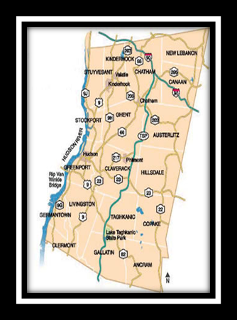
Another aspect that stood out while comparing the towns in Columbia was the fact that there have been several additional towns created since 1860. Towns like Lorenz Park, Valatie, Philmont, Scottville, and Claverick- Red Mills, never existed in 1860 so I was unable to get a population for them. Seeing as though there were fewer towns in 1860 than there are today, I found that populations in many of the towns tended to be greater in 1860 than in 2000 because there were fewer towns to choose from. This could be one Caption:Map of Columbia County
http://affordablehousinginstitute.org/blogs/us/2010/12/the-weekending-of-rural- america.html

reason that Kinderhook and Chatham, as mentioned before, had many more people within their towns in 1860 than they did in 2000. However, when looking at the overall population in Columbia County from 1860 to 2000, it is very clear that the population has greatly increased from 47,172 to 63,094 people (U.S. Census Bureau; Columbia County, New York - Wolfram|Alpha).

Population in Columbia County by Town
 | Year
Town | 1860 | 2000
Hudson | 7,187 | 6,173
Claverack | 3,477 | 6,021
Greenport | 1,431 | 4,106
Livingston | 2,014 | 3,646
Copake | 1,839 | 3,615
Stockport | 1,445 | 2,815
New Lebanon | 2,127 | 2,305
Stuyvesant | 2,366 | 2,027
Lorenz Park | - | 2,053
Valatie | - | 1,819
Clermont | 968 | 1,965
Canaan | 2197 | 1,710
Hillsdale | 2,552 | 1,927
Niverville | - | 1,662
Chatham | 4,163 | 1,770
Ancram | 1,720 | 1,573
Austerlitz | 1,889 | 1,654
Gallatin | 1,533 | 1,375
Philmont | - | 1,379
Scottville | - | 1,375
Kinderhook | 4,331 | 1,211
Taghkanic | 1717 | 1,310
Claverick- Red Mills | - | 913
Germantown | 1,353 | 845
Copake Lake | - | 823
Ghent | 2,803 | 564

It was slightly more difficult to compare occupations in Columbia County from 1860 to those of 2000 because in 1860, occupations were classified much differently than they are today. Since the majority of people’s occupations in 1860 were in the agriculture or manufacturing industry, the census did not break down occupations by industry, but rather by classes of manufactures. The top ten classes of manufactures in 1860 can be seen in the chart. Today there are such a variety of different occupations out there, that occupations must be classified or put into specific industry categories in order to keep it more simplistic and easier to understand. By looking at the classes of manufactures chart, it is clear how many occupations in 1860 revolved mostly around farming, agriculture, manufacturing, and other forms of production (Ellis). From the industries of 2000 chart, one can see that agriculture and manufacturing play a very small role in society. In Columbia County today, occupations are more focused to industries of business, management, office work, government and other related fields. There is much less of a concentration on manufacturing and agricultural related occupations because there is not as much of a need for these types of jobs in today’s society (U.S. Census Bureau).

Classes of Manufactures in Columbia County 1860 (Top 10)
Class | Number of Establishments | Number of Hands | Capital Invested
Carriages and Wagons | 44 | 112 | $55,100
Flour-Mill Products | 32 | 83 | $312,900
Saddlery and Harness | 19 | 48 | $30,500
Tin, Copper, and Sheet-Iron Ware | 17 | 50 | $48,800
Cotton Goods | 13 | 874 | $1,180,500
Paper Wrapping | 13 | 193 | $349,000
Clothing (Women’s) | 12 | 55 | $20,980
Clothing (Men’s) | 11 | 102 | $47,450
Agricultural Implements | 9 | 28 | $27,700
Machinery | 8 | 50 | $42,000

*Since the majority of people’s occupations in 1860 were in the agriculture or manufacturing industry within 1860, the census did not break down occupations by industry, but rather by classes of manufactures. (This can be seen in the chart above).

Industries in Columbia County 2000

Industry | Percentage of People in Industry
Management, Professional, and Related Occupations | 33.6
Sales and Office Occupations | 23.5
Government Worker (local, state, or federal) Occupations | 19.3
Service Occupations | 16.8
Production, Transportation, and Material Moving Occupations | 13.8
Construction, Extraction, and Maintenance Occupations | 10.8
Manufacturing Occupations | 10.4
Agricultural, Forestry, Fishing, and Hunting Occupations | 3.0

*Today there are such a variety of different occupations that occupations must be classified or put into specific industry categories. (This can be seen in the chart above).

Hannah Fernandez
Mock up of the highway route markers and mockup of interpretive signs
Columbia County has many exciting and interesting sites and attractions. From Olana Estates (home of Frederic Church) to the American Museum of Firefighting, Columbia County has something for everyone. Some of the main sites and attractions are: Frederic Church Estates, American Museum of Firefighting, Shaker Museum and Library, Hudson-Athens Lighthouse, Stuyvesant Falls Mill District (which consists of upper and lower falls, mills and dams), Martin Van Buren National Historic Site, Germantown (which contains the Clermont State historic site), and the mansion of Judge James Vanderpoel To represent each site we have come up with a site sign. ”. (Columbia County Tourism) Our prototype sign is of “Olana Estates” (see image 1). On this sign there is two photos: one of a painting by Frederic Church of his estate and the other photo is of his home. The text on the sign reads: “This is the home of a well-known painter- Frederic Church. Frederic Church’s paintings were reflective of his 250-acre estate. The Persian-style home was built between 1870-1891. Built on a high hill overlooking the Hudson River Valley, to Frederic Church this was known as “the center of the world”. Today the home remains unchanged and looks as it did in the 1890s. You will find the paintings and furnishings of Frederic and his family acquired over the years of residency.” The sign was designed with an orange background because the color orange is bright and exciting and will capture the viewer’s attention. The text of Olana Estates has an old English look to it. This gives this modern sign and old-fashioned twist since the site was built in the 1800s.
Each route marker has two main elements: the route number and “Columbia County” written on it (see image 2). Our route marker isn’t the typical two-color boring route marker you see when you drive down the highway. Our route marker’s background is a picturesque image of Columbia County, which is pleasing to the eye and interesting. The background isn’t however too distracting and keeps your focus on what the route marker is for (the route number). There is also a map of New York State on the route marker and Columbia County is highlighted red. This is not only resourceful so the traveler has an idea of what part of New York they are in but it also contributes to the uniqueness of the sign. Finally the sign has the official Columbia County seal which reads “founded in 1785”. The route markers will be strategically placed among main highways and roads that lead to key sites such as Route 32B is located near Olana Estates. Route markers for the Shaker museum and library would be placed on Route 90, for the Museum of Firefighting on route 9 and route 66, for the Hudson-Athens’s Lighthouse on routes 9, 66 and 203, for the Stuyvesant Falls Mill District routes 90, 86 and 203, for the Martin Van Buren National Historic Site routes 203 and 295, Germantown routes 9, 23, and 66 and finally the mansion of Judge James Vanderpoel routes 66 and 9. The reasons for placing the markers along these routes is to bring attention you can find each of these sites off of or along the marked highway.

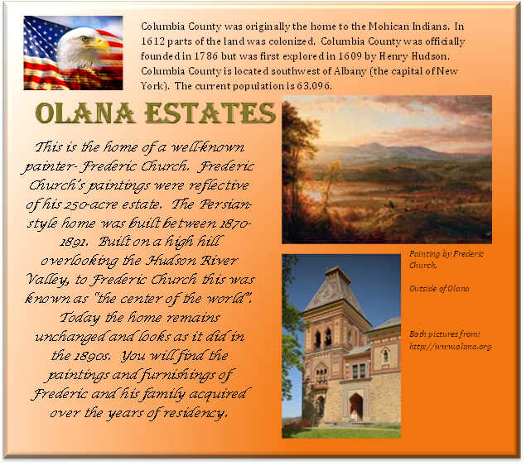
Image 1:
Image 2:

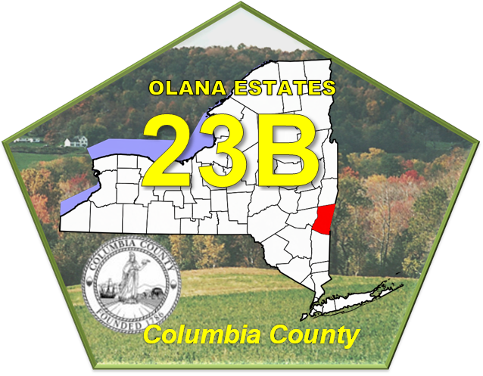

Bibliography

"1860 Census of Population and Housing." Census Bureau Home Page. http://www.census.gov/prod/www/abs/decennial/1860.html

-This website was extremely valuable in that I used the information to compile the charts on population and race in Columbia County in 1860. There were very few sources to find this information from 1860, so I found this source to be very unique and important for my research.

“Columbia County New York” http://www.columbiacountytourism.org/

-I used this source to obtain a general idea of some of the most popular historical, cultural and industrial sites in Columbia Country, and to acquire background information about each of them.

“Columbia County, New York”
http://en.wikipedia.org/wiki/Columbia_County,_New_York

-I used this site to obtain information about Columbia County as well as images such as the Columbia County seal and the map of New York

“Columbia County NY: History” http://www.columbiacountyny.com/history.html

-I used this website to further my discussion on the history of Columbia County, geographically speaking. I was able to find information on how Columbia County was formed and the specific towns that make up the county currently and back then (7 original towns and now currently 19). (Jaimie Ehardt)

"Columbia County, New York - Wolfram|Alpha." Wolfram|Alpha: Computational Knowledge Engine.
http://www.wolframalpha.com/input/?i=columbia+county%2C+new+york
&buttonstates=%7B%22Cities%22+-%3E+%7B1%2C+%22Partial%22+- %3E+15%7D%7D

-This was a good source that provided me with information about each town's population within Columbia County in 1860. With this information, I was able to create the chart comparing the populations of each town in Columbia County in 1860 and 2000.

Columbia County, History and Heritage. Volume 4, Number 2. Spring 2005

-I felt it was beneficial to use this historical magazine because not only did it describe in detail the prominent historical characters of Columbia County but it also had great images from the time. On the internet, I could only find updated photo’s of Columbia County however in this article they had scanned pictures from paintings and photo’s from the 17th/18th century. (Jaimie Ehardt)

Columbia County. History and Heritage. Volume 2, Number 1. Summer 2003

-I used the same historical magazine however a different issue and volume number because I was so successful with the first I figured I should try reading another item through the collection. I was able to find in depth and specific explanations on the early settlers of the land and a lot of information about the Claverrack Landing; a key historic land feature. I got a ton of information on the history and starting of that, as well as a lot of first-hand photographs to incorporate into my slide presentation. (Jaimie Ehardt)

Ellis, Captain Franklin. History of Columbia County, New York; with illustrations and biographical sketches of some of its prominent men and pioneers. Philadelphia: Everts & Ensign, 1878.

-This book was very useful in that it gave me many details regarding occupations and industries within Columbia County in 1860. With this information I was able to create a chart which classified the classes of manufactures in 1860 and was then able to compare it to the industries in Columbia County in 2000.

“Martin Van Buren: National Historic Site New York” www.nps.gov/mava

-I used this site to research the Martin Van Buren Historical Site, as well as to obtain a copyright-free image of the site.

Smith, David A. "The Weekending of Rural America." Affordable Housing Institute: US. http://affordablehousinginstitute.org/blogs/us/2010/12/the-weekending-
of-rural-merica.html

-This website provided me with the image of Columbia County, which I used to get a better idea or picture of where the towns were throughout the county. I was then able to compare which towns were closer to one another and where they were in relation to the Hudson River. Other than getting this map of Columbia County, this site did not provide me with any other information for my research.

U.S. Census Bureau. "Columbia County, New York." American Fact Finder factfinder.census.gov/servlet/SAFFFacts?_event=ChangeGeoContext&_county=
Columbia&_state=04000US36

-This website was a good source with valuable information. It provided me with information on the population, race, and industries of people in Columbia County from the 2000 census. I was therefore able to create the charts which compared the races and also the industries in Columbia County from 2000.

Citation Links in Power point:

Columbia County. History and Heritage. Volume 2, Number 1. Summer 2003
Columbia County, History and Heritage. Volume 4, Number 2. Spring 2005
http://www.hudsonathenslighthouse.org/
http://www.olana.org/
http://www.fasnyfiremuseum.com/
http://www.columbiacountyny.com/
http://www.ruralintelligence.com/index.php/ruralroadtrips_section/ruralroadtrips_articles_excursions/christmas_strolls_etc--for_dec_3_blast/
http://hvrt.org/
http://www.nps.gov/mava/index.htm

