Individual Essays
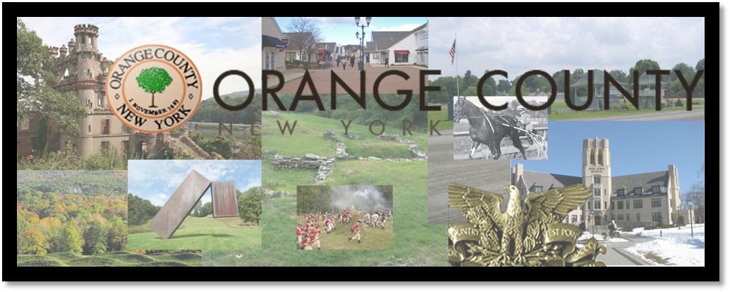
Of Orange County, New York
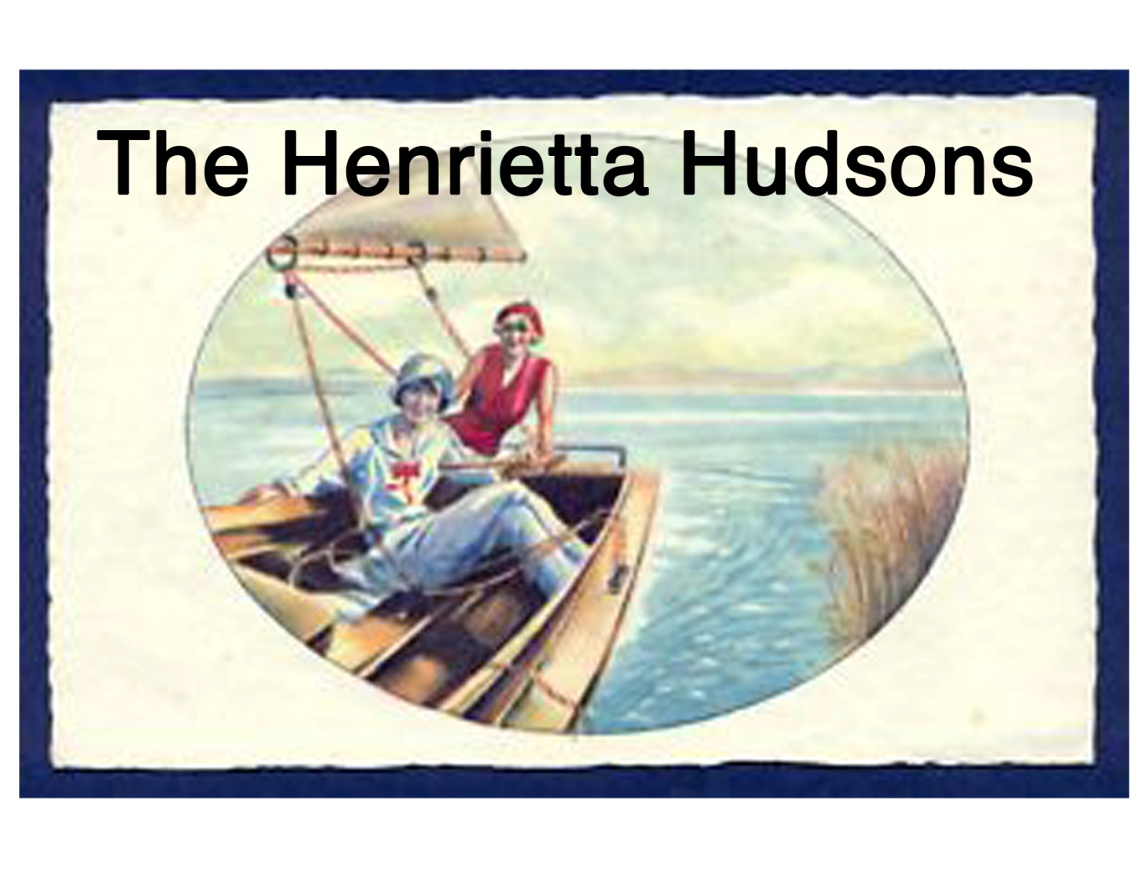
History of Orange County – Elizabeth O’Brien
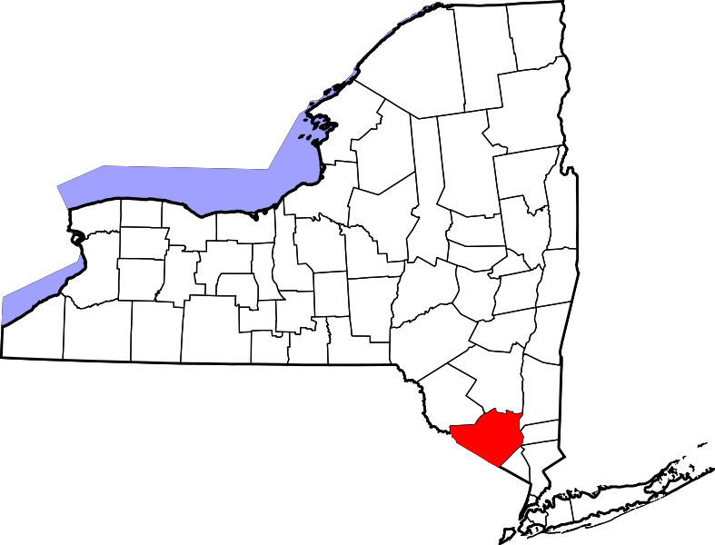
Orange County is one of the oldest counties in the state and it is the only county located between two rivers; the Hudson River borders its east side while the Delaware River borders its west side. (“Orange County Tourism”) Orange County is also bordered by six other New York counties, two New Jersey counties and one Pennsylvania county.
Map of New York State, with Orange County highlighted
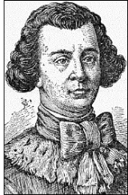
The Native Americans were the first to settle the land. The main tribe that inhabited the land that is now Orange County was the Munsees (“Native Americans”); however there is evidence that parts of Orange County were also occupied by the Esopus Indians (Headley, 24). Many legends are derived from the time of the Indians, including the story of how Moodna creek acquired its nickname “Murderer’s Creek.”
Colonel Thomas Dongan
(Frisbie)
Following Henry Hudson’s arrival to the area in 1609, Orange County was later established in 1683 and was named after the Prince of the House of Orange, King William III (“About Orange County”). It was one of twelve original counties in the Province of New York at the time. In 1684 Colonel Thomas Dongan became governor of the county with the hopes that his previous experience in France might benefit the new province. (“Thomas Dongan”) In the early 1700’s Luis Moses Gomez, an American Jewish leader came to Orange County and built a house that lies north of Newburgh to be used as a stone trading post. In its later years it became the home of many influential people including Wolfert Acker, an American Revolution patriot and Orange County leader. (“About Us”) Today, this Gomez Mill House is “the oldest surviving Jewish residence in America.” (“Orange County Tourism”)
Orange County played a significant role during the Revolutionary War. George Washington spent his longest residency in Newburgh during this time period (“About Orange County”) and founded the Badge of Military Merit here in 1782. Later this award became the more famous Order of the Purple Heart. (“Military Order of Purple Heart) Two major battles were also fought in this county: the battles of Fort Montgomery and Fort Clinton. Although the colonists lost the battles that occurred here the Americans aided in delaying British reinforcements from joining Burgoyne and were able to defeat him at the battle of Saratoga. (“The Battles of…”)
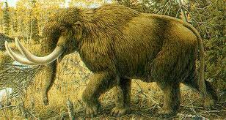
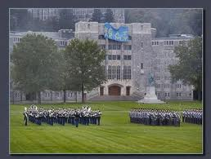
After the war, in 1797, the county split from present day Rockland County and added five towns from Ulster County. (Headley, 11) A few years later the first full skeleton of a Mastodon was exhumed in Montgomery. (Devine) This same year the final boundaries of the county were determined. A year later, in 1801, the Unites States Military Academy at West Point was founded. It is now the oldest military academy in the US. Many years later, in 1850, George Washington’s
West Point Military Academy
headquarters became the first Registered National Historic Landmark in the United States. (“United State Military Academy”) Also important to this county is Thomas Edison and his supervision of the construction of the first central and electric generating facility, designed to produce power for incandescent lighting. (“Orange County Tourism”) Lastly, in 1887 Downing Park
West Point Military Academy
was designed by Frederick Law Olmstead and Calver Vaux as a tribute to their mentor Andrew Jackson Downing who believed parks were vital to human existence in a city. (“Orange County Tourism”)
West Point Military Academy

Historical, Cultural and Industrial Sites- Elizabeth Hamberger
Bear Mountain-Harriman state park came to be in the early 1900’s with a big thanks to “a group of wealthy business men who donated land and large sums of money for the purchase of the property on the condition that it always is preserved as a park.” (“Orange County Tourism”) Their wish came true and the State Park still stands and is visited frequently today. Later in the century, around 1923, the first section of the Appalachian Trail was created at Bear Mountain. (“Orange County Tourism”) Just seven years later, in 1930, a man by the name of Archie Stewart donated 220 acres of land to Newburgh to make an airport. The airport served as part of West Point until 1989 when it was opened as a passenger airport with one of the longest runways in the US. (“History-About the Airport”)
The history of Orange County is vital to the history and existence of our nation. From the Native Americans to Henry Hudson to George Washington, many influential people inhabited the lands we still prosper from today. It is important to learn the history of these lands and the people that have occupied it many years ago in order to better the land and people of our nation for years to come.
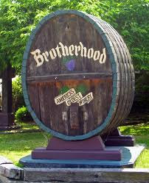
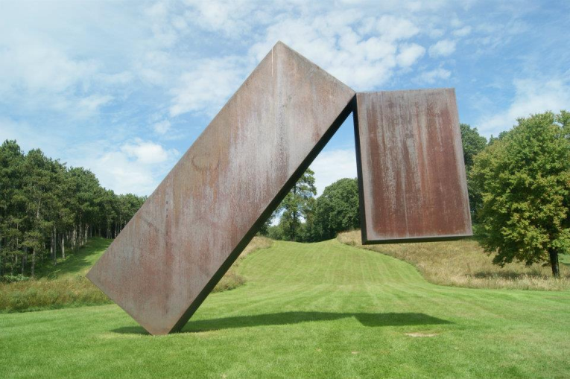
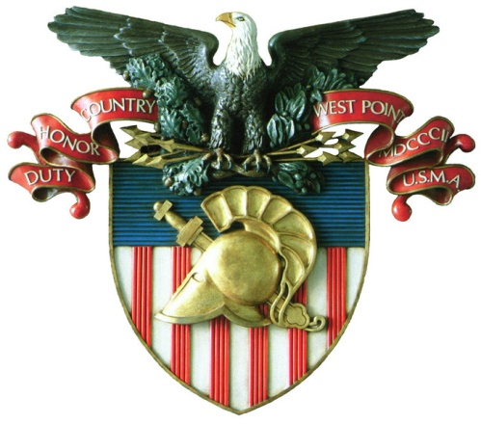
Orange County has so much to offer in the Hudson Valley. Orange County not only filled with tons of vital history, but has great attractions for its visitors.
One historical site is Washington’s Headquarters. During the Revolutionary War, this is where Washington spent the most of his time. The site was crucial because it was his Continental Army Headquarters. Here Washington oversaw his troops which only had
the utmost reverence for him. He was such a great leader that people wanted him to become the King. It was also here that Washington rejected the idea of monarchy. The site was open to the public in 1850 becoming the first historic site in the United States. Along with the house, there is a museum containing artifacts.
(http://www.palisadesparksconservancy.org/historic/14/)
Another important historical site is Fort Montgomery. The importance of controlling the Hudson River was apparent to both the American and British troops. Whoever controlled the Hudson would regulate what materials went through. Even though both Fort Montgomery and Clinton were lost, the battle slowed the British progress. Fort Montgomery and Clinton are National Historic Landmarks, owned and operated by the state of New York as State Historic Sites. At the site you can see many of the important artifacts, and large-scale models of the fort and attack. The site also has different trails which allow students to see a lot of the Hudson. There are many signs which explain the sites history. The site does a great job of making history come alive. (http://www.palisadesparksconservancy.org/historic/18/)
One cultural site is America’s oldest winery called the Brotherhood Winery established in 1839. The cellars are oldest and largest in America and still used today. In 1921, there was a new owner named Louis Farrell who understood the big picture of the
winery. He continued to sell wine for religious ceremonies throughout prohibition. This helped draw a large clergy population to the area. The proximity to the city allowed the winery to excel. Also, he began giving tours which highlighted interesting facts that people enjoyed learning about. The family basically invented the idea of wine tourism. (http://www.brotherhood- winery.com/aboutUsHistory.html) (http://www.orangetourism.org/)
Another attraction is the Gillinder Glass Factory Tour. Again like the winery, ?Gillinder? is one of the oldest glass companies in the United States. Each piece of glass is transformed into something beautiful by the skilled craftsmen. When you visit you can see ordinary glass being melted into useful objects that you can request. (http://www.gillinderglassstore.com/) (http://www.orangetourism.org/)
A newer attraction sure to attract a lot of women is the Woodbury Common Premium Outlet?. These outlets offer some of the top brands at very discounted prices. There are over two hundred twenty discount stores making it the largest in the United States. Even men who aren’t fond of shopping can sit outside and take in the beautiful
scenery. There are numerous people who travel all the way from New York City (which has every store) all the way to the Outlets. The Woodbury Common Premium Outlets get
(http://www.orangetourism.org/) <http://www.co.orange.ny.us/content/124/1378/4614.apx>.
An attraction geared more towards men is the Orange County Choppers center. While going through the channels you have definitely come across the American Chopper show on the Discovery Channel. When you visit this site, you can actually watch an episode being filmed through a viewing window. In addition you can even have maintenance done on your own bike. There is a gift ship and a display room with a plethora of motorcycles. (http:// www.orangecountychoppers.com/) (http://www.orangetourism.org/)
A fourth attraction is the Sugar Loaf Art and Craft Village. This shopping experience is unique in that the vendors are located in original barns and buildings going all the way back to the 1700s and 1800s. The fair is surrounded by beautiful apple and horse farms. The fair features many resident artists with their handmade items.
(http://www.orangetourism.org/)
Another unique attraction is the Storm King Art Center. The Storm King Art Center is one of the world’s leading sculpture parks. It is the largest sculpture park in the country spanning over 500 acres. It is filled with modern art and was opened to the public in 1960. It is not only a museum, but a nature conservancy. There are always new and exciting exhibitions. The exhibitions are outside and have beautiful backdrops like fields, hills, and forests. (http://www.orangetourism.org/)(http://www.stormking.org/)
A sixth attraction is the Harness Racing Museum and Hall of Fame. Similar to the Storm King Art Center the exhibits continuously change. The site is dedicated to the promotion of the Standard bred Industry. Like many of the other attractions the goal is to promote education and to appeal to people’s interests. The museum wishes to display the history and excitement of harness racing. The museum displays various artifacts from the past to the present, many hands on exhibits, a 3-D horse simulator, and the opportunity to see real horses. (http://www.harnessmuseum.com/) (<http://www.co.orange.ny.us/content/124/1378/4614.aspx>.)
Finally, another great attraction is the military academy at West Point. Specifically, the museum displays items like military flags, uniforms, and weapons. During the tours you can learn about great historic figures who have attended the school like George Washington, Robert E. Lee, U.S Grant, and many other significant figures. The museum supports military and cultural instruction. The artifacts in the museum represent just about every aspect of warfare. The museum even has artifacts from the Revolutionary War. The museum represents centuries of history involving the military. Events like West Point
football also garner a lot of visitors. (http://www.orangetourism.org/) (http://www.usma.edu/)
All of these attractions make Orange County what it is. The variety of attractions draws many different types of people. The historical, cultural, and industrial sites of Orange County make it unique. Even though Orange County is an hour away from New York City it doesn’t stop people from visiting. These sites attract millions of people. Orange County’s historical sites hold some of the most important information about The Revolutionary War. First Orange County offers great shopping sites such as: The Woodbury Common Outlets, and the Sugar Loaf Art and Craft Village. These offer two completely different types of shopping experiences. There are also attractions where you can go on factory tours like: The Gillinder Glass Factory, the Harness Racing Museum and Hall of Fame, and the Orange County Chopper Museum. Another unique attraction is the Storm King Art Center. Here visitors can visit the largest sculpture park in the country spanning over 500 acres. There is also the Brotherhood Winery which is America’s Winery. Lastly, there is the West Point. Here visitors can get a real feel for America’s important military artifacts.
Brotherhood Winery
http://photos.igougo.com/pictures-photos-p314429-The_Brotherhood_Winery.html
West Point Crest

Interpretative Signs – Lauren Pecoraro

Orange County, New York, is the home of many sites such as Wineries, Premium Outlets, Storm King Sculpture Park, and The U.S. Military Academy. These sites all have signs indicating their locations. The current signs are blue with a yellow boarder, including in depth information about the sites and their history. I think the current signs are not special enough for each of the unique sites around Orange County.
I remade a sign for West Point as my contribution. I felt that it should be a personalized sign about West Point and what it stands for. I decided to start off by finding the eagle symbol, from the West Point website. I felt that this represented what West Point stands for. West Point is about military education and a thorough history of all aspects of warfare. An eagle is a noble symbol, and it proudly represents men of action. Putting an eagle as the main focus of the West Point site marker truly describes what the site is about. From there I decided to use West Point’s motto “Duty, Honor, Country”. I feel that these three words summarize what West Point stands for. Instead of writing the complete history on the front of a site marker, I feel that a direct quote, such as the one I used, is more effective in telling about the site. I would prefer to put Orange County’s history and the site information on the back of the sign. I would love to see the site markers in the Hudson River Valley be more personalized for each site. If all of the signs are so similar, they won’t stand out to the visitors.
Other examples of site marker ideas for Orange County, New York:
- Storm King: For Storm King I would put a photograph of one of the sculptures and a quote such as “one of the world’s leading sculpture parks”
- Winery: I would put an elaborate photograph if grapes and wine bottles along side a short description of what kinds of wine offered there.
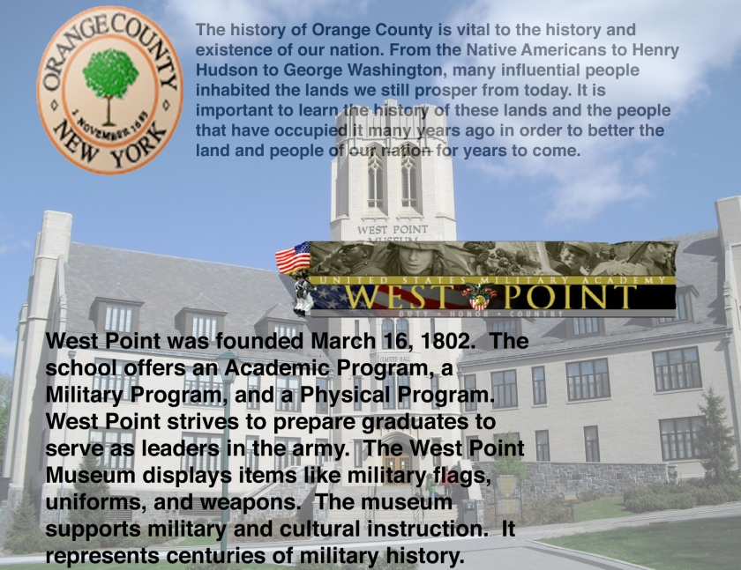
- Woodbury Commons Premium Outlets: I would put a photograph of the areal view of the outlet center from Route 6 in Orange County. I would then put a quote such as “Designer Finds at the Smartest Prices”
All of the above examples would also have the history of Orange County, as well as the site’s key information on the back of the sign. I believe that having the signs set up this way will attract tourists to the sign because of the image rather than the writing.

Highway Route Markers – Lauren Mullen
Orange County is an essential part of the Hudson River Valley’s history and cultural. It is important that tourists take time to explore the county, and to learn about its significance. Once way to promote this is to have interesting signs on the highways to attract tourists to certain sites. Currently, the highway signs may direct travelers to desired sites, however they fail to attract travelers. The signs are plain, boring, and they do not give any information about the site.
I made a highway marker for the historic site, Washington’s Headquarters. This site is not only important in the history of the Hudson River Valley, but also the history of the entire nation’s history. This is where Washington first created the Badge of Military Merit, which was the precursor to the Purple Heart Award.
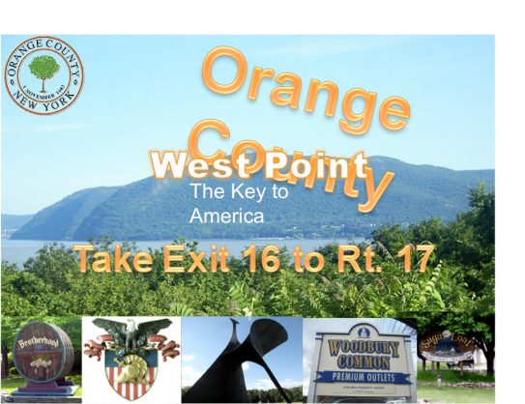
I kept the highway marker simple and direct. Although there are many facts that can be included on this sign, people won’t be able to read all of the information if they are driving by on the highway. Keeping the highway marker concise and to the point is more effective. I used one of the Union’s first adaptations of the flag. Although there were various versions of the flag during Washington’s time, this version is the most widely known currently. I used a sketch of George Washington because he was the most famous occupant during the Revolutionary War. I included the name of the site, and also that it is the country’s first public historic site. This fact is important because it makes the site even more unique, and tourists are more likely to stop by and visit. On the bottom of the sign, I included driving directions. This sign would be placed on the northbound side of the thruway. The directions on the bottom of the sign would obvious be adapted according where the sign is located. Ideally, these markers would be located on the northbound and southbound sides of the New York State Thruway, and on the Palisades Parkway.
This is just one idea for a highway marker, and there are many other sites that could use new markers. A cultural site that would benefit from a new highway marker would be the Orange County Choppers. Many motorcyclists enjoy nice weather by going on long drives on the highway. This is a demographic that would be likely to stop by the site. This sign would include an interesting picture of a motorcycle, and a quote like, “As seen on the Discovery Channel and TLC.” Then the sign would include directions to the site.
Demographics – Brittany Engbarth
In 1860, the population of Orange County was approximately 63,812 including white, black, and mulatto people. The total white population was 51,952 and the total black population was 1,925. And New York State’s total population during this time was 3,880,735 (1860 Census of Population and Housing). As far as occupations go in the 1860’s the jobs were typical jobs that supported the town and community. Among the most popular jobs in New York were; farmers, farm laborers, servants, tailors, merchants, laborers, carpenters, shoemakers, blacksmiths, and clerks. There were about 254,786 farmers in New York State and about 115,728 farm laborers (1860 Census of Population and Housing). So, there must have been an abundance of farms with acres and acres of crops and many animals. The land in Orange County is not too hilly either, so that’s a plus for growing crops. As well as the proximity to the Hudson River and the Popolopen Creek because farmers need large amounts of water irrigate their crops. Farming was huge for the county and New York State at the time and resulted in the high demand for farmers, whereas the demand for surgeons was not too high because they only had about 137 in the whole state (1860 Census of Population and Housing).
Historical Populations of Orange County
Year | Population
1860 | 63,812
1870 | 80,902
1880 | 88,220
1890 | 97,859
1900 | 103,859
1910 | 116,001
1920 | 199,844
1930 | 130,383
1940 | 140,113
1950 | 152,255
1960 | 183,734
1970 | 221,657
1980 | 259,603
1990 | 307,647
2000 | 341,367

And 140 years later the population of Orange County changed pretty drastically. The population increased about 535% and the total population was about 341,367. The male to female ratio was about equal at 170,965 males and 170,402 females. And a total of 242,211 people in Orange County in the year 2000, were 18 years or older (Orange County, New York). Compared to the total New York State population, which was 18,976,457 million people. As far as occupations go for Orange County in 2000, the majority of people worked in the field of management or a type of professional job (about 50,357 people). Sales, office, and service occupations had a great amount of people for both females and males. The jobs the least amount of people did were farming, fishing, farm managers, and forestry with approximately less than 1,200 people (Orange County, New York). Aircraft, traffic control, rail, water, and other transportation occupations also had few amounts of people due to the smaller demand because of how the county became more urban due to the increasing population. Some other statistics about Orange County in 2000 include the median family income, which was about $60,355 and 6,432 families were below poverty level (Orange County, New York).

Town | Total Population in 2000
Newburgh | 27,568
Middletown | 25,388
Monroe | 31,407
Montgomery | 20,891

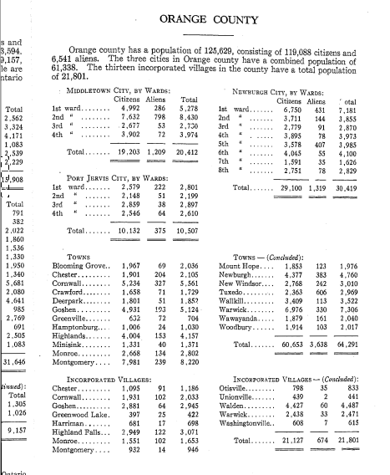

Works Cited
"About Orange County - Orange County, New York." Home - Orange County, New York. http://www.co.orange.ny.us/content/1156/default.aspx (accessed October 10, 2011).
This website gave a lot of useful information on Orange County. This page specifically helped me to map out a time line of the county’s history.
"About us." Gomez Foundation for Mill House. http://www.gomez.org/about.html (accessed October 9, 2011).
The information I found at this website gave me some insight about this historic site located in Orange County.
Devine, Joseph. "The Mastodons of Orange County New York." American History/Prehistoric Essays and Maps. http://home.roadrunner.com/~montghistory/The%20Mastodons%20of%20Orange%20County%20042809.pdf (accessed October 10, 2011).
Joseph Devine's analysis showed me a timeline of the life of the Mastodon and when and where it was found in Orange County. For the purpose of this assignment I could have done without a lot of Devine's information but the analysis gave me what I needed.
Frisbie, Richard. "The Concise History of Orange County." New York and New York State Books on History Genealogy and Regional Interest for sale from HopeFarm Press. http://www.hopefarm.com/orange.htm (accessed October 10, 2011).
This website provided a lot of information about the early history of Orange County.
Headley, Russel. All-name index to Russel Headley's 1908 History of Orange County, New York. Middletown, NY: Orange County Genealogical Society, 1993.
This book was helpful with the general history of Orange County. When author went in to each town specifically was when the book was not as useful to me for the purpose of this assignment.
"History - About the Airport - Stewart International Airport - Port Authority of New York & New Jersey." The Port Authority of New York & New Jersey. http://www.panynj.gov/airports/swf-history.html (accessed October 10, 2011).
The information I learned about Stewart Airport was found at this website. I used this information, with other information, to create a visual timeline of Orange County.
"Military Order of the Purple Heart." Homepage | Military Order of the Purple Heart. http://purpleheart.org (accessed October 10, 2011).
I was interested to learn more about the Order of the Purple Heart once I had found out it was founded in Orange County. This website, and employee handbook, gave me the appropriate information I needed.
"Native Americans." Albert Wisner Public Library | Albert Wisner Public Library. http://www.albertwisnerlibrary.org/Factsandhistory/History/Nativeamericans.htm (accessed October 9, 2011).
This website gave my some information on the Native Americans in the Warwick Valley. The site was a bit vague and I could have used more detail for the purposes of this assignment.
"Orange County Tourism - Fascinating Facts." Orange County Tourism - Welcome to Orange County. http://www.orangetourism.org/fascinating-facts (accessed October 9, 2011).
This website provides useful information about many parts of Orange County. This specific page helped me include interesting and important aspects of the county’s history.
"The Battle of Fort's Montgomery and Clinton." The American Revolutionary War. http://www.revolutionarywar.n2genealogy.com/battles/771006.html (accessed October 10, 2011).
Although I already knew most of this information, this website helped to fill in the details I was missing.
"Thomas Dongan." Â The Civil War. http://www.sonofthesouth.net/revolutionary-war/colonies/thomas-dongan.htm (accessed October 10, 2011).
I used a portion of this website to gain a little bit of background information on Thomas Dongan at the time he became governor of the county.
"United States Military Academy, West Point, New York 10996." United States Military Academy, West Point, New York 10996. http://www.usma.edu/ (accessed October 10, 2011).
The West Point website provided with simple information about when the Academy was created.

"Brotherhood Winery | America's Oldest Winery Est. 1839 | History." Brotherhood Winery
| America's Oldest Winery Est. 1839 | Welcome! Web. 8 Oct. 2011.
<http://www.brotherhood/- winery.com/aboutUsHistory.html>.
After reading about the Brotherhood Winery on the Orange County Tourism site, I decided to
visit the official website. The website provided me with a lot of other additional
information.
Gillinder Glass Store. Web. 7 Oct. 2011. <http:// www.gillinderglassstore.com>.
After reading about the Gillinder Glass the Orange County Tourism site, I decided to click on the link to the official website. The website provided me with a lot of other additional information.
Harness Racing Museum and Hall of Fame. Web. 11 Oct. 2011. <http://www.harnessmuseum.com/>.
I used this site to get additional details about the harness museum. Once I heard the name from the video I watched it was easy to get additional information. Again the website was great in providing pictures and details all about the attraction.
Orange County Choppers. Web. 9 Oct. 2011. <http:// www.orangecountychoppers.com/>.
After reading about the Orange County Choppers on the Tourism site, I decided to visit the official website. The website provided me with a lot of other additional information.
Orange County Tourism - Welcome to Orange County. Web. 9 Oct. 2011.
<http://www.orangetourism.org/>.
This site was most crucial to finding all of my information. It provided me with a plethora of information and interesting facts. The site was very easy to navigate and all of the information was accurate. The site helped me gain a perspective of what the top attractions in Orange County are. I had never realized how many different attractions Orange County had. The website did a great job of organizing the information and made it easy to find specific attractions. The website had a lot of useful links to specific sites. The site included a summary of the information, phone numbers, and pictures.
"Orange County Video - Orange County, New York." Home - Orange County, New York. Web. 11 Oct. 2011. <http:// www.co.orange.ny.us/content/124/1378/4614.aspx>.
One of my teammates recommended this site to me. I used this site to help me read about any last minute attractions that I didn’t already read about. After watching a video on tourism, I found just the information I was looking for. In class, I had spoken to Professor Johnson about the attractions I already had listened. He mentioned one which I hadn’t come across in my research. This was the harness museum.
Storm King Art Center. Web. 11 Oct. 2011. <http://www.stormking.org/>.
Again, I originally used the Orange Tourism site and clicked on this site for additional details. This website provided me with a lot of additional information.
United States Military Academy, West Point, New York 10996. Web. 8 Oct. 2011. <http://www.usma.edu/>.
Again, I originally used the Orange Tourism site and clicked on this site for additional details. This website provided me with a lot of information about the school and the museum. The website also had a lot of lovely pictures.
"American Family Campground - Explore." Pocono Mountain Campground Pocono Campground Pocono New York Campground West Point NY Campground. http://americanfamilycampgrounds.com/explore.html (accessed October 11, 2011).
I used this website to retrieve a photo of the Orange County Landscape for our banner.
Car. "Orange County Tourism - Welcome to Orange County." Orange County Tourism - Welcome to Orange County. http://www.orangetourism.org (accessed October 11, 2011).
I used this Orange County Tourism site to gather photographs for the banner as well as the background from our slides.
"Oil Paintings - Reproductions." Oil Paintings - Reproductions. http://www.oceansbridge.com (accessed October 11, 2011).
I used this site for an Orange County landscape photograph as well.
"Premium Outlets: Everyday Discounts on Designer Brands." Premium Outlets: Everyday Discounts on Designer Brands. http://www.premiumoutlets.com (accessed October 11, 2011).
I used this website to get the logo for Woodbury Commons Premium Outlets, one of our Key Sites for Orange County.
"United States Military Academy, West Point, New York 10996." United States Military Academy, West Point, New York 10996. http://www.usma.edu (accessed October 11, 2011).
I used the West Point website for both its photographs and its information for my site marker contribution.

"West Point, NY | Brohammas." Brohammas | Seeking adventure for its own sake. http://brohammas.wordpress.com/2010/05/19/west-point-ny/ (accessed October 11, 2011).
I used this photo of the West Point crest to go along side my key site marker.
Orange County Tourism - Welcome to Orange County. Web. 11 Oct. 2011. <http://www.orangetourism.org/>.
This site was really useful in my research, and provided me with almost everything I needed for this assignment. Not only did it provide me with information about the sites I discussed, but it also provided directions to the site.

"Orange County, New York." American FactFinder. U.S Census Bureau. Web. 10 Oct. 2011. H <Http://factfinder.census.gov/home/saff/main.html?_lang=en>.
"1860 Census of Population and Housing." Census Bureau Home Page. Web. 10 Oct. 2011. < <http://www.census.gov/prod/www/abs/decennial/1860.html>.

