Orange County Tourism

Final Presentation
Hudson River Valley Renegades Group
Kimberly McVetty, Gaby Gilmartin, Dani Carpiniello, Melissa Suppe & Matt Kelly
December 10, 2012


Table of Contents
Contributor | Portion of Presentation, Contributor
Midterm Case Study Revisions | Gilmartin, Kelly, Carpiniello, Suppe
Lesson Plan | McVetty
Guidebook Pages | Suppe
Itinerary | Carpiniello
Wayside Panels | Kelly
Highway Route Markers | Gilmartin
Bibliography | McVetty

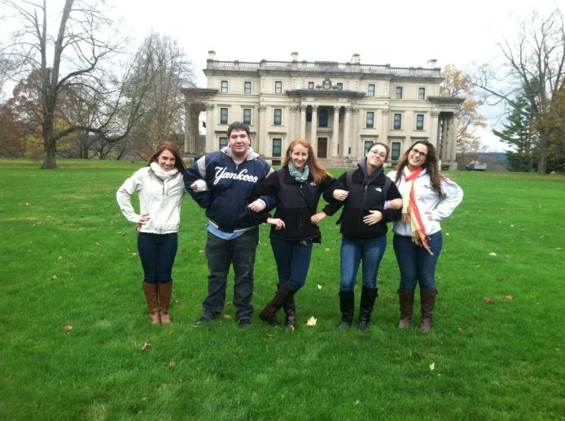
Team members at Vanderbilt Mansion on a field trip.

Interpretive Signs: Matt Kelly (With Credit to Kimberly McVetty- Midterm Essay)
During the process of making the interpretive signs for several sites in Orange County, many factors came to mind. Specifically, each interpretive sign needs to be brightly colored and contains bold lettering so that people can read it. Also, each sign contains the Orange County logo, along with a short blurb about the county. Each interpretive sign also contains the Twitter symbol and the “hash tag” HRVOC (which stands for Hudson River Valley Orange County) in order to avoid confusion with the other Orange County in California. All of these elements were chosen to increase Orange County’s status as a relevant and exciting tourist area.
As mentioned earlier, each interpretive sign contains the Orange County Logo ("Orange County Offices by Orange County NY Shooters."). Also located on each interpretive sign will also be a short blurb promoting tourism in Orange County, which reads as follows:
“Orange County is one of the most exciting tourist attractions in our nation due to the variety of the attractions present within it. The vast amounts of both recreational and historical facilities prove its relevance as a tourist region and make it a great place to visit with friends and family. From our country’s first publically owned property, The Hasbrouck House, to the Woodbury Common Outlets, the county has tons to offer visitors of all interests!”
The second element present on each of the signs is the Twitter symbol, along with the “hash tag” HRVOC to promote Orange County in the Hudson River Valley. The use of social media at these recreational sites allows tourists to share their experiences with family and friends, and is likely to bring in more tourists in to these sites. The use of social media allows people to comment about the sites, and in addition can bring in more tourists. The sites will be able to evaluate visitor comments and as a result, make any necessary changes. Not only can that, but incorporating social media into the process modernize this sometimes older experience. Using twitter at these recreational sites makes a tourist’s visit interactive as well, and includes visitors of all ages.
Images of the recreational sites will be used on each panel to give tourists a visual of the site. Along with the blurb regarding Orange County Tourism, each interpretive sign will contain a brief description of all the activities that can be done at each site.

In designing the interpretive signs, careful consideration was also given to materials that would be used in the process. Although the prototypes created for this project don’t use these materials, if the signs were produced for actual use, the chosen materials would be imminent to the signs' success. Each sign would be constructed of custom cut polycarbonate sheets (Lexan brand). In the sign industry, this product is widely considered to be unbreakable and extremely durable when used outdoors. Computer designed and cut vinyl letters and photos would be placed thereon. To be sure the signs do not fade, chip or peel; they would be sealed in pourable plastic. Plastic edge caps may also be used to increase the longevity of the signs (Conversation with McVetty, October 6, 2012).
Twitter logo used; from SimplyZesty.com
The aim of all interpretive signs is to increase visitors’ knowledge of the recreational site they are visiting, as well as their general knowledge of Orange County as a tourist region.

Resources
George, Rogero. Orange County Offices, "Orange County Offices by Orange County NY Shooters." Accessed October 5, 2012. http://www.ocshooters.com/Gen/politics/orangecountyofficers.htm.
Orange County Offices’ site provided the current Orange County Logo, used for the interpretive sign by Kimberly McVetty and then Matt Kelly

Simply Zesty , "Simply Zesty: Social. Digital. Mobile. ." Last modified 2012. Accessed October 5, 2012. http://www.simplyzesty.com/category/social-media/twitter/.
Simply Zesty offered the Twitter logo, which is also used in the interpretive sign by Kimberly McVetty and then Matt Kelly.
History of Recreation in Orange County: Dani Carpiniello

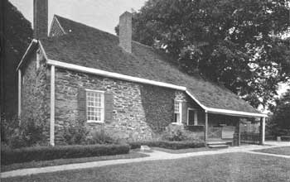
Orange County, New York, is located in the mid-Hudson scenic region of the Hudson Valley, and is surrounded by the counties of Dutchess, Putnam, Rockland, Sullivan, Ulster, and Westchester, as well as Passaic and Sussex counties in New Jersey and Pike County in Pennsylvania. Set in southeastern New York State, the climate of Orange County has a higher rainfall and snowfall average than that of New York State in general, and humidity is just about the same as the average of New York State. Orange County was one of the first twelve counties established by the Province of New York in 1683, and included present-day Rockland County before the Revolutionary War. Orange County is home to many historic sites, buildings, and monuments, due to its inhabitants in the 18th century during the first settlements of the colonists and the many wars the county had experienced throughout time.
Hasbrouck House, image found at NationalParkService.gov
When Orange County’s occupants began to realize that their town had historical and recreational value, the state of New York bought the Hasbrouck House in Newburgh, which become Washington’s Headquarters during the American Revolutionary War. It is the oldest house in the city of Newburgh, as well as the first property attained and preserved by any U.S. state for historic reasons in 1961 ( National Park Service, 2005). Newburgh is a very significant aspect of Orange County’s historical recreation, and this among other properties is meant for the public to observe as part of their historic experience in Orange County.
The scenic quality of Orange County has always been admired by its inhabitants, even since the creation of the county in the Province of New York. Orange County was always home to a vast amount of open land and biodiversity, something that from the beginning was seen as a recreational opportunity waiting to be developed. To honor this historic natural beauty, Orange County has created multiple parks and outdoor recreational activities. One of the outdoor amenities provided by the county is Heritage Trail, a 10-foot wide trail following the route of the former Erie Railroad. The current 11.5-mile trail takes its travelers through a bird and wildlife sanctuary, historic landmarks, streams, meadows and friendly communities. This trail attracts the visitors of the county who are interesting in biking, walking, jogging, or hiking to enjoy the nature of the county (A1 Trails, 2010).
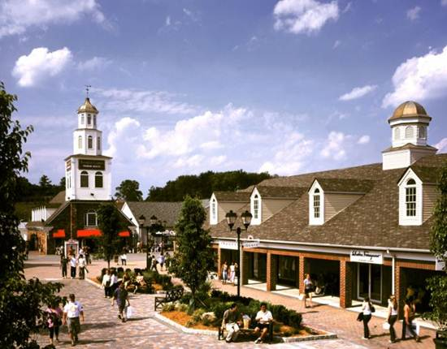
A main focus of Orange County’s recreational reputation is the cash revenue they achieve from certain recreational establishments. Woodbury Common Premium Outlets in Central Valley, Orange, New York, opened in late 1985, was expanded in 1993, and again in 1998. The center now has 220 stores on more than 800,000 square feet of land and is one of the largest adjoining outlet centers in the world. Its location is quite close to New York City, and has become a major tourist attraction for people visiting Orange County. This shopping center brings in a significant portion of the county’s revenue, and it appeals to every age group, making it an even more desired location to visit. For this reason it is one of the most well-known attractions in Orange county (Simon Premium Outlets, 2012). Another establishment made to appeal to families and bring in revenue is The Castle Fun Center in Chester, New York. This amusement park is located in the heart of Orange County, and provides visitors with an enjoyable outdoor and indoor activity to experience with their family (The Castle Fun Center,2011).
Woodbury Common Outlets; image from OrangeTourism.org
To appeal to the climate of Orange County and to also draw in more visitors and revenue is the Tuxedo Ridge Ski Center at Sterling Forest. This establishment is another example of how Orange County tourism was formed to appeal to a wide range of visitors so there is something to do for everyone who visits (Tuexdo Ridge Ski Center 2012).
Looking at these different recreational opportunities offered in Orange County, it is obvious that Orange County is becoming more and more of a family-oriented region, with a majority of opportunities for recreation being offered outdoors. Orange County is a great place to visit with family, not only for its historical value and importance, but also to enjoy an outdoors experience of the Hudson River Valley nature at its finest.

Bibliography

A1 Trails, "Heritage Trail." Last modified 2010. Accessed October 7, 2012. http://www.a1trails.com/rail/ny/heritage.html.
This site provided information on the Heritage Trail.

National Park Service, "Colonials and Patriots: Survey of Historic Sites and Buildings: Washington's Headquarter's (Hasbrouck House)." Last modified 2005. Accessed October 6, 2012. http://www.cr.nps.gov/history/online_books/colonials-patriots/sitec35.htm.
This site provided information on the Hasbrouck House.

Simon Premium Outlets, "Woodbury Common Premium Outlets." Accessed October 8, 2012. http://www.premiumoutlets.com/outlets/outlet.asp?id=7.
This site was used to gain information on the Woodbury Common Outlets.

The Castle Fun Center, "The Castle Fun Center." Last modified 2011. Accessed October 7, 2012. http://www.thecastlefuncenter.com/.
This site was used to gain information on the Castle Fun Center.

Tuxedo Ridge Ski Center, "Tuxedo Ridge Ski Center at Sterling Forest." Accessed October 8, 2012. http://www.tuxedoridge.com/.
This site was used to gain information on the Tuxedo Ridge Ski Center.

County Tourism Developments: Matt Kelly
The Orange county website, www.orangetourism.com, is dedicated to the tourism of the county. This website is an important means to communicate to the world all that Orange County has to offer. The site lists links to various events, attractions, lodging, and restaurants in Orange County, a set up that is extremely user friendly and organized. The “Events” column provides users with the time, the date, the location, and a little description of the event. It also has directions. The “Attractions” is divided into history and culture, recreation, farm markets, antiques and shopping, as well as wineries and breweries. Each of those sub-divisions is then broken up into even more subdivisions such as museums, state parks, U-Pick farms and shopping centers. When users finally decide on a place to visit, the website provides them with a link to the website of that place, so that users can discover even more information about the site. The “Lodging” section is broken up into bed and breakfasts, conference facilities, and hotels and motels. Finally, “Restaurants” is divided by town. All of these titles give the users links so that they can discover attractions, lodging, restaurants, and events on their own, making this website easy to access and use.
An image of kayakers at Thomas Bull Memorial Park, from OrangeTourism.org
The website is part of the “I LOVE NEW YORK” campaign which tries to promote tourism in New York. Hudson Valley Tourism, Inc., also part of the “I LOVE NEW YORK” organization created a website and smartphone app that acts as a directory for everything going on in all the counties of the Hudson River Valley. The app is a quick way to get a variety of tourist information at the palm of one’s hand and the website has a working “group travel” link to help large groups tour with ease.
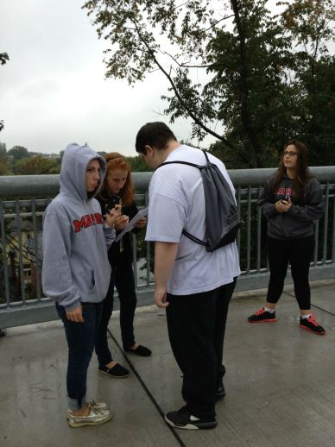
Although the I LOVE NEW YORK campaign does use the internet to advertise and promote tourism by making a website and a Smartphone application, this isn’t spreading the word sufficiently about all the great things that can be seen in Orange County. If I were in charge of promoting tourism for Orange County I would make a Facebook page so that people can see what Orange County has to offer. In order to improve such endeavors, I would increase the usage of the existing Facebook page, Orange County Tourism NY. I would make a Twitter account and tweet regularly about all of the fun things that can be done in Orange County. Next, I would take out radio advertisements and put them on all the local radio stations to help spread the word. Another thing I would do is put advertisements in all the local newspapers in the area to promote Orange County Tourism since many people still read the newspaper in the morning. Another viable option would be to place ads in the Penny Saver, which often provides coupons for events in the community. This would inform residents and tourists alike about Orange County, all the tourist attractions within the county, and how affordable it can be for families to go there for a trip.
Team Members work together on Catarina Dos Santos’ lesson plan.

Bibliography
ILOVENY , "Orange County Tourism: In the Beautiful Hudson Valley." Last modified 2012. Accessed October 6, 2012. http://www.orangetourism.org/.
Orange County Tourism’s website was used to evaluate the current practices of the tourism board and to decide what needed to be improved.
Key Recreational Sites in Orange County, New York: Melissa Suppe
Less than 100 miles away from New York City, it is no surprise that many people come to Orange County to connect with nature and see its beauty. Orange County, located in the Hudson River Valley, offers beautiful scenery and enjoyable recreational activities to visiting tourists of all ages. The best recreational sites in Orange County are the Woodbury Common Premium Outlets, the Heritage Trail, the Thomas Bull Memorial Park, the Castle Fun Center, and Tuxedo Ridge Ski Center.
The Woodbury Common Premium Outlets located in Central Valley is famously known as the largest collection of designer outlets in the world. With 220 stores such as Burberry, Polo Ralph Lauren, J. Crew, and Jimmy Choo, these Outlets provide tourists and locals with a pleasant shopping center where they can spend a lot of money and time in. The Woodbury Common Outlets also have restaurants and a food court for when shoppers need an extra energy boost. The Outlets also provide tourists with locker and stroller rentals, foreign currency exchange, and ATM. Open from 10am to 9pm daily, except on special holidays, the Woodbury Common Premium Outlets is a great place to spend a day with your family and friends.
The Heritage Trail in Goshen is a scenic pathway where visitors are welcomed to walk, jog, bike, roller-skate, etc. Converted from the rail bed of the Erie Rail Road, this scenic walkway is a great place to spend an afternoon with family and friends of all ages. Currently stretching 11.5 miles, this walkway will soon reach 20 miles connecting the City of Middletown to the Village of Harriman. Visit and enjoy exercise with a view, but remember to follow trail etiquette!
The Thomas Bull Memorial Park located in Montgomery houses the world famous Arboretum. This Arboretum not only lets visitors walk through beautiful gardens, but it also has a memorial walkway for those who lost their lives on September 11th. The park also has seasonal snow tubing, cross country skiing, ice skating, and sleigh-rides. The Thomas Bull Memorial Park also offers picnic and recreational areas, fishing, golf courses, playgrounds, horseback riding, a boathouse, and a dog park. The Hill-Hold Museum of farm life in the 1830s is also in the park, as well as a first class restaurant. The Thomas Bull Memorial is great place to have fun, learn about history, and relax all in one place!
The Castle Fun Center in Chester offers a great amusement park for children. With bumper cars, laser tag and maze, roller-skating rink, mini-bowling, and rock wall, kids will never get bored. The Castle Fun Center also offers mini golf, batting cages, go-karts, an arcade, and a playground. There is also Jester’s Restaurant and Pub as a convenient place to eat. Open year-round with the opportunity to celebrate birthdays, the Castle Fun Center is a great place for children to have a fun and exciting day.
Tuxedo Ridge Ski Center in Tuxedo, NY is a great place to spend a day in the mountains. With seven trails, four chair lifts, and Terrain Park, this ski center will have skiers of all levels smiling and having a great time. Tuxedo Ski Center not only offers skiing but snowboarding and snow tubing as well. There are also ski/snowboard lesson and rentals for those who are beginners. The ski center has a cafeteria and pub on the grounds for skiers who need some energy, and also lets visitors ski at night. The Tuxedo Ridge Ski Center is the perfect place for families to have a fun, snow-filled day.
Where is Tuxedo Ridge?

Sources:
ILOVENY , "Orange County Tourism: In the Beautiful Hudson Valley." Last modified 2012. Accessed October 6, 2012. http://www.orangetourism.org/.
"Orange County NY Parks & Recreations." Orange County NY Parks & Recreations.
N.p., n.d. Web. 09 Oct. 2012.
<http://www.orangecountynyparks.com/index.php?option=com_content>.
Simon Premium Outlets, "Woodbury Common Premium Outlets." Accessed October 8, 2012. http://www.premiumoutlets.com/outlets/outlet.asp?id=7.
The Castle Fun Center, "The Castle Fun Center." Last modified 2011. Accessed October 7, 2012. http://www.thecastlefuncenter.com/.
Tuxedo Ridge Ski Center, "Tuxedo Ridge Ski Center at Sterling Forest." Accessed October 8, 2012. http://www.tuxedoridge.com/.

Kimberly McVetty December 6, 2012
Lesson Plans- Synopsis Colonel Johnson
Lesson Plan Overview
It should be noted that for this final presentation, six lesson plans were created in total. This was done to ensure that each field trip contained an activity pertaining to the various New York State Standards. The final lesson plan was created to ensure that, collectively, the objectives of each former lesson plan were achieved. The first five lesson plans were created specifically for each respective site. The final cumulative lesson plan was created to tie together the experience of touring Orange County, NY to the students and encompass all aspects of the trips.

Kimberly McVetty December 6, 2012
Lesson Plan Colonel Johnson
All Aboard the Knowledge Train!

Learning about the Erie Railroad along the Heritage Trail
Grade Level: 4
Overview: Students will participate in a pseudo scavenger hunt on a field trip to the Heritage Trail. Students, in groups, will work to gain as much knowledge while on their “trip” as possible. Students will work interactively with the interpretive panels along the site. The group who has gained the most knowledge will earn a prize.
Objective: Students will increase their knowledge of Erie Railroad and its history. Students will better their ability to work cooperatively in groups to reach a goal.
Learning Intelligences: Verbal/Linguistic, Bodily-Kinesthetic, Interpersonal.
Procedure:
- Teacher, students and chaperones will arrive at the Heritage Trail.
- Teacher will divide students into 5 groups of four students each.
- Teacher will administer each group eight tickets and one handheld hole-puncher.
- Teacher will explain to the class that each group is going aboard a different “knowledge train” and that each of the eight tickets has a question on it. The teacher will explain that students must read each interpretive panel to find the answer to their ticket’s questions. Teacher will explain to students that they will punch the right answer, similar to how ticket collector’s punches train tickets.
- Each group of students will travel from interpretive panel to interpretive panel, punching the right answers on their tickets. Each ticket will have different questions, so as to avoid cheating.
Assessment: Each group will hand in their tickets to the teacher, who will then check for the right answers. The student group with the most CORRECT answers punched out will receive a small prize.

Standards Used:
Reading Standards for Informational Text
2. Determine the main idea of a text and explain how it is supported by key details; summarize the text.
4. Determine the meaning of general academic and domain-specific words or phrases in a text relevant to a grade four topic or subject area.
7. Interpret information presented visually, orally, or quantitatively (e.g. in charts, graphs, diagrams, time lines, animations, or interactive elements on web pages) and explain how the information contributes to an understanding of the text in which it appears.
10. By the end of the year, read and comprehend informational texts, including history/social studies, science, and technical texts, in the grades 4-5 texts complexity band proficiently, while scaffolding as needed at the high end of the range.

Materials Used:
- Paper -Heritage Trail
- Panels -Interpretive Panels
- Hole Punchers
Resources:
NYS P-12 Common Core Learning Standards for English Language Arts and Literacy, 2011
http://www.american-rails.com/erie-railroad.html (Used for panel)

Sample Ticket



Erie Railroad- Heritage Trail Line
Round Trip Ticket
First Stop:
During what time did the Erie Railroad Operate?
- May 1843 to May 1983.

- June 1845 to June 1977

- March 1843 to May 1920

- May 1856 to May 1999

A Train


Kimberly McVetty December 6, 2012
Lesson Plan Colonel Johnson
Shop ‘til you drop!

Using a Trip to Woodbury Common Outlets to Create Graphs
Grade Level: 3
Overview: Students will take a trip to the Woodbury Common Outlet Center and complete a “shopping list” of items. They will record prices of similar products from various stores and use the data to create a bar graph while in the classroom. Students will interpret this data to discover who had the cheapest prices.
Objectives: Students will better their ability to create bar-graphs. Students will improve their ability to analyze data from graphs, as well. In addition, students will work interactively with peers.

Learning Intelligences Used: Bodily-Kinesthetic, Logical/Mathematical, Interpersonal.
Procedure:
- Students, teachers and chaperones will arrive at Woodbury Common Outlet Center.
- The teacher will divide students into 5 groups of four and give each group a shopping list ( Found at end of lesson). Each list will ask for a different item to be found at 6 stores ( ex: jeans)
- Students will visit each store as designated and marking the price of each item on their shopping list, with a chaperone.
- Students will gather on the bus and leave Woodbury Common Outlet Center.
- The next class day, students will re-enter their groups
- Each group will place their recording into a table, created by the teacher.
- Each group will then create a bar graph of the data.
- Students will then analyze the data, answering questions such as:
- Which store sold the item at the most expensive price?
- Which store sold the item at the least expensive price?
Assessment: The teacher will evaluate each group’s graph to determine their ability. The teacher will evaluate the students’ analyzing skill by their answers to the prompt questions.
Standards Used:
Represent and interpret data.
3. Draw a scaled picture graph and a scaled bar graph to represent a data set with several categories. Solve one- and two-step “how many more” and “how many less” problems using information presented in scaled bar graphs. For example, draw a bar graph in which each square in the bar graph might represent 5 pets.

Materials:
- Paper - Poster board
- Markers - Pencils
- Woodbury Common Outlet Center

Resources:
http://www.p12.nysed.gov/ciai/common_core_standards/pdfdocs/nysp12cclsmath.pdf

http://www.premiumoutlets.com/outlets/store_listing.asp?id=7

Group Names: _________________,___________________,____________________,_____________
Welcome to the Woodbury Common Premium Outlets! While you are shopping, be sure to keep your eye out for a pair of denim jeans in each of the six stores on your list. Be careful to record the price of each pair, you will need the data for tomorrow’s group project!

Shopping list

- The Children’s Place Outlet
- J. Crew- Crew Cuts
- Polo Ralph Lauren Children Factory Store
- Tommy Hilfiger Kids
- Aeropostale
- American Eagle Outfitters
Data Table

Store | Price
 | $
 | $
 | $
 | $
 | $
 | $

Kimberly McVetty December 6, 2012
Lesson Plan Colonel Johnson
The Castle Fun Center Open

Using Mini-Golf to Practice Addition Skills
Grade Level: 2
Overview: Students will play a round of mini golf on a trip to the Castle Fun Center and keep track of their scores. Students will use adding skills to determine their total scores.
Objectives: Students will better their addition skills through finding their total scores, as well as improve their ability and knowledge of golf.
Learning Intelligences Used: Bodily- Kinesthetic, Logical/ Mathematical, Spatial, Interpersonal.
Procedure:
- Students and teacher will arrive at Castle Fun Center’s mini golf section.
- Teacher will distribute score cards to each student.
- Students will play a round of mini golf, keeping track of their scores for each hole.
- Students will add their scores to determine their final scores.
Assessment:
- Teacher will collect each score card to be sure that students added correctly.
Standards Used:
Grade 2 Basic Math Standards:
Understand place value.
1. Understand that the three digits of a three-digit number represent amounts of hundreds, tens, and ones; e.g., 706 equals 7 hundreds, 0 tens, and 6 ones. Understand the following as special cases:
a. 100 can be thought of as a bundle of ten tens — called a “hundred.”
b. The numbers 100, 200, 300, 400, 500, 600, 700, 800, 900 refer to one, two, three, four, five, six, seven, eight, or nine hundreds (and 0 tens and 0 ones).
2. Count within 1000; skip-count by 5s, 10s, and 100s.
3. Read and write numbers to 1000 using base-ten numerals, number names, and expanded form.

Use place value understanding and properties of operations to add and subtract.
5. Fluently add and subtract within 100 using strategies based on place value, properties of operations, and/or the relationship between addition and subtraction.
6. Add up to four two-digit numbers using strategies based on place value and properties of operations.
7. Add and subtract within 1000, using concrete models or drawings and strategies based on place value, properties of operations, and/or the relationship between addition and subtraction; relate the strategy to a written method. Understand that in adding or subtracting three-digit numbers, one adds or subtracts hundreds and hundreds, tens and tens, ones and ones; and sometimes it is necessary to compose or decompose tens or hundreds.
8. Mentally add 10 or 100 to a given number 100–900, and mentally subtract 10 or 100 from a given number 100–900.

Physical Education Standards:
Key Idea a.: perform basic motor and manipulative skills. They will attain competency in a variety of physical activities and proficiency in a few select complex motor and sports activities.
Elementary Level:
- participate in physical activities (games, sports, exercises) that provide conditioning for each fitness area
- develop physical fitness skills through regular practice, effort, and perseverance
- demonstrate mastery of fundamental motor, non-loco motor, and manipulative skills, and understand fundamental principles of movement

Materials Used:
- Castle Fun Center mini golf -score cards
- Mini golf clubs

Resources:
http://www.p12.nysed.gov/ciai/common_core_standards/pdfdocs/nysp12cclsmath.pdf
http://www.p12.nysed.gov/ciai/pe/pe1.html
http://thecastlefuncenter.com/activities/mini-golf/

Kimberly McVetty November 27,2012
Lesson Plan Colonel Johnson
What’s All the Buzz About?

Learning About Bees and their Colonies
Grade Level: 4
Overview: Students will engage in a hands-on learning experience to learn about bees and their colonies. Students will partake in a field trip to the Thomas Bull Memorial Park Arboretum’s Apiary, where a beekeeper will shed light on the “day in the life” of bees. Students will complete an activity where each student plays a different role in the bee community and work to achieve a common goal-keep the colony at its best!
Objectives: Students will better understand the basic functions of a bee colony. Students will understand the roles of the three different types of bees found within a hive: Queen, worker and drone. Students will understand how bees help the world around us and the natural environment.
Learning Intelligences Used: Bodily- Kinesthetic, Visual, Spatial, Auditory, Naturalistic, Intrapersonal
Procedure:
- Students will enter the arboretum. Before entering the apiary, students will find a seat on the ground. The teacher will discuss the importance of students remaining on their best “bee-havior”. The teacher will ask students to remain quiet and respectful when the beekeeper is talking, and to never touch anything until given permission to do so. The teacher will add that these rules are in place so everybody remains safe.
- Students will enter the apiary along with teacher, chaperones and the beekeeper. Students will sit down around the apiary at a safe distance behind the fence as designated by the beekeeper. The beekeeper will prompt the students with questions about bees so as to determine the students’ original basis of knowledge and built upon it.
- Questions asked could include:
- “Do you ever see bees in your backyard?”
- “Are you scared of bees because of their stingers? Do you know what the stingers are for?”
- “How many types of bees live in a colony?”
- “Do all types of bees fly? What do they use to fly?”
- “What is the name for a baby bee?”
- “Who is the most important bee in the colony?”
- “What do you think each bee does as their job?”
- “What do bees make?”
- “Why do bees make honey?”
- “How do bees help the rest of the world?”
- While Part 2 is occurring, the teacher will set up the activity to follow in the Children’s Garden. The teacher will place 2 buckets in front of 4 different flowers. One bucket will be full of water (to represent pollen), with the other empty. The teacher will place a large piece of paper on a small section of grass with markers (students will use this to “build” a hive). The teacher will set up bottles of honey and many small cups (students will use this to “make honey”).
- After the group discussion is over, the students will watch a brief display of the beekeeper at work. The beekeeper may take some bees out of their hive. The beekeeper may also show the students a part of the hive, or honeycomb. Students will not be permitted to interact with the bees or touch them by any means without appropriate parental permission or dress. No student with allergies will be permitted to go on this trip. In this area of the arboretum, at least.
- Students will stand up and gather in a group on the lawn. The teacher will then designate to each student which type of bee they will be playing for the activity. The types include Queen Bee and worker bee. There will be worker bees with different jobs however. The teacher will hand out index cards explaining their jobs in depth.
- Students will enter the Children’s Garden. The children will divide into groups of similar jobs (each group having their own chaperone). At this point, each group will complete their own task for the “better of the colony”. They are as follows:
- Queen Bee: The Queen Bee role will be played by any teacher or beekeeper so as to avoid conflict amongst students. The Queen Bee also does not do much, so it would not make sense to have a child play this role.
- Worker Bee (Pollinators): These children will each receive their own plastic cup. These children will travel to each of the four flowers designated by the teacher earlier. These children will scoop some water from the bucket in to their cup. They will travel to the next flower, placing their water in the empty bucket and taking water from the full bucket in to their cup. Students will repeat this action until they have visited all the flowers.
- Worker Bee (Hive Builders): These children will work together to draw a hive for the colony to simulate “hive building”. Children will work to create a hive that has space for the Queen, larvae and workers.
- Worker Bee ( Honey Makers): These children will work to distribute the honey in to small cups for each child to taste. This will simulate “making honey”. Since this is not possible, these students will squeeze honey in to the cups and have them ready to pass out when the class rejoins each other.
- Worker Bee ( Cleaners): These children will follow each group and be sure that the stations are tidy. They will place markers back in their box, collect the cups of honey when classmates are finished, and help the teacher with the buckets.
- When each group completes their task, they will gather together in a spot in the Children’s Garden, where the teacher will conduct a casual evaluation of students’ understanding.
Assessment: The teacher will have a representative from each group describe their task to the rest of the class. The Pollinators will describe their buckets. The Hive Makers will show their drawing of the hive. The Honey Makers will distribute the honey for each student to taste. The teacher will then again prompt students to check their understanding with questions such as:
- “What types of jobs did we talk about with the beekeeper that we didn’t get to act out?” (Larvae, Drones protecting Queen, cleaning).
- “How did The Pollinator group help the Children’s Garden?”
- “What similarities do we as people have to bees?” (Working together, community, etc.).
- Why were these jobs important?
Standards Utilized:
Standard 4: The Living Environment (Elementary Science Core Standards K-4)
3.1a.Each animal has different structures that serve different functions in growth,
survival, and reproduction.
• wings, legs, or fins enable some animals to seek shelter and escape predators
3.1c. In order to survive in their environment, plants and animals must be adapted to
that environment.
• animal adaptations include coloration for warning or attraction, camouflage, defense mechanisms, movement, hibernation, and migration

4.1a. Plants and animals have life cycles. These may include beginning of a life, development into an adult, reproduction as an adult, and eventually death.

5.1b. An organism’s external physical features can enable it to carry out life functions in
its particular environment.

6.1e. An organism’s pattern of behavior is related to the nature of that organism’s environment, including the kinds and numbers of other organisms present, the availability of food and other resources, and the physical characteristics of the environment.

Materials Used:
-Index cards, images, typed text for Role Cards. -Hose for water
-Computer to type text, print cards. -Honey
-Plastic Cups - 8 Buckets
- Large sheet of paper (from school’s art room) - Markers
- Thomas Bull Memorial Park Arboretum Apiary and Children’s Garden
Resources:
http://ehub23.webhostinghub.com/~orange20/photo-gallery/boces-4-h-kids-garden
http://www.p12.nysed.gov/ciai/mst/pub/elecoresci.pdf

SAMPLE INDEX CARDS:
WORKER BEE- CLEANER
Roll up your wings and get ready to earn your stripes, because today you are in charge of keeping the colony in tip-top shape! Although it may not seem like the most fun job in the hive, you are very important to the Queen and rest of the workers. Today, make sure all of the groups are staying tidy and the garden is just how we left it!
WORKER BEE- POLLINATOR
Hope your wings are ready for adventure- because you are in charge of pollinating the flowers within the garden! Your job is especially important because you will be helping not just bees, but flowers as well! Collect water from each flower’s bucket and carry it to the next one to help them pollinate and stay alive.
WORKER BEE- HIVE BUILDER
Put on your hard-hat, because you are in charge of building a hive big enough to store all of your fellow bees! Make sure you build a hive that will keep all of the larvae safe- and the Queen comfortable! Be sure there is space for honeycombs as well. Draw out your plan for a hive on the paper at your station.
QUEEN BEE
Hello, Your Majesty! You are in charge of making sure everything is going as it should within the colony. Keep track of all your worker bees to be sure they are doing their jobs. Don’t forget to relax a little bit too. After all, you are Royalty!
WORKER BEE- HONEY MAKER
You are a honey bee! Bees and people both love the sweet taste of your product- so you have a big job to complete! First, you create a honeycomb to store your honey in. Then, you make honey to be eaten in the hive during the cold winter months! Today, you will pour honey into cups for all of your fellow bees in the class!

Kimberly McVetty December 4, 2012
Lesson Plan Colonel Johnson
Ski How Far You Can Go!

Learning How to Ski Like an Olympian
Grade Level: 4

Overview: Students will visit the Tuxedo Ridge Ski Center and take a lesson in beginner skiing. They will go through “ski school” with instructors and participate in many different games and activities with their peers.
Objectives: Students will improve their physical abilities and specifically, their skiing skills through the lesson. Students will work cooperatively with peers on various tasks.
Learning Intelligences Used: Bodily-Kinesthetic, Intrapersonal, Interpersonal
Procedure:
- Students will arrive at the ski center with the teacher.
- The teacher will administer, along with the ski instructor, all gear needed to ski on the mountain to each student.
- Students will find a seat inside the lodging area. The ski instructor and teacher will discuss the many safety rules about being on the mountain. Students will be told what to do if they are feeling nervous, about touching one another and listening to the instructors.
- Students will begin their “ski school” experience!
- Students will follow instructions given by the instructor and attempt the process themselves, as teachers and instructors give individual attention to those needing it.
- Students will take part in games and activities provided by the site.
Assessment: Students will compete in races so instructors and teachers can observe their skill level. As each child completes the race they will be given a gold medal, like a true “Olympian”.
Standards Utilized:
Physical Education Standard 1: Students will have the necessary knowledge and skills to establish and maintain physical fitness participate in physical activity, and maintain personal health
Key Idea a.: perform basic motor and manipulative skills. They will attain competency in a variety of physical activities and proficiency in a few select complex motor and sports activities.
Elementary Level:
- participate in physical activities (games, sports, exercises) that provide conditioning for each fitness area
- develop physical fitness skills through regular practice, effort, and perseverance
- demonstrate mastery of fundamental motor, non-loco motor, and manipulative skills, and understand fundamental principles of movement

Materials Used:
  - Tuxedo Ridge Ski Center Ski School
  - Rental Ski gear
  - Ski Instructors
Resources:
http://www.p12.nysed.gov/ciai/pe/pe1.html
http://www.tuxedoridge.com/index.php?option=com_content&view=article&id=54&Itemid=71

Kimberly McVetty December 6, 2012
Lesson Plan- Cumulative Colonel Johnson
Scrapbooking Orange County, NY

Recording and Writing about Field Trips throughout the Year
Grade Level: 4
Overview: Students will reflect upon their field trip experiences through creating a scrapbook. Students will write about their memories of the trips. Students will type their work. Students will creatively design a scrapbook along with the art teacher. It should be noted that this lesson plan is a cumulative assessment of the student’s experiences on field trips throughout the school year. This lesson plan ties in all activities in the previous five lesson plans/ activities.
Objective: Students will improve writing skills, typing skills, and work creatively to create a scrapbook that best represents each of their experiences. Students will create a scrapbook that includes a paragraph about each trip, their favorite memory and least favorite memory.
Learning Objectives Used: Linguistic, Interpersonal, Intrapersonal, Bodily- Kinesthetic, Visual/ Spatial
Procedure:
- Students will go on the field trip to the Thomas Bull Memorial Park Arboretum and complete activities found in the “What’s All the Buzz About?” lesson plan.
- Students will write a short paragraph about their experience.
- Students will go on the field trip to Tuxedo Ridge Ski Center School and complete activities found in the “Ski How Far You Can Go” lesson plan.
- Students will write a short paragraph about their experience.
- Students will go on the field trip to the Heritage Trail and complete activities found in the “All Aboard the Knowledge Train” lesson plan.
- Students will write a short paragraph about their experience.
- Students will go on the field trip to the Castle Fun Center and complete activities found in the “Castle Fun Center Open” lesson plan.
- Students will write a short paragraph about their experience.
- Students will go on the field trip to the Woodbury Common Outlet Center and complete activities found in the “Shop ‘Til You Drop” lesson plan.
- Students will write a short paragraph about their experience.
- Students will write paragraphs about their favorite and least favorite memories.
- Students will hand in their hand-written paragraphs to the teacher.
- The teacher will return the paragraphs with corrections.
- Students will type their corrected paragraphs on the computer and print them.
- The teacher will print any photos taken of the class on the field trip and give each child various photos of themselves to place in the scrapbook.
- Students will work with the art teacher to paste in their typed paragraphs and photos.
- Students will work with the art teacher to decorate the scrapbook as desired.
Assessment: While working, teacher will assess student’s typing abilities. Teacher will also assess the student’s ability to take note of the teacher’s corrections. The teacher will assess the final product based on the writing level of the student.
Standards Used:
Writing Standards Grade 4 Students:
- Write opinion pieces on topics or texts, supporting a point of view with reasons and information.
- Introduce a topic of text clearly, state an opinion, and create an organizational structure in which related ideas are grouped to support the writer’s purpose.
- Provide reasons that are supported by facts and details.
- Link opinion and reasons using words and phrases.
- Provide a concluding statement or section related to the opinion presented.
- Write narratives to develop real or imagined experiences or events using effective technique, descriptive details, and clear event sequences.
b. Use dialogue and description to clearly develop experiences and events or show the responses of characters to situations.
c. Use a variety of transitional words and phrases to convey experiences and events precisely.
d. Provide a conclusion that follows from the narrated experiences or events.

Materials:
- Construction paper
- Computer
- Photo paper
- Markers, crayons, art room supplies
- 5 Sites: Thomas Bull Memorial Park Arboretum, Tuxedo Ridge Ski Center School, Castle Fun Center, Heritage Trail, Woodbury Common Premium Outlets.
- All materials found in the five previous lessons.
Resources:
NYS P-12 Common Core Learning Standards for English Language Arts and Literacy, 2011
Danielle Carpiniello
History and Culture of the Hudson River Valley - Final Project

Itinerary – Orange County
Day 1

- Breakfast- at home

- Destination#1: Tuxedo Ridge Ski Center

Description: (SEE GUIDEBOOK)
7 trails, 4 chair lifts. Vertical drop 450'. Skiing, snow tubing and
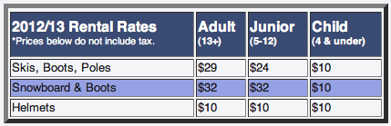
snow boarding. Snowmaking. Rentals and lessons. Cafeteria and Ridge Pub (also open summer Fri & Sat), Sun-Thur until 9 PM; Fri & Sat until 10 PM. Lodge available for private and business functions up to 175 people. Less than 40 miles from NYC, Tuxedo Ridge Ski Center at Sterling Forest is the closest Ski Area of New York (SANY member) for family snow tubing. With a lift-serviced hill, you have fun cruising down the hill without the climb back to the top. Plus, tubing is one winter sport that is EASY and FUN for everyone (no skills needed!).
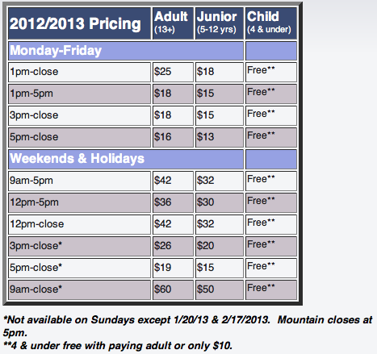

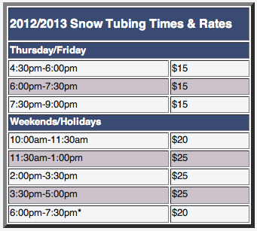

(All information collected from http://www.tuxedoridge.com/)

Travel: from George Washington Bridge to Tuxedo Ridge Ski Center
Address: Tuxedo Ridge LLC
581 Route 17A West, Tuxedo NY 10987
Contact information: (845) 351-1122
info@tuxedoridge.com

Suggested route: NJ-17 N
Approximate travel time: 36.9 mi, 47 mins

Directions: (Start at George Washington Bridge)
1. Head east on Interstate 95 Upper Level N toward Exit 1 (Entering New York) - 0.5 mi
2. Take exit 1 toward W 178 St - 0.2 mi
3. Turn left toward Interstate 95 Lower Level S - 105 ft
4. Turn left to merge onto Interstate 95 Lower Level S (Entering New Jersey) - 1.8 mi
5. Take exit 72A on the left for New Jersey 4 W toward Paramus - 0.4 mi
6. Merge onto NJ-4 W - 6.8 mi
7. Take the New Jersey 17 N ramp to Mahwah/Garden State Parkway N - 0.3 mi
8. Merge onto NJ-17 N - 13.9 mi
9. Take the New Jersey 17 N/Interstate 287 N exit toward Interstate 87/North Y. Thruway - 0.2 mi
10. Keep left at the fork, follow signs for I-287 N/I-87/NJ-17 N/N Y. Thruway and merge onto I-287 N/NJ-17 N (Entering New York) - 0.6 mi
11. Keep left at the fork, follow signs for I-87 N/NY-17 N/Albany and merge onto I-87 N/NY-17 N - 1.5 mi
12. Take exit 15A for NY-17 N - 0.2 mi
13. Turn left onto NY-17 N/Orange Turnpike. Continue to follow NY-17 N - 7.3 mi
14. Take the exit on the left toward New York 17A W - 0.1 mi
15. Turn left onto New York 17A W – 3.1 mi
*Destination will be on the left*

- Lunch- Ski Center Lodge Cafeteria

Description: Inside the rustic lodge, you may enjoy the cafeteria style dining which includes American cuisine and healthy options overlooking our slopes. Classic American Grill (Burgers, Hot Dogs, Pizza, Fries, Philly Cheese Steaks, Grilled Chicken)
Hours: Monday - Friday: 12pm - Close . Weekends & Holidays: 8am – Close.
Pricing: $8-$15 meals

Contact Information: (845) 351-1122
- Dinner- Piccolo Posto

Description: Classic Italian Bistro. Pizza, pasta, meat and seafood.
Pricing: $15-$20 classic dinner dishes
Alcohol: Full Bar
Noise Level: Quiet
TV: Yes

Travel: from Tuxedo Ridge Ski Center to Piccolo Posto
Address: 150 West Mombasha Road, Monroe NY 10950
Contact information: (845) 837-1431

Suggested route: Benjamin Meadow Rd and County Rd 91
Approximate travel time: 2.8 mi, 5 mins
Directions: (Start at Tuxedo Ridge Ski Center)
1. Head west on New York 17A W toward Benjamin Meadow Rd - 121 ft
2. Take the 1st right onto Benjamin Meadow Rd - 1.4 mi
3. Turn left onto Bramertown Rd/County Rd 91. Continue to follow County Rd 91 - 1.4 mi
*Destination will be on the right*

- Overnight stay: Caren House Bed and Breakfast ‎

Description: The Caren House Bed and Breakfast was built in 1810. The house
grew as Thomas Caren's family did, which gives each part its own charm. This comfortable home has three cozy bedrooms with country flavor. A delicious full breakfast is served each morning in the spacious dining room in front of a large fieldstone fireplace. There are three guest rooms with private baths in this non-smoking house. The single queen room has an attached bath, while the other two rooms have separate nearby baths. Wireless DSL internet access is available free of charge. The house sits on 4 acres with a pond, which is stocked with trout and smallmouth bass for catch-and-release fishing. Or, you can relax with a book on a bench by the pond or on the 75' front porch listening to sounds of the country. Perfect for couples or family getaways, the Inn is approximately one hour from NYC and major airports. The house is located on Orange Turnpike - a historical stagecoach run from NYC to Albany. (All info collected from http://www.carenhousebb.com/ )
Pricing: Guestrooms - Rates from $89 - $119 with full breakfast included

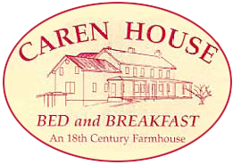
Travel: from Piccolo Posto to Caren House Bed and Breakfast
Address: 1371 Orange Turnpike, Monroe NY 10950
Contact Information: (845) 782-0377
carenbb@frontiernet.net

Suggested route: Berry Rd
Approximate travel time: 3.5 mi, 9 mins

Directions: (Start at Piccolo Posto)
1. Head north on County Rd 91/W Mombasha Rd toward Lakeview Dr - 0.7 mi
2. Take the 2nd right onto Berry Rd - 1.2 mi
3. Continue straight onto Rye Hill Rd - 0.9 mi
4. Turn right onto Reynolds Rd - 0.4 mi
5. Turn right onto County Rd 19/Orange Turnpike - 0.4 mi
*Destination will be on the right*
Day 2
- Breakfast – complimentary at Caren House Bed and Breakfast

- Destination #2: Woodbury Common Premium Outlets

Description: (SEE GUIDEBOOK)
Shopping outlets complex. Find impressive savings at Ann Taylor,
Balenciaga, Banana Republic, Burberry, Calvin Klein, Chloe, Coach, Dior, Dolce & Gabbana, Gucci, Last Call by Neiman Marcus, Michael Kors, Polo Ralph Lauren, Prada, Saks Fifth Avenue Off 5th, Tom Ford, Tommy Hilfiger and more. (All info collected from http://www.premiumoutlets.com/outlets/outlet.asp?id=7 )
Hours: Daily 10am-9pm http://www.premiumoutlets.com/outlets/hours.asp?id=7

Travel: from Caren House Bed and Breakfast to Woodbury Common Premium
Outlets
Address: 498 Red Apple Court, Central Valley NY 10917‎
Contact information: (845) 928-4000
premiumoutlets.com

Suggested route: County Rd 19 and County Rd 64
Approximate travel time: 4.9 mi, 13 mins
Directions: (Start at Caren House Bed and Breakfast)
1. Head north on County Rd 19/Orange Turnpike toward Prestwick Dr - 0.6 mi
2. Slight right onto County Rd 19/Still Rd - 0.7 mi
3. Continue onto County Rd 40 - 0.6 mi
4. Continue onto Bakertown Rd/County Route 105 - 0.5 mi
5. Turn right onto County Rd 64/Dunderberg Rd. Continue to follow County Rd 64 - 1.9 mi
6. Turn left onto NY-32 N - 0.2 mi
7. Turn right onto Woodbury Outlets Blvd N - 256 ft
8. Take the 1st right onto Ring Rd - 0.3 mi
9. Turn left onto Center Rd S - 0.1 mi
*Destination ahead*
- Lunch – Au Bon Pain Bakery Café

Description: a fast-casual bakery and cafe chain serving coffee drinks, baked goods
(with a focus on croissants and bagels), and lunch items such as soup, salads, and sandwiches.
Pricing: $5-$15 meals
Menu: http://www.aubonpain.com/menu/FS_TAKEHOME_MENU_FLAT.pdf

Address: On Woodbury Common Premium Outlets property, Food Court Suite 512
Contact information: (845) 928-4516

- Destination #3 – The Castle Fun Center

Description: (SEE GUIDEBOOK)
The Castle Fun Center is located in the heart of the Hudson Valley in Chester, NY. Just 10 minutes from Woodbury Commons and 50 miles from NYC. Activities include Ballocity, Roller Skating, Laser Maze, Mini Bowling, Bumper Cars, Free Fall, Rock Climbing, Lazer Tag, Arcade with Parent's Lounge and seasonal Go Karts, Mini Golf and Batting Cages. Perfect fun for all ages, from kids to adults. The Castle offers Birthday Parties, Groups, School and Camp Trips, Roller Derby and more.
Pricing: http://thecastlefuncenter.com/pricing-info/
Hours: http://thecastlefuncenter.com/pricing-info/hours-directions/

Travel: from Woodbury Common Premium Outlets to The Castle Fun Center
Address: 109 Brookside Avenue, Chester, NY 10918
Contact information: (845) 469-2116
http://thecastlefuncenter.com/
Suggested route: US-6 W
Approximate travel time: 9.9 mi, 14 mins
Directions: (Start at Woodbury Common Premium Outlets)
1. Head south on Center Rd S - 0.1 mi
2. Turn right onto Ring Rd - 0.2 mi
3. Turn left onto Woodbury Outlets Blvd N - 348 ft
4. Turn left onto NY-32 S - 0.2 mi
5. Take the ramp onto NY-17 W
Toll road - 0.9 mi
6. Continue onto US-6 W - 7.7 mi
7. Take exit 126 for NY-94 toward Florida/Chester - 0.2 mi
8. Turn right onto NY-94 E - 0.1 mi
9. Take the 1st left onto Brookside Ave - 0.4 mi
*Destination will be on the left*

- Dinner – Chester Diner

Description: Classic Diner menu. Breakfast, Lunch, Dinner.
Hours: 7 days a week: 6am-11pm.
Pricing/menu: http://www.thechesterdiner.com/Chester_Diner_Main_Menu_06-12.pdf
Travel: From The Castle Fun Center to Chester Diner
Address: 67 Brookside Ave, Chester NY 10918
Contact information: (845) 469-4488
Suggested route: Brookside Ave
Approximate travel time: 0.5 mi, 2 mins
Directions: (Start at The Castle Fun Center)
1. Head south on Brookside Ave toward West Ave - 0.5 mi
*Destination will be on the right*
- Overnight Stay: The Dominion House Bed and Breakfast

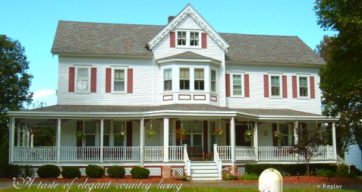
Description: Located just miles away from West
Point, the historic Dominion House Bed and Breakfast is an ideal place to stay for a vacation, romantic getaway or casual trip with friends. The elegant inn was built in 1880 by local farmer Benjamin Strong and is comprised of spacious rooms, stunning marble mantles and original furnishing. However, the old-fashion building also has all of the modern amenities that one would expect, including cable TV, air conditioning and wireless internet. Accommodations also feature a swimming pool, a slate top pool table and extensive library to keep you relaxed and entertained during your stay. All of the rooms our non-smoking and lodging includes a delectable country breakfast. Snacks, tea, coffee and cold drinks are also available 24 hours a day.
Pricing: $125-$199/night with full breakfast included
Travel: From Chester Diner to The Dominion House Bed and Breakfast
Address: 50 Old Dominion Rd, Blooming Grove, NY 10914
Contact information: (845) 496-1826
http://www.thedominionhouse.com/

Suggested route: NY-94 E
Approximate travel time: 6.3 mi, 10 mins
Directions: (Start at Chester Diner)
1. Head northwest on Brookside Ave toward Academy Ave/NY-94 E - 0.1 mi
2. Take the 1st right onto Academy Ave/NY-94 E - 0.2 mi
3. Turn left onto Main St/NY-94 E. Continue to follow NY-94 E - 5.5 mi
4. Turn left onto Old Dominion Rd - 0.4 mi
*Destination will be on the right*
Day 3
- Breakfast – complimentary at The Dominion House Bed and Breakfast

- Destination #4 – The Heritage Trail
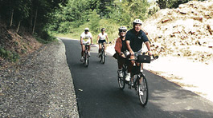
Description: (SEE GUIDEBOOK)
11.5 Mile Linear Trail from Goshen to Monroe. The first multi-use asphalt trail developed in the parks system. This trail offers attractive scenic vistas and access from the Village of Goshen to the Village of Monroe for walking, biking and roller blading.
Amenities: Trail, Benches and Parking.
Travel: from The Dominion House Bed and Breakfast to The Heritage Trail
Address: Access Point @ St. James Place, Goshen NY 10924
Contact Information: Administrative Office (845) 615-3830
Suggested route: NY-94 W and Craigville Rd
Approximate travel time: 8.3 mi, 16 mins
Directions: (Start at The Dominion House Bed and Breakfast)
1. Head southeast on Old Dominion Rd toward NY-94 W - 0.4 mi
2. Turn right onto NY-94 W - 2.2 mi
3. Turn right onto Craigville Rd - 148 ft
4. Turn left onto Co Rd 51/Hulsetown Rd - 0.2 mi
5. Slight left onto Co Rd 8/Craigville Rd. Continue to follow Craigville Rd - 4.7 mi
6. Turn left onto Main St - 0.7 mi
7. Turn left onto S Church St - 0.1 mi
8. Take the 2nd right onto St James Pl - 354 ft
*Destination will be ahead*
- Lunch: Catherine’s Restaurant and Pub

Description: For over 14 years, Catherine’s Restaurant has been proudly serving
high quality food using only the best and freshest ingredients available. Many of Grandma Catherine’s recipes are still used in the restaurant today; including her famous Irish soda bread.
Menu: Lunch – Appetizers, salads, sandwiches and wraps, pasta and other entrees. (http://www.catherinesrestaurant.net/home.asp?cnt=lnch&img=ilnch )
Hours: Closed Sunday and Monday. Lunch: Tuesday – Friday, 11:30am – 2:30pm
Pricing: $10-$20 lunch meals, very large portions
Travel: from The Heritage Trail
Address: 153 West Main St., Goshen NY 10924
Contact Information: 845-294-8707
info@catherinesrestuarant.net
Suggested route: The Heritage Trail and W Main St
Approximate travel time: 0.4 mi, 2 mins
Directions: (Start at The Heritage Trail)
1. Head southwest on St James Pl toward Orange Heritage Trail - 59 ft
2. Take the 1st right onto The Heritage Trail - 0.1 mi
3. Take the 2nd right onto Greenwich Ave - 266 ft
4. Turn left onto W Main St – 0.2 mi
*Destination will be on the left*

- Destination #5: Thomas Bull Memorial Park

Description: (SEE GUIDEBOOK)
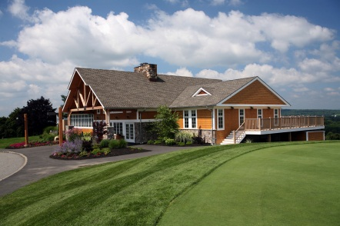
The largest developed facility of the county parks system, featuring year-round activities for all ages. From toddlers to senior citizens, this facility will meet both your active and passive recreation interests. Amenities: 18 Hole Golf Course, Driving Range, Banquet Facility, Pro Shop, Tennis Courts, Boat House, Ball Fields, Horse Riding Area/Stables, 5-Acre Pond, Fishing, Winter Sports Area, Picnic Shelters, Picnic Tables, Benches, Exercise Area, Arboretum, Playgrounds, Volleyball Courts, Horseshoe Pits, Hill-Hold Historic Museum, Comfort Stations and Parking.
Pricing: Prices range per activity
(http://www.orangecountynyparks.com/index.php?option=com_content&view=article&id=25&Itemid=3 )

Travel: from Catherine’s Restaurant
Address: 211 New York 416, Montgomery NY 12549
Contact Information: Administrative Office: (845) 615-3830
Park Maintenance Building: (845) 457-4914
Stony Ford Golf Course: (845) 457-4949
Suggested route: NY-207 E
Approximate travel time: 6.4 mi, 10 mins
Directions: (Start at Catherine’s Restaurant)
1. Head east on W Main St toward New St - 1.4 mi
2. Continue onto NY-207 E - 3.4 mi
3. Slight left onto NY-416 N – 1.5 mi
*Destination will be on the left*

- Travel: Back to George Washington Bridge

Suggested route: I-87 S
Approximate travel time: 59.0 mi, 1 hour 7 mins
Directions: (start at Thomas Bull Memorial Park)
1. Head south on NY-416 S toward Ottaway Ln - 1.5 mi
2. Continue onto NY-207 W - 4.7 mi
3. Turn left onto S Church St - 0.3 mi
4. Turn right onto South St - 0.6 mi
5. Turn left onto New York 17M W/Harriman Dr - 0.3 mi
6. Slight left to merge onto NY-17 E/US-6 E - 11.4 mi
7. Continue onto NY-17 E - 1.1 mi
Partial toll road
8. Keep right at the fork, follow signs for Interstate 87 S/New York and merge onto I-87 S - 14.6 mi
Partial toll road
9. Take exit 15 for NY-17 S/I-287 S toward New Jersey - 0.8 mi
10. Merge onto I-287 S - 0.6 mi (Entering New Jersey)
11. Take exit 66 on the left for NJ-17 S toward Mahwah - 0.4 mi
12. Slight left onto NJ-17 S - 13.3 mi
13. Keep left at the fork - 0.4 mi
14. Take the exit toward Fort Lee/New York - 0.5 mi
15. Merge onto NJ-4 E - 6.9 mi
16. Keep left at the fork, follow signs for I-95 N/G W Bridge/New York City and merge onto Interstate 95 Lower Level N - 0.5 mi
17. Slight left onto U.S. 9 N - 0.4 mi
Partial toll road
18. Merge onto Interstate 95 Upper Level N - 0.6 mi
Partial toll road
*Destination will be on the left*



Orange County Tourism
Guidebook
For More Information on Orange County, NY Tourism please visit:
http://www.orangetourism.org/

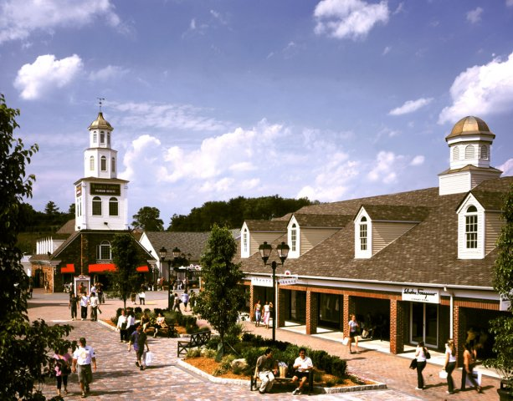
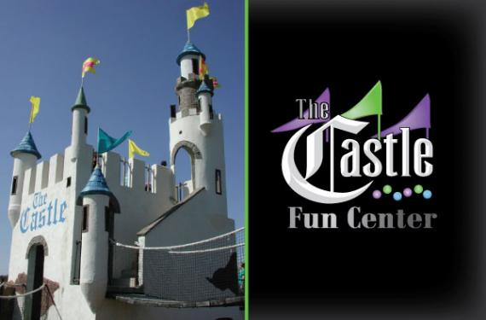
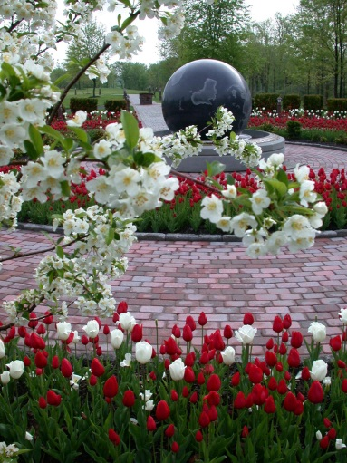
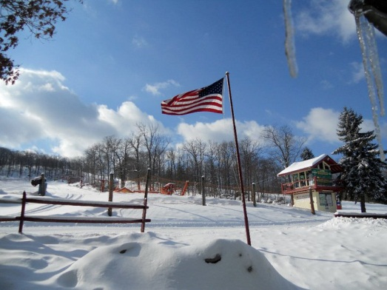
The Woodbury Common Premium Outlets
The Castle Fun Center
Thomas Bull Memorial Park Arboretum
Heritage Trail
Tuxedo Ridge Ski Center
The Woodbury Common Premium Outlets

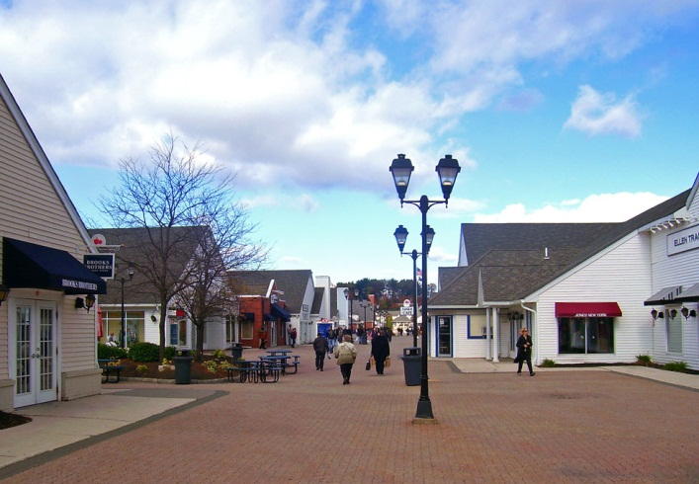
498 Red Apple Court
Central Valley, NY 10917

Phone: (845) 928-4000

Regular Hours
Open daily: 10am-9pm
Other Holiday Hours can be found on the website.

http://www.premiumoutlets.com/outlets/
outlet.asp?id=7

History: Opened in late 1985, the Woodbury Common Premium Outlets was expanded in 1993, and again in 1998.
Description: The Woodbury Common Premium Outlets located in Central Valley is famously known as the largest collection of designer outlets in the world. With 220 stores such as Burberry, Polo Ralph Lauren, J. Crew, and Jimmy Choo, these Outlets provide tourists and locals with a pleasant shopping center where they can spend a lot of money and time in. The Woodbury Common Outlets also have restaurants and a food court for when shoppers need an extra energy boost. The Outlets also provide tourists with locker and stroller rentals, foreign currency exchange, and ATM. Open from 10am to 9pm daily, except on special holidays, the Woodbury Common Premium Outlets is a great place to spend a day with your family and friends.

The Heritage Trail
11.5 Mile Linear Trail from Goshen to Monroe
Access Points/Parking – Chester Depot Museum, Village of Chester; St. James Place, Village of Goshen: Park and Ride Lot B, Village of Monroe.
Phone: (845) 615-3830
Fax: (845) 457-4906
Hours: From dawn to dusk
Email: parks@orangecountygov.com
http://www.orangecountynyparks.com/index.php?option=com_content&view=article&id=21&Itemid=3
The Heritage Trail in Goshen is a scenic pathway where visitors are welcomed to walk, jog, bike, roller-skate, etc. Converted from the railbed of the Erie Rail Road, this scenic walkway is a great place to spend an afternoon with family and friends of all ages. Currently stretching 11.5 miles, this walkway will soon reach 20 miles connecting the City of Middletown to the Village of Harriman. Visit and enjoy exercise with a view, but remember to follow trail etiquette!
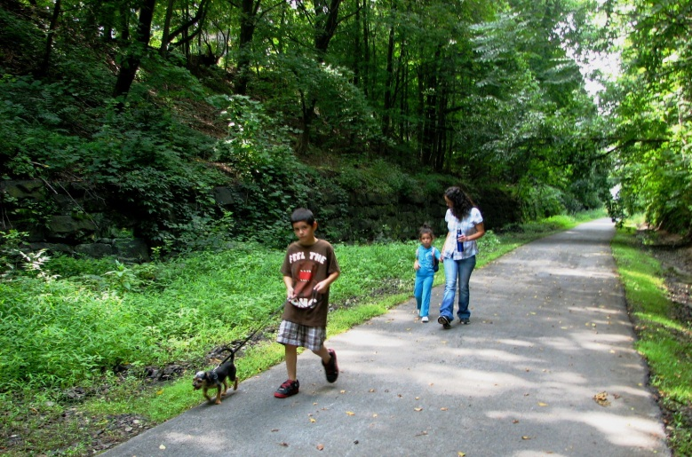
The Thomas Bull Memorial Park Arboretum

Grove St. entrance to
Thomas Bull Memorial Park
Route 416
Montgomery, NY 12549
Phone: (845) 615-3830
Fax: (845) 457-4906
Hours: From dawn to dusk
Email: parks@orangecountygov.com
http://www.orangecountynyparks.com/index.php?option=com_content&view=article&id=17&Itemid=3

The Thomas Bull Memorial Park located in Montgomery houses the world famous Arboretum. This Arboretum not only lets visitors walk through beautiful gardens, but it also has a memorial walkway for those who lost their lives on September 11th. The park also has seasonal snow tubing, cross country skiing, ice skating, and sleigh-rides. The Thomas Bull Memorial Park also offers picnic and recreational areas, fishing, golf courses, playgrounds, horseback riding, a boathouse, and a dog park. The Hill-Hold Museum of farm life in the 1830s is also in the park, as well as a first class restaurant. The Thomas Bull Memorial is great place to have fun, learn about history, and relax all in one place!
The Castle Fun Center
109 Brookside Avenue,
Chester, NY 10918
Phone: (845) 469-2116
Open year round. Hours change seasonally and can be found on the website.
Email: main@thecastlefuncenter.com
For Group or Event Center bookings or questions, please contact Susan at 845-469-2116 ext. 7000 or sue@thecastlefuncenter.com
http://www.thecastlefuncenter.com/
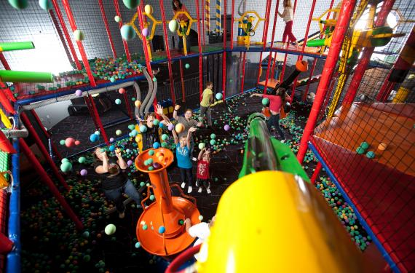
The Castle Fun Center in Chester offers a great amusement park for children. With bumper cars, laser tag and maze, roller-skating rink, mini-bowling, and rock wall, kids will never get bored. The Castle Fun Center also offers mini golf, batting cages, go-karts, an arcade, and a playground. There is also Jester’s Restaurant and Pub as a convenient place to eat. Open year-round with the opportunity to celebrate birthdays, the Castle Fun Center is a great place for children to have a fun and exciting day.
Tuxedo Ridge Ski Center
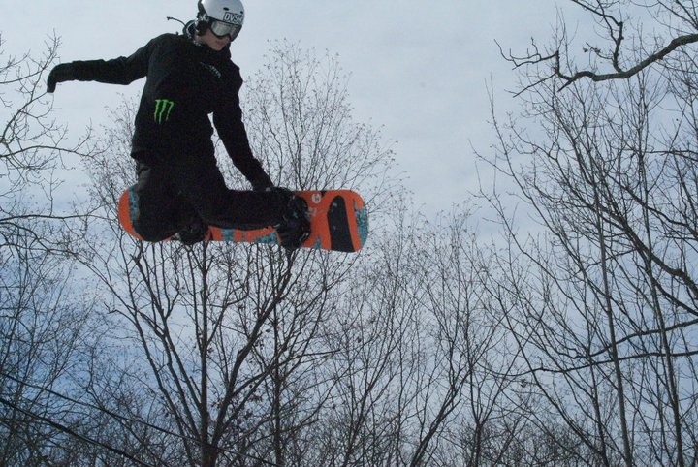
581 Route 17A West,
Tuxedo NY 10987
Phone: (845) 351-1122
Email: info@tuxedoridge.com
2012/13 Skiing and Snowboarding Hours
Monday-Friday: 1:00pm-9:00pm
Saturday/Holidays: 9:00am-9:00pm
Sunday: 9:00am-5:00pm
http://www.tuxedoridge.com/

Tuxedo Ridge Ski Center in Tuxedo, NY is a great place to spend a day in the mountains. With seven trails, four chair lifts, and Terrain Park, this ski center will have skiers of all levels smiling and having a great time. Tuxedo Ski Center not only offers skiing but snowboarding and snow tubing as well. There are also ski/snowboard lesson and rentals for those who are beginners. The ski center has a cafeteria and pub on the grounds for skiers who need some energy, and also lets visitors ski at night. The Tuxedo Ridge Ski Center is the perfect place for families to have a fun, snow-filled day.

Bibliography

A1 Trails, "Heritage Trail." Last modified 2010. Accessed October 7, 2012. http://www.a1trails.com/rail/ny/heritage.html.
This site provided information on the Heritage Trail to Dani Carpiniello.

"Apiary." Orange County Arboretum. Ehub23.webhostinghub.com/~orange20 Company, 2012. Web. 2012. <http://ehub23.webhostinghub.com/~orange20/photo-gallery/apiary>.
This source was used in the creation of Kimberly McVetty's "What's all the Buzz About?" lesson plan.

"Baby Blue Bird Clip Art." - Vector Clip Art Online, Royalty Free & Public Domain. N.p.,
n.d. Web. 09 Oct. 2012. <http://www.clker.com/clipart-baby-blue-bird.html>.
This contributed an image to Gaby Gilmartin’s highway marker.

Belsito Communications Inc., "Orange Pathways." Last modified 2010. Accessed October 7, 2012. http://www.orangepathways.org/heritage.html.
This site provided the information used by Kimberly McVetty directly on the interpretive signs, as well as the picture that serves as the backdrop.
Conversation with Scott McVetty, October 6, 2011.
Information from McVetty was used by Kimberly McVetty and Matt Kelly in understanding the most useful materials for creating an interpretive sign.

"Elementary Science- Core Curriculum Grade K-4." Nysed.gov. The University of the State of New York State Education Department, 2012. Web. 2012. <http://www.p12.nysed.gov/ciai/mst/pub/elecoresci.pdf>.
This source was used in the creation of Kimberly McVetty's "What's All the Buzz About?" lesson plan.

"Explore Sapsucker Woods." Birds, Trails, Birdwatching. N.p.,
n.d. Web. 08 Oct. 2012. <http://www.birds.cornell.edu/page.aspx?pid=1576>.
This site was used for Gaby Gilmartin’s highway marker.

George, Rogero. Orange County Offices, "Orange County Offices by Orange County NY Shooters." Accessed October 5, 2012. http://www.ocshooters.com/Gen/politics/orangecountyofficers.htm.
Orange County Offices’ site provided the current Orange County Logo, used for the interpretive sign by Kimberly McVetty.

"Go Karts Â» The Castle Fun Center | Chester NY." Go Karts Â» The Castle Fun Center. N.p., n.d. Web. 05 Dec. 2012. This source was use for the photo of the kid on the go cart at castle fun center.

"Heritage Trail (aka Orange Heritage Trail)." Bike Trails, Walking Trails & Trail Maps.
N.p., n.d. Web. 07 Oct. 2012. <http://www.traillink.com/trail/heritage-trail-(aka-orange-heritage-trail).aspx>.
This site was used for Gaby Gilmartin’s highway marker.

"Hike Shoe Print Clip Art." - Vector Clip Art Online, Royalty Free & Public Domain. N.p.,
n.d. Web. 09 Oct. 2012. <http://www.clker.com/clipart-hike-shoe-print.html>.
This contributed an image to Gaby Gilamrtin’s highway marker.

ILOVENY , "Orange County Tourism: In the Beautiful Hudson Valley." Last modified 2012. Accessed October 6, 2012. http://www.orangetourism.org/.
Orange County Tourism’s website was used to evaluate the current practices of the tourism board and to decide what needed to be improved. It was used by Matt Kelly and Melissa Suppe.

"Mini Golf." The Castle Fun Center. Round Here Productions, 2012. Web. 2012. <http://thecastlefuncenter.com/activities/mini-golf/>.
This source was used in the creation of Kimberly McVetty's " The Castle Fun Center Open" lesson plan.

National Park Service, "Colonials and Patriots: Survey of Historic Sites and Buildings: Washington's Headquarter's (Hasbrouck House)." Last modified 2005. Accessed October 6, 2012. http://www.cr.nps.gov/history/online_books/colonials-patriots/sitec35.htm.
This site provided information on the Hasbrouck House to Dani Carpiniello.

"Nature Trail Outline Clip Art." - Vector Clip Art Online, Royalty Free & Public Domain.
N.p., n.d. Web. 09 Oct. 2012. <http://www.clker.com/clipart-nature-trail-
outline.html>.
This site contributed an image to Gaby Gilamrtin’s highway marker.

NYS P-12 Common Core Learning Standards for English Language Arts and Literacy, 2011. This source was used in the creation of Kimberly McVetty’s “All Aboard the Knowledge Train!” and “Scrapbooking Orange County, NY” lesson plans.

"Orange County NY Parks & Recreations." Orange County NY Parks & Recreations. N.p., n.d. Web. 05 Dec. 2012. This site was used for the photos for the pictures on the panels for the Heritage Trail, and the Thomas Bull Memorial Park Arboretum. It was also used for the blurbs on each interpretive panel. It was also used in Melissa Suppe’s guidebook.

"Physical Education Learning Standards." Nysed.gov. University of the State of New York - New York State Education Department, 2009. Web. 2012. <http://www.p12.nysed.gov/ciai/pe/pe1.html>.
This source was used in the creation of Kimberly McVetty's "Ski How Far You Can Go!" and "The Castle Fun Center Open" lesson plans.

"P-12 Common Core Learning Standards for Mathematics." Nysed.gov. Common Core State Standards Initiative, 2012. Web. 2012. This source was used in the creation of Kimberly McVetty's "The Castle Fun Center Open" and "Shop 'til You Drop" lesson plans.

"Roseanna Piter.com." Trees Clipart Image. N.p., n.d. Web. 09 Oct. 2012.
<http://www.rosiepiter.com/clipart_illustrations/three_pine_trees_0071-0910-2204-5015.html>.
This site contributed an image to Gaby Gilmartin’s highway marker.

Simon Premium Outlets, "Woodbury Common Premium Outlets." Accessed October 8, 2012. http://www.premiumoutlets.com/outlets/outlet.asp?id=7.
This site was used to gain information on the Woodbury Common Outlets by Dani Carpiniello and Melissa Suppe.

Simply Zesty , "Simply Zesty: Social. Digital. Mobile. ." Last modified 2012. Accessed October 5, 2012. http://www.simplyzesty.com/category/social-media/twitter/.
Simply Zesty offered the Twitter logo, which is also used in the interpretive sign by Kimberly McVetty.

"Ski Schools and Lessons." Tuxedo Ridge at Sterling Forest. Tuxedo Ridge LLC, n.d. Web. 2012.<http://www.tuxedoridge.com/index.php?option=com_content&view=article&id=5 4&Itemid=71>.This source was used to assist in the planning of Kimberly McVetty's "Ski How Far You Can Go!" lesson plan.

"Store Listings and Center Map." Woodbury Common Premium Outlets. SIMON, 2012. Web. 2012.This source was used in the creation of Kimberly McVetty's " Shop 'til You Drop!" lesson plan.

The Castle Fun Center, "The Castle Fun Center." Last modified 2011. Accessed October 7, 2012. http://www.thecastlefuncenter.com/.
This site was used to gain information on the Castle Fun Center by Dani Carpiniello and Melissa Suppe.

"The Erie Railroad." American- Rails.com. American-Rails.com, 2012. Web. 2012. <http://www.american-rails.com/erie-railroad.html>.
This source was used in the creation of Kimberly McVetty's " All Aboard the Knowledge Train!" lesson plan.

Tuxedo Ridge Ski Center, "Tuxedo Ridge Ski Center at Sterling Forest." Accessed October 8, 2012. http://www.tuxedoridge.com/.
This site was used to gain information on the Tuxedo Ridge Ski Center by Dani Carpiniello and Melissa Suppe.
"Tuxedo Ridge at Sterling Forest Ski, Snowboard, Tube Close to NYC." Tuxedo Ridge at Sterling Forest Ski, Snowboard, Tube Close to NYC. N.p., n.d. Web. 05 Dec. 2012. This site was used for the picture of the snow tubing group in the Tuxedo Ridge interpretive panel.

"Tuxedo Ridge." Tuxedo Ridge. N.p., n.d. Web. 05 Dec. 2012. This site was used for the information blurb about Tuxedo Ridge on the Tuxedo Ridge interpretive panel. It was also used for Melissa Suppe’s guidebook.

"Welcome to the Castle Fun Center in Chester, NY! Â» The Castle Fun Center | Chester NY." Welcome to the Castle Fun Center in Chester, NY! Â» The Castle Fun Center. N.p., n.d. Web. 05 Dec. 2012. This source was used for the information blurb on the castle fun center interpretive panel. It was also used for Melissa Suppe’s guidebook.

Woodbury Common outlet. Digital image. The Native New Yorker Blog. N.p., 30 Aug. 2012. Web. 5 Dec. 2012. This site was used for the first picture on the Woodbury Common interpretive panel.

"Woodbury Common Outlets Shopping 1-Day Tour." Woodbury Common Outlets Shopping 1-Day Tour. N.p., n.d. Web. 05 Dec. 2012. This source was used for the second picture on the Woodbury Common interpretive panel.

