Putnam County: Fierce Five


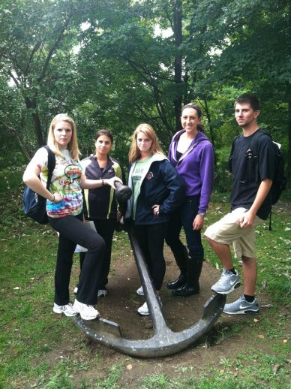

Stephanie Kilponen, Rosanna Ruggiero, Kaity Meagher, Kelly Limerick, Jake Chico
Professor Johnson
History 218 Section 111
10 December 2012
Table of Contents
- History of Recreation in the County (Stephanie Kilponen)
- Key Recreational Sites (Rosanna Ruggiero)
- Interpretive Signs (Kaity Meagher)
- Highway Route Markers (Kelly Limerick)
- Tourism Strategies and Organization (Jake Chico)
- Overview of County
- Annotated Bibliography

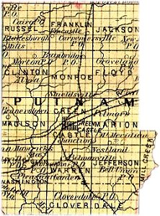
History of Recreation and County
Lying on the east shore of the Hudson River, between Westchester and Dutchess counties, is Putnam County. This section embraces nearly all of the Highlands east of the river. Putnam County formed in 1812, when it detached from Dutchess County. Putnam was slow to be settled compared to other parts of the Hudson Valley, for two reasons. Firstly, it was privately owned and settlement was limited to tenant farmers willing to pay a portion of their earnings to Phillipse. Secondly, it was mostly hilly and rocky and unattractive to farmers looking for tillable cropland, and therefore was limited to dairy farming and wood cutting.
http://www.putnamindianacemeteries.com/aweb/Maps/CoMap/Putnam%20County1879.jpg
But, Putnam was also able to function as a separate county because of the easy transportation provided by the Hudson River. Boats transporting goods traveled up the Hudson to ports, mainly at Peekskill, where it was brought out Peekskill Hollow Rd. into Putnam County, or goods were unloaded in Putnam County itself at Cold Spring. Problems arose when the river froze in the winter, which resulted in little food or goods being brought to the county. The Philipstown Turnpike was created in 1815 as a toll road from Cold Spring to Connecticut. The wagons that traveled the road would transport produce from eastern Putnam County. Transportation improved again with the railroad, Harlem Line, which was built in the 1840s, connecting Putnam to New York City.
http://www.crwflags.com/fotw/images/u/us-ny-pu.gif
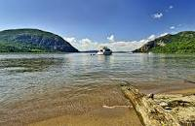
In Putnam County, much of the farmland was flooded to create reservoirs. The abandoning of farms, the creation of reservoirs, and the preservation of the remaining open land resulted in scenic lands that drew large amounts of tourism from New York City. By the 20th century, improved roads brought vacationers from New York City, which led to creation of the Taconic State Parkway during the Great Depression. This brought more vacationers, which were attracted to the scenic land and the inexpensive hotels, inns, and summer houses. Putnam County's population doubled during the summer months.
http://www.flickr.com/photos/philhaber/6056040146/

Some recreational sites in Putnam County include Foundry Dock Park, Clarence Fahnestock Memorial State Park, Little Stony Point Park, and Stonecrop Gardens. Foundry Dock Park is in Cold Spring and is a beautiful park on the riverfront. This park used to be a loading dock of the West Point Foundry in 1818. This dock produced artillery, locomotives, steamships, and pipes. Finished parts were shipped from the pier to many different points worldwide. This once loading dock was closed in 1911 and turned into a historic, scenic national park. Clarence Fahnestock Memorial State Park has many different recreational activities. The original land was a donation of about 2,400 acres in 1929 by Dr. Ernest Fahnestock. It was donated as a memorial to his brother Clarence. Clarence Fahnestock, Ernest's brother, died in the post-World War I influenza epidemic treating patients with the disease.
http://upload.wikimedia.org/wikipedia/commons/thumb/0/05/Putnam_County_10.svg/220px-Putnam_County_10.svg.png
In the early 1900s the Hudson River Stone Company begins filling in the water at the base of Bull Hill with silt, rubble and stone. But, in 1940 the Hudson River Conservation Society stopped the filling of Little Stony Point. In 1970 Little Stony Point officially became a state park of the Hudson Highlands. 1994 the park was closed due to an unsafe bridge but later reopened in 1996.
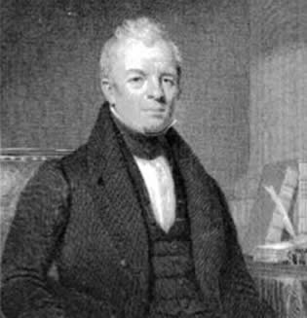
Stonecrop Gardens is located in Cold Spring, New York; the garden was the home of Anne and Frank Cabot, who founded the Garden Conservancy in 1989. Before Stonecrop came into existence, Anne’s parents, George and Lynn Perkins, purchased property located in the Hudson Highlands in 1929. The property expanded to include 2,500 acres of fields, lakes, farm, and forests, and the couple wanted to show the importance of open space preservation.
http://www.nysl.nysed.gov/mssc/steamboats/images/kent.jpg

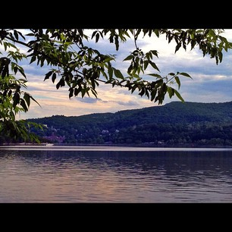
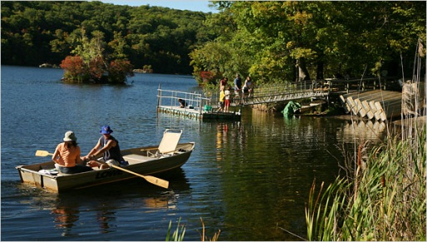
Recreation Sites in Putnam County Putnam County is located in the lower Hudson Valley of New York. It has a vast array of recreational sites that are open to the public, where people can enjoy many activities outdoors. Some include hiking, swimming, campsites, gardens, and special events. Foundry Dock Park is located on the western store of the Cold Spring Train Station. The Foundry produced some of the first locomotives, steamships, and pipes for New York City’s water system. The finished goods were transported by rail to a pier off of Foundry Dock Park where they were then shipped worldwide. Some of the parks features include: the great views of the Hudson Highlands, bird watching/nature study, fishing, kayak and canoeing, picnicking and walking. This is a great place to take the family on a Sunday, to bond and to enjoy nature. Clarence Fahnestock Memorial State Park is another recreational site that covers part of both Putnam and Duchess County. The beautiful scenery is a great place to take advantage of the hiking trail, Canopus Lake, picnic areas, the campground and opportunities to boat, hunt and fish. One feature that many take advantage of is the eighty campsites at the park that each has a picnic table and a fire ring. Visitors can fish at the lake as long as they have a Regional Parking Permit. Fishing is great at Canopus for those looking to catch bass, pickerel, perch, brook or rainbow trout. On weekends the park features organized hikes and craft activities and on Saturday evenings movies are shown for all campers.
http://web.stagram.com/location/15410004shipped

http://travel.nytimes.com/2007/09/30/nyregion/nyregionspecial2/30Rleaves.html

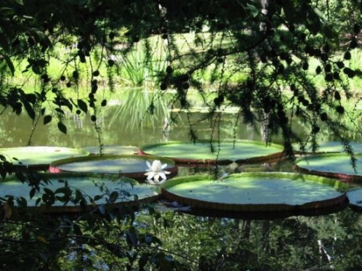
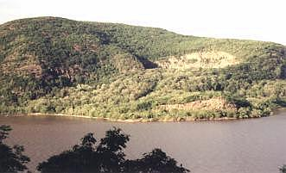
Another recreational site in Cold Spring is Little Stony Point Park, this park was founded in 1989 and “is dedicated in keeping the New York State Park beautiful and accessible to the public.” Stony Point has many events throughout the year that all are welcomed to attend. “Hoot on the Hudson” is an event that was started 17 years ago. It is featured the day after Labor Day where either solo performers or full bands come and entertain their visitors. The festival runs from 1 to 6 and is free for all; visitors can bring a picnic lunch and spend the day at the beach and the hiking trails. Another event “Little Stony Point Cleanup Day” takes place in the spring. It is a day where visitors come and clean up “Sandy Beach” for the summer months. It is a great day to meet other people, keep our environment clean, and enjoy the beautiful park. “Maple Syrup Day” is a day where visitors come to the park to enjoy fresh pancakes, hot apple cider, and maple syrup. Visitors eat their breakfast as they listen to live music and enjoy the beautiful scenery of the Hudson River. Stonecrop Gardens is another beautiful recreational sight that was originally home of Anne and Frank Cabot. It became a public garden in 1992 under Caroline Burgess. The garden covers about twelve acres of gardens and plants. There are water gardens, a grass garden, raised alpine stone beds, cliff rock gardens, and an English style flower garden. One unique aspect of this garden is that the plant and garden selections serve as an educational resource, which is based on the School of Practical Horticulture. The garden also contains a Conservatory; a display Alpine House and a Pit House that has a collection of dwarf Bulbs. The Conservatory also has four winds that each has a unique environment controlled by climate control systems. One event that it features is the “Annual Garden Party.”
http://hvgateway.com/STONYPT.HTM

Interpretive Signs
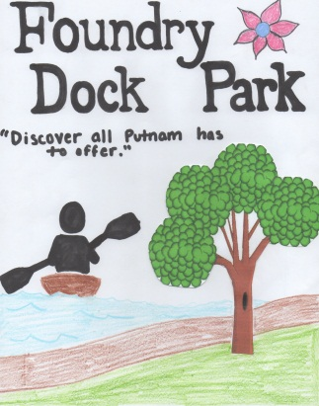
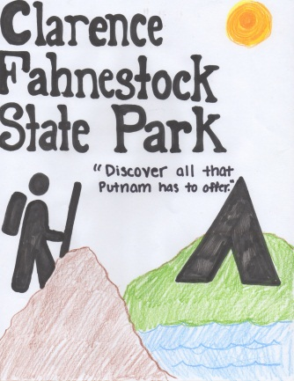
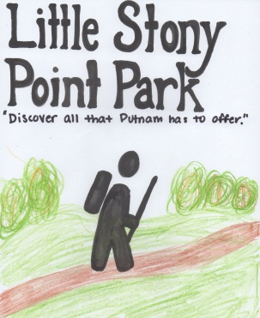
There are many geographical sites in the Hudson River Valley, which not only hold great historical significance, but offer so much to visitors in the present day. These sites represent the formation of America, and hold such history in its timeless natural beauty. The same grounds that these significant first footsteps were made, are how recognized geographical sites, that not only contains enormous historical background, but brings the memory of that history to the visitors today. In Putnam County alone, there are five significant sites that provide vast recreational opportunities to those who come to experience the beauty of the Hudson River Valley. The first site that we chose to focus on is Foundry Dock Park, located in Cold Spring, Putnam County. Even though it is small in size, it is vast in beauty. In the mockup of the interpretive sign, I chose to include pictures of a trail, for hiking, observing the beautiful natural landscape, and bird watching. I also included an image of a kayaker, because this park encourages kayaking and canoeing and has renting available. I used natural colors such as greens, oranges, blues, and browns, to represent that vast variety of activities that can be performed at this park.
The second site that we chose to study was Clarence Fahnestock Memorial State Park, located in Carmel, Putnam County. In my mockup of the interpretive sign, I chose to highlight the availability of camping and hiking at this historic site. I used colors such as browns and greens, to represent the feel of what is observed while hiking and camping. I included images of hikers and a campground to signify these strong aspects of this park.
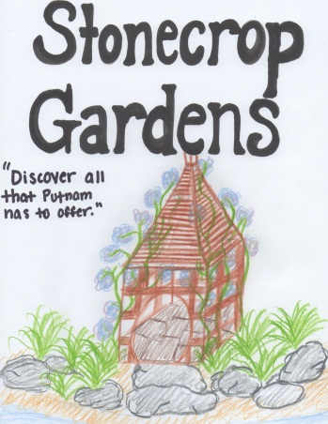
The third site we chose to study was Little Stony Point Park, located in Cold Spring, Putnam County. I chose to include images of hiking, kayaking, and trail to represent the three biggest aspects of this park. There is also much to observe in the park in terms of types of trees, grasses, and other plants. I chose to include colors such as greens to represent the natural beauty, blues to represent the water activities, and browns and oranges for hiking. The fourth site that we chose to study was Stonecrop Gardens, which is located in Cold Spring, Putnam County. In my mockup of the interpretive sign for this park, I chose to include images of walking trails and flower gardens. Stonecrop Gardens is famous for its floral beauty and is known to be a beautiful place to study. I chose to include colors such as green, yellow, purple, pink, and orange, to represent the great variety of the floral diversity in this historical park.
The mock-up signs that have been designed are significant to the identity of each park that we chose to study. These signs welcome visitors into the beauty of each of these parks, and give visitors a strong idea of what they can find at each particular park. These four parks in Putnam County all hold historical significance, but also present day beauty.

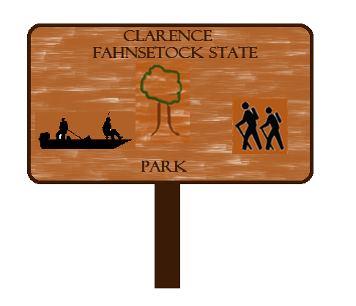
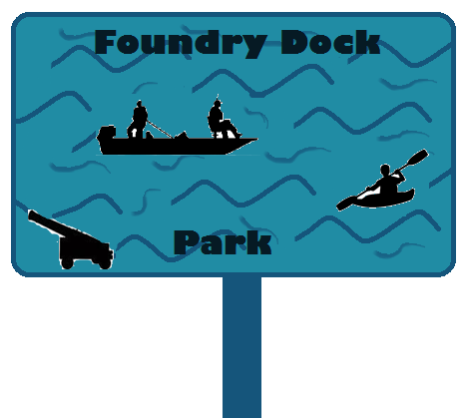
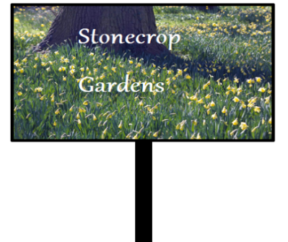
Highway Route Markers Roadway markers should represent the recreational area of the county they are promoting. The color of the sign should stand out to the drivers on the road. The signs should have pictures that will catch people’s attention and that represent that to the particular place. For example, a state park sign might have trees or hiking trail on them. When designing the road sign for Clarence Fahnestock Memorial State Park, I decided to make the color of the sign a dark orange because that color reminds people of autumn colors found in nature. I chose to include other pictures on my sign as well. I added a picture of a fishing boat because there is a large beach at Canopus Lake. This is where many people enjoy swimming and fishing. Clarence Fahnestock Memorial State Park has over 14,086 acres of forest, so I also included a tree on the sign to represent the forest. The final picture is of hikers because the park has many different trails that are great for hiking. There are also 80 different campsites. The road sign for Foundry Dock Park is blue. It has waves because the park is on the Hudson River. I included a picture of a fishing boat and a kayak as well. I added this because there are many water activities that can be done at Foundry Dock Park. There is fishing, kayaking, canoeing and tours provided by Hudson Valley Outfitters. I also included cannon on the road sign because in 1818 the Foundry produced artillery for the U.S government. They manufactured Parrot guns and cannons.
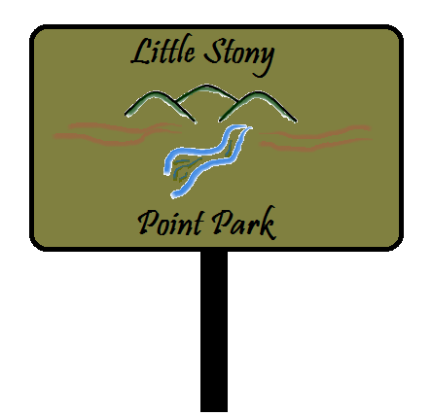
When designing the road sign for Stonecrop Gardens, I decided to fill the background of the sign with flowers and a tree to represent a diverse collection of plants on the approximately 12 acres of land. There are also over fifty plant families that are in the Stonecrop Gardens as well. The Little Stony Point Park sign I made is the color green because I thought it would represent the color of nature. I added mountains, a river and trails in the road sign as well. I included these things, because a viewer is able to see both Storm King and Breakneck Mountains. There are also many trails that are excellent places for hikers to see the amazing view of nature. I included the river because Little Stony Point Park sticks out into the Hudson River as seen from Breakneck Ridge.
Roadway signs need to be able to catch an individual’s attention while giving specific information about the recreational area. There needs to be a bold color that stands out and is significant to the place. There also needs to be pictures that accurately portray the recreational site. Roadway signs provide a very important a first impression of the recreation site. They help individual see what a site has to offer along with the history of the site

Tourism Strategies and Organization
Many Putnam County tourist attractions are easily accessible and are all great places to visit. This region has a great history and the scenery is excellent. Some popular tourist attractions are Foundry Dock Park, Clarence Fahnestock Memorial State Park, Little Stony Point Park, and the Stonecrop Gardens.
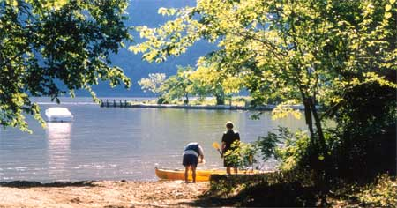
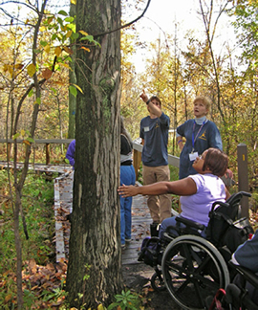
There are many different means of transportation to Foundry Dock Park. You can access the park by train, car, and inside the park is accessible by foot and other devices. Depending on the season, you can snowshoe or even kayak. The trail is great for walking and is wheelchair friendly. The park has a great history as it used to be a railroad port during the Civil War. It has since been reconstructed into a beautiful park that features a great view of the Hudson River Valley area. This site can be greatly promoted on Facebook. The public can view their page, which will feature scenic pictures and the different activities available. A link to the Facebook page will be available on Putnam County’s website. Another beautiful recreational site located in Putnam County is the Clarence Fahnestock Memorial State Park. This park has a lot of activities with in it, such as hunting, boating, and fishing. There is a lake, which is boat friendly if tourists have the appropriate license. The park is 14,086 acres and includes a walking trail as well as 80 campsites. It covers area in both Putnam and Dutchess Counties. The park, along with all New York State Parks, is committed to making all parts of the park accessible to all people, no matter what their limitations are. At Clarence Fahnestock Park, any area that is not accessible by all is will be updated with. Any place that is a pedestrian area is wheelchair accessible. People using motorized vehicles, may not have access to all the parks amenities because there is a potential for danger in that area. This park is accessible by RV, car, and bus. This site will have a twitter account which will promote the different activities available and help increase tourism. Tourists can write a tweet to the site’s account with reviews and suggestions. The link to the twitter account will be available on the county’s website.
http://www.landthatmattersmost.org/files/u1/launchingatfdp_450.jpg
http://nysparks.com/Images/Photos/Accessibility/TreeIdentification.jpg

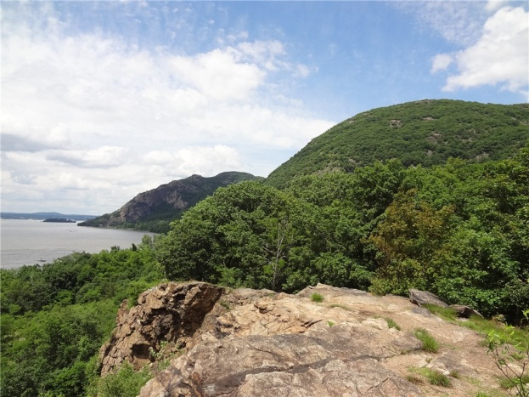
Little Stony Point Park is another tourist site located in Putnam County. It is another state park and is known as one of the most beautiful places in the Hudson Valley. It is located two miles north of Cold Springs and has a great loop trail, a sandy beach, and a cave that can be explored. The trail is very flat and only a mile long. It can be reached through the metro North train or by car; however, it is on a main road so travelers be cautions while crossing the street. There will be shuttles available that will take tourists from the parking lot to the park site. A busing program will also be available that will pick up elderly or handicapped tourists and will bring them to the site. For the most part, it is wheelchair friendly except for the beach and the cave. This site also has twitter account and features pictures and comments about the available parking and shuttle programs. The link will be on the county’s website.
http://2.bp.blogspot.com/aKP2CwTxU0I/TgiIDJDxz8I/AAAAAAAADDg/yzFSc4qwuAI/s1600/DSC00571%2Bbreakneck%2Bridge%2Band%2Bbull%2Bhill%2Bfrom%2Blittle%2Bstony%2Bpoint.jpg
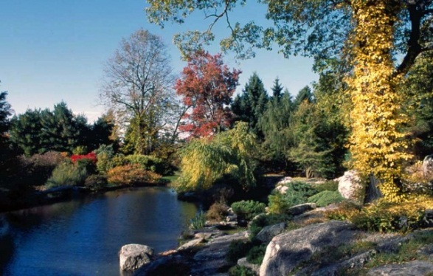
The last and final recreational site in Putnam County is called Stonecrop Gardens. It is located in Cold Springs, New York and is a 12 acre garden featuring all stone gardens, water gardens, a grass garden, and a cliff garden. It is open Monday-Saturday from 10:00am to 5:00pm and admission is $5. Unfortunately, Stonecrop Gardens has all sorts of elevations and narrow paths. It also does not have a paved roadway so strollers and wheelchairs are not allowed. However, if a person who has limited mobility and still wants to visit the gardens, they can contact a representative at (845)-265-2000. There are no pets or smoking allowed at the gardens and taking or touching any plant or pedal is prohibited. Stonecrop Gardens has a website that is accessible to the public. It features scenic pictures, accessibility, activity hours, and the price of admission. The link to the website will be available on the county’s website as well.
http://stonecrop.server265.com/cmpg/gallery2/main.php?g2_itemId=183

Overview of Putnam County
Putnam County, located in New York, was once a part of Duchess County, until 1812 when it became its own county. The creation of the Taconic Parkway in the 20th century influenced tourists to visit Putnam County for its improved roadway systems, scenery, and its many recreational sites that it has. The four sites we chose are Foundry Dock Park, Little Stony Point Park, Clarence Fahnestock State Memorial Park, and Stonecrop Gardens. Each has its own history and great reasons as to why anyone should visit them at some point while in Putnam County.
Foundry Dock Park has been a park since 1911. The park has a great view of the Hudson Valley, and has amenities such as bird watching, fishing, dog walking, kayak renting, and a park wide walking path. The park is universally accessible and is wheelchair friendly, which allows for any person, no matter what their limitations may be, to access the park and explore it. Foundry Dock Park has its own Facebook and Twitter page that allows followers to see updates on what activities are going on.
Clarence Fahnestock State Memorial Park is 14,086 acres of land that spreads across both Putnam and Duchess County. It has a hiking trail, a beach, picnic areas, many campgrounds, and areas for hunting. It is part of the Taconic Outdoor Education center that teaches kids about the park. It also has the Fahnestock Winter Park that visitors can come to for skiing and snowshoeing. With 80 campsites, there is plenty of room for people. On weekends, the camp runs organized hikes, arts and crafts, and movie showings for all campers. The trail at Fahnestock Park is 1 mile long and is paved, making it wheelchair friendly. Future visitors can visit the park’s Facebook and twitter pages, as well as the Putnam county website, to keep up to date with any activities that are going on.
Little Stony Point Park, located in Cold Springs New York, that has been reopened since 1996. It is a park dedicated to keeping itself clean, beautiful, and fully accessible to the public. It has several yearly events, such as; Hoot on the Hudson, Little Stony Point Cleanup Day, and Maple Syrup day. Hoot on the Hudson, is entertainment put on by the park through music for visitors, as well as letting them explore the hiking trails and relax on the beach. The Stony Point Cleanup Day gathers volunteers and work to help maintain the park’s cleanliness. They keep the trail and the beach clean and are able to enjoy the beauty of the park at the same time. The park’s Maple Syrup Day is a day where visitors can come and enjoy fresh pancakes and listen to live music and overall enjoy themselves while looking at the scenery of the Hudson River. The park features a mile long trail that is wheelchair friendly.
Our final recreational site in Putnam County is called Stonecrop Gardens. Stonecrop Garden is located in Cold Springs, New York and was originally the home of Anne and frank Cabot. It became a public garden in 1992 and now features several gardens that are all different types. The gardens span over 12 acres and some of the plans here are used as an educational resource. The conservatory here has four separate wings that are all different climates that allows for unique plants to grow. Even though Stonecrop gardens has so much to offer, and is really a beautiful place for anyone to visit, it is at different elevations, and is often wet and slippery. Due to this, people with limited mobility are not allowed to visit all of what the gardens has to offer. However, a person may make reservations to see certain parts of the gardens by calling them at 845-265-2000.
The interpretive and highway signs are both specifically designed to catch the tourists’ attention, help educate tourists, and guide the public to these wonderful sites in Putnam County. Each sign is designed with color and pictures as well as historical information about Putnam County and the sites. The signs will help the public to understand the sites that they are at and also understand Putnam County. The Highway sings are also on major highways helping the tourists to drive to their location, such as, the Taconic Parkway and the Palisades Parkway.
Each recreational site has an interactive activity and lesson plan for schools to explore and learn about the history and fun activities in Putnam County. Teachers can bring their students on field trips to the sites provided and use the lesson plans created. All sites also have a guide book that help tourists to navigate and take advantage of all the opportunities available at each recreational site. All information needed for the sites is provided in the guide books and also available on the Hudson Valley website. Finally, there is an itinerary that helps tourists and visitors pick restaurants to go to and hotels to stay at overnight. It also gives precise directions to and from the recreational sites, restaurants, and hotel. With these accommodations tourists can enjoy Putnam County to the fullest.
Putnam County is a county with a great history and great scenery. Located in the beautiful Hudson River Valley, Putnam County has a lot of recreational sites that anyone who wants to get a full experience should visit.

Annotated Bibliography
“Fahnestock State Park (Clarence Fahnestock) - NYS Parks, Recreation & Historic Preservation." New York State Parks Recreation & Historic Preservation. N.p., n.d. Web. 6 Oct. 2012.
This website provides the history of Clarence Fahnestock State Park as well as different activities available and information on accessibility. This source was used for the interpretive signs and highway markers as well. It showed what type of tourists the signs will attracted as well as information that needed to be put on the signs.
"Foundry Dock Park | Scenic Hudson." Home | Scenic Hudson. N.p., n.d. Web. 6 Oct. 2012.
The Foundry Dock Park website features the history of the park, the activities, accessibility, and information for both of the signs. This source is used to describe the history of the park and the activities available. The tourist organization and strategies also accessed this source for information and details.
"Hiking Little Stony Point Park." NY - NJ - CT Botany. http://www.nynjctbotany.org/lgtofc/littlest.html (accessed October 4, 2012).
This website provides information on the history of Little Stony Point Park. This resource is only used in the history of recreation. It offers precise dates, details, and information.
"The Hudson River Valley Institute - Review." The Hudson River Valley Institute - Your Gateway to the Historic Hudson Valley. http://www.hudsonrivervalley.org/review/ (accessed December 3, 2012).
This website provided the information for the lesson plans, guide book, and itinerary necessary for all four recreational sites. Examples were used to help decide what was needed for each section and to perfect our work so that it can go on the internet.
"Little Stony Point Park." Little Stony Point Park. N.p., n.d.Web. 6 Oct. 2012.
Little Stony Point Park website provides the time and date of activities, telephone numbers, accessibility, and pictures. This source is used to describe the recreational site, the tourism organization, and on the interpretive signs and highway markers.
"Putnam County Online - Making Putnam Work for You." Putnam County Online - Making Putnam Work for You. N.p., n.d. Web. 6 Oct. 2012.
The Putnam County website features the recreational sites in Putnam County and the entire history of Putnam County. It also has different pictures and maps available. It provides information about different departments in the county. This source is used to describe the history of the county and recreational sites.
"STONECROP GARDENS - www.STONECROP.org." STONECROP GARDENS - www.STONECROP.org. N.p., n.d. Web. 6 Oct. 2012.
The Stonecrop Gardens’ website is also used for the history, activities, and accessibility. From the website there are pictures and also information on the interpretive signs and highway markers. The website was mostly used for the history and information on the activities available.

"Putnam County Online - Making Putnam Work for You." Putnam County Online - Making Putnam Work for You. N.p., n.d. Web. 6 Oct. 2012.
ibid
ibid
"Foundry Dock Park | Scenic Hudson." Home | Scenic Hudson. N.p., n.d. Web. 6 Oct. 2012.
“Fahnestock State Park (Clarence Fahnestock) - NYS Parks, Recreation & Historic Preservation." New York State Parks Recreation & Historic Preservation. N.p., n.d. Web. 6 Oct. 2012.
"Hiking Little Stony Point Park." NY - NJ - CT Botany. http://www.nynjctbotany.org/lgtofc/littlest.html (accessed October 4, 2012).
"STONECROP GARDENS - www.STONECROP.org." STONECROP GARDENS - www.STONECROP.org. N.p., n.d. Web. 6 Oct. 2012.
"Foundry Dock Park | Scenic Hudson." Home | Scenic Hudson. N.p., n.d. Web. 6 Oct. 2012.
“Fahnestock State Park (Clarence Fahnestock) - NYS Parks, Recreation & Historic Preservation." New York State Parks Recreation & Historic Preservation. N.p., n.d. Web. 6 Oct. 2012.
"Little Stony Point Park." Little Stony Point Park. N.p., n.d.Web. 6 Oct. 2012.
"STONECROP GARDENS - www.STONECROP.org." STONECROP GARDENS - www.STONECROP.org. N.p., n.d. Web. 6 Oct. 2012.
"Foundry Dock Park | Scenic Hudson." Home | Scenic Hudson. N.p., n.d. Web. 6 Oct. 2012.
“Fahnestock State Park (Clarence Fahnestock) - NYS Parks, Recreation & Historic Preservation." New York State Parks Recreation & Historic Preservation. N.p., n.d. Web. 6 Oct. 2012.
"Little Stony Point Park." Little Stony Point Park. N.p., n.d.Web. 6 Oct. 2012.
"STONECROP GARDENS - www.STONECROP.org." STONECROP GARDENS - www.STONECROP.org. N.p., n.d. Web. 6 Oct. 2012.
“Fahnestock State Park (Clarence Fahnestock) - NYS Parks, Recreation & Historic Preservation." New York State Parks Recreation & Historic Preservation. N.p., n.d. Web. 6 Oct. 2012.
"Foundry Dock Park | Scenic Hudson." Home | Scenic Hudson. N.p., n.d. Web. 6 Oct. 2012.
"STONECROP GARDENS - www.STONECROP.org." STONECROP GARDENS - www.STONECROP.org. N.p., n.d. Web. 6 Oct. 2012.
"Little Stony Point Park." Little Stony Point Park. N.p., n.d.Web. 6 Oct. 2012.
"Foundry Dock Park | Scenic Hudson." Home | Scenic Hudson. N.p., n.d. Web. 6 Oct. 2012.
“Fahnestock State Park (Clarence Fahnestock) - NYS Parks, Recreation & Historic Preservation." New York State Parks Recreation & Historic Preservation. N.p., n.d. Web. 6 Oct. 2012.
"Little Stony Point Park." Little Stony Point Park. N.p., n.d.Web. 6 Oct. 2012.
"STONECROP GARDENS - www.STONECROP.org." STONECROP GARDENS - www.STONECROP.org. N.p., n.d. Web. 6 Oct. 2012.

