Flowing 5's Logo!

Katie McAuliffe
Kathleen Clarke


5's

Katherine Miller

Table Of Contents
Dutchess County

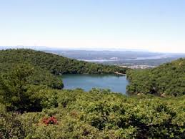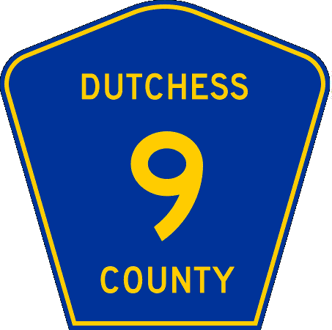
bridgeandtunnelclub.com
en.wikipedia.org
History of Recreation Jamie Landry
County Tourism Development Strategies Marissa Scarpitta
Mockup of Interpretive Signs Katie McAuliffe
Key Recreational Sites Katie Miller
Mockup of Highway Route Markers Kathleen Clarke
Synthesis Essay The Flowing 5’s

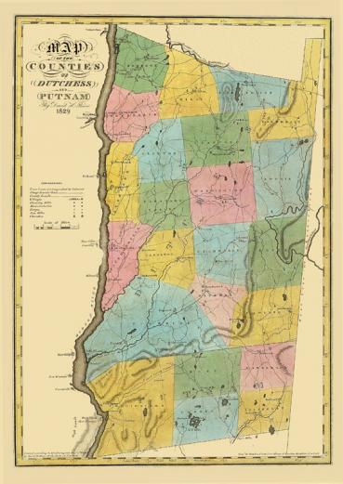
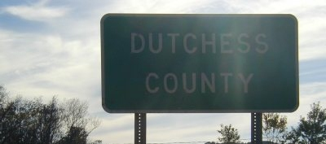
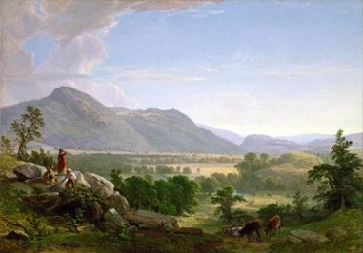
newyorkhistoryblog.com
upstatenyroads.com
conservapedia.com

History of Dutchess County
By: Jamie Landry
Many of us know Duthess County because it is where Marist is located, but there is much more to this area than just Poughkeepsie. Throughout the 19th century industry played a major role in this area, with production rates so high trade increased, and many wealthy people came to Dutchess to make their estates, such as the Astors, Rogers, and Vanderbilts. With the economy booming people were able to participate in leisure activities, culture and education were a main focus at this time. Money was put towards libraries even in the smallest communities; higher level education was put into motion as well as advancements in landscaping and architecture. The area was left with some outstanding historical sites that would carry out into today’s modern recreation.
Since Dutchess County was founded during a time where the economy was booming, it gave the people time to participate in more leisurely activities. They could now go for walks in the state parks, as well as spending time in the libraries and going shopping. Many Aristocrats made their mansions in the area and would host elaborate parties for the other high class citizens. Many artists and writers took in the natural beauty and were inspired to create works of art for the public to enjoy!
The Poughkeepsie railroad (the Walkway over the Hudson) is a key historical site in this county. It was a huge engineering achievement for its time, and allowed the mass transportation of people, products, and supplies. Dutchess County was chosen for the location of this railroad over the Hudson because of its prime location in between New York City, and Albany, as well as its potential to connect Pennsylvania to New England. This railroad was an asset to the economy at its time but eventually caught fire and burned in 1974, the damages were not repairable. The former railway is now a walking bridge over the Hudson where walkers, joggers, and bikers can all come to enjoy the outdoors and the scenic views that Dutchess has to offer.
Blue Sky Balloons is located in Poughkeepsie and is a great time for everyone. They have been up and running for thirty-six years opening in 1976, and Bill Hughes, a former Navy Pilot, has been running it himself for the past twenty five. A ride is $225 a person and they don’t take flight in the winter due to weather conditions. Hyde Park Roller Magic is located in the Historic Hyde Park. This recreational site is great for families and is filled with plenty of activities such as roller skating, in-line skating, birthday parties, holiday skate parties, dances, private parties, fund-raising events and corporate events. This wholesome family site is great for all ages!
Some more action sites in Dutchess County would be the Big Bear ziplines in Hyde Park, and the Aerodrome in Old Rhinebeck. The ziplines were opened in 2011 and allow people to enjoy the scenic parts of Dutchess County while getting an adrenaline rush. The Aerodrome has one of the largest collections of early aeroplanes in the world. The Aerodrome shows people aeroplanes, automobiles, motorcycles, early engines and memorabilia from 1900-1935. There are also four museum buildings displaying aircraft form the Pioneer Era, World War I and the Lindbergh/Barnstorming era which were all key times in the creation of aviation.
Dutchess County is filled with history that committees and groups have kept alive for centuries. It is amazing to see these museums and activities, and think back to how they started. These are just a few of this county’s historical sites, but they are all key examples as to why Dutchess is a great place to experience and visit. You will never be bored, and you will feel the history come to life all around you!

Marisa Scarpitta
Professor Johnson
HIST 218L-111
Final Individual Essay
October 10th, 2012
Dutchess County has many exciting and beautiful attractions that can pertain to people of all ages, such as, the Big Bear Zipline, the famous historic Walkway over The Hudson Bridge, Hyde Park Roller Magic, the Old Rhinebeck Aerodrome, and Blue Sky Balloons. In order to draw people to visit these heritage sites, country tourism development organizations and strategies need to be implemented. The five attractions above all have websites to promote the services they provide and are successful in attracting visitors.

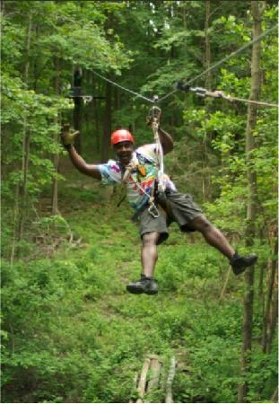
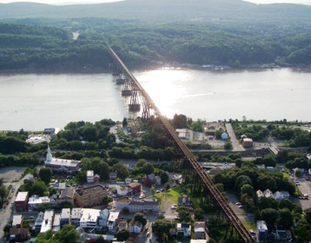
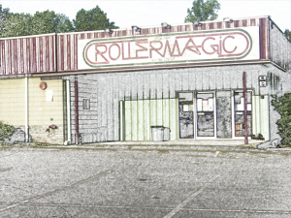
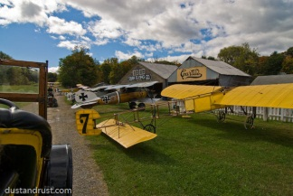
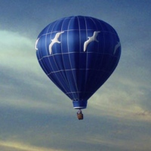
To find out information about Big Bear Zipline, you can visit www.bigbearziplines.com. The website has a very welcoming and colorful appearance that will help draw potential visitors in. On the home page, on the top right corner there are some small icons. If you click on the first one, which is the icon for Youtube, you will be directed to a Big Bear Zipline video, on the Youtube channel, where you can actually see people ziplining in action. The video has catchy music playing, and great views of people ziplining. It is definitely an excellent way to get people excited about the adventure and adrenalin rush ziplining provides. The next icon brings you to Yelp, where you can read reviews about other’s experiences. There is also a Trip Advisor icon for more reviews. They also provide links to two of the most popular social media pages, Twitter and Facebook, to further promote their site. Big Bear Zipline’s website is very detailed and helpful in promoting their site, but to further promote their activities they could put articles in tourism magazines or hang up flyers.
The Walkway over The Hudson State Historic Site also has a website, www.walkway.org. This site provides magnificent photos in the Walkway Quick Pics section, to help draw in tourism. It also provides media coverage which discusses what is going on with the bridge now, so potential visitors can read about what the bridge has become today before they visit. It also provides information on upcoming events, which is also a good strategy to get people excited about upcoming activities. On the bottom left corner of the page, are the Twitter and Facebook icons, where people can follow what is going on, trough social media. Walkway over the Hudson, should put pictures of their magnificent views on magazines or newspapers, so the public has more opportunities to witness all the walkway has to offer.
In order to draw visitors to the Hyde Park Roller Magic roller-skating rink, they have a website that promotes family fun (http://www.hydeparkrollermagic.com/). The website includes the various special events the roller rink hosts, such as, birthday parties, holiday skate parties, fundraising events, and corporation events. The websites have pictures from fun events like Halloween themed roller skating, where families can get a glimpse of what their experience will be like. There is an announcement section where potential visitors can view all the upcoming events to help them plan their visit. They have a Facebook page, which they frequently update with events and pictures, which is beneficial. They could also post videos on Youtube to better show all the excitement the rink can provide families and organizations with. It is also a good idea to write about the fundraising events they had in newspapers, to promote awareness about what the rink does to help respectable causes; because such generosity is noteworthy
The Old Rhinebeck Aerodrome has a cute and simple website making it easy for visitors to navigate. (www.oldrhinebeck.org) Visitors can view the event schedule, read articles about the site and can check out the online store, and see all the wonderful and interesting souvenirs. This site can be liked on Facebook, and followed on Twitter as well. This site couls work on developing a virtual tour, of a photo gallary of all the planes to assist in drawing in tourists.
Lastly, the Blue Sky Balloons also has a website (http://www.blueskyballoons.com/). This website was the most simple out of all the websites, and could use some updates. The website does allow views to take a virtual flight, which is great because then people can see what it is like to ride in a hot air balloon before deciding if they want to book a flight. Viewers can also read about the pilot, which is a beneficial, because it can help the possible visitors feel more comfortable knowing information about who would be flying their air balloon. Flights can be booked online, making it convenient and hassle free. The website has no social media links, so that may be a good idea to add so people can follow updates through social media. It also may be helpful in further promoting their activities since their website is already kind of plain. They could also put a recording of one of the flights on Youtube, so the public can see the air balloon in action.
The most popular strategy used for all these extraordinary sites, is their online websites. They all provide viewers with pictures, and information on all the attractions they have to offer, as well as event schedules to help family and friends plan their visits. Most of the websites also incorporate links to social media, which I think was beneficial because it is extremely popular today, and now viewers will be able to follow these fun recreational sites through social media. This makes it easier for the public to follow upcoming events and activities. The websites are all definitely worth visiting. However, social media is not the only way these recreational sites can promote their activities. All the sites can put ads in magazines or articles in the newspaper that explain the activities families and groups of all ages can partake in. Each individual site could also try to get their information up on a billboard, so when people are driving they will notice the billboard and then maybe want to look into planning a visit. Dutchess County actually has a tourism magazine that lists all the activities and places to visit in Dutchess County. Everyone should consider getting a copy of the magazine, so they can stay updated on all the adventures of Dutchess County.
thedailygreen.com
tripadvisor.com
_{hydeparkrollermagic.com}
dustandrust.com
funnewyork.com

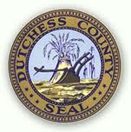
Dutchess County Logo 1

Interpretative Signs of Dutchess County
Katie McAuliffe
There are many things to learn and discover while visiting Dutchess County. There are five recreational sites in Dutchess County that will be described using an interpretative sign. These sites include Big Bear Zip Line, Walkway Over the Hudson, Blue Sky Balloons, the Old Rhinebeck Aerodrome and the Hyde Park Roller Magic. The purpose of this essay is to show their interpretative sign and describe each sign. Another purpose is to give a description about each individual site. Interpretive signs are a useful source in giving visitors a chance to learn and gain more knowledge about the site by reading the text and by looking at the pictures.
The Big Bear Zip line is the number one adventure tourist site located in Hyde Park. This site is an outdoor site that is fun and enjoyable for the whole family. This interpretative sign is a picture of one of the zipline courses. The visitors will be gliding through 50 acres of woodlands and hay fields. The zip line sign represents this site because these visitors will be gliding through eight of these through various speeds and heights. The visitors follow professional trained Zip pilots through the eight-obstacle zipline course. Visitors climb fire truck ladders, swoop down turzon vines and look at breathtaking views while gliding through the course. Anybody who participates in the zipline adventure needs to wear helmets and safety harnesses for their safety.
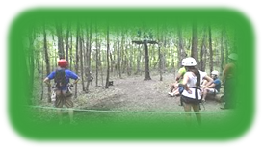
http://www.bigbearzipline.com/
The Walkway Over the Hudson is a pedestrian park located in Poughkeepsie. The New York State Park Taconic Region maintains this park. The walkway is the longest most elevated pedestrian bridge that spans across the Hudson River. The interpretive sign I used is a picture of the bridge because it symbolizes how important and unique the bridge really is. The bridge is 212 feet tall and 1.28 miles long. This park is a recreational site because visitors may walk, roller skate, ride bikes, jog, and walk their dogs on a leash. Visitors may also bird watch, spot trains passing by, observe river traffic, have a self-guided tour and picnic while being on the bridge. Visitors can also use the audio tour guide on the interpretative signs around the bridge in which they can use their phones to dial a number to hear more information about that sign. The Walkway Over the Hudson is a great recreational site to go visit and see the scenic views of the Hudson River Valley.


http://nyspark.com
The Blue Sky Balloon is a scenic hot air balloon tourist attraction. This site is located in Beacon for over 36 years with perfect safety records. This tourist site is a great family outdoor adventure. The interpretative sign I choose was their Blue Sky Hot Air Balloon that the visitor will be traveling in when having a scenic view of the Hudson River Valley. The visitors can see some many different views of the Hudson River Valley while gliding in the hot air balloon. Bill Hughes is the Balloonmeister. This is the person who is responsible for all of the operational aspects of the balloon events. He also makes sure before each balloon launches that it is safe and within FAA safety regulations. Hughes also makes the decisions of whether or not its safe flying conditions on each launch based on the weather conditions and his knowledge of the flying area. The flights take place in the morning just after sunrise or in the evening just before sunset. There are several blue-sky balloons festivals that take place such as the Adirondack Balloon Festival for the past 25 years. Visitors may also ask for special flights such as birthday, anniversary or a special occasion like an engagement flight.

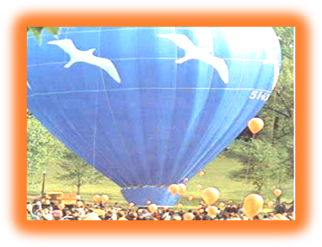

http://blueskyballoons.com

Old Reinbeck Aerodrome is located in Red Hook, New York. This place is an aviation museum that shows people early aviation engines, aeroplanes, motorcycles and automobiles from 1900 through 1935. The interpretative sign I choose is a picture of one of the aeroplanes a visitor would see flying in the air on the weekends. This recreational site features air shows from mid-June through mid-October where visitors have a chance at seeing the old aviation aeroplanes flying in the air depending on the weather. There are also different themes depending on if it is Saturday or Sunday. On Saturday, the Old Reinbeck Aerodrome shows the History of Flight showing Pioneer, WWI, and Linderberg era aircrafts flying in the sky. When winds are calm they also fly their oldest aircraft, which was built in 1909 called Bleriot. On Sunday, they feature World War I dogfight plus brainstorming aircrafts. There are pre-show activities for the visitors before the air show, which includes a parade they show early aviation engines, aeroplanes, motorcycles and automobiles from 1900 through 1935. Old Reinbeck Aerodrome also has early aviation brainstorm rides where visitors can experience themselves the thrill of early aviation while looking at the scenic views of the Hudson Valley from below in an Open Cockpit 1929 new standard biplane. Visitors get to view back into time how aviation once existed and how much it has changed since then.
http://www.oldrhinebeck.org/ 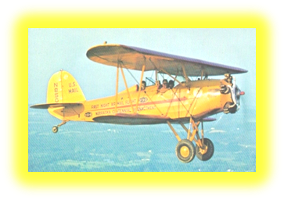
Hyde Park Roller Magic (HPRM) is located in Hyde Park, New York. The interpretative sign I choose is the sign in which you would see hanging outside the Hyde Park Roller Magic site. The actually building of this place does not look pretty at all but once you go in-doors the visitor would be amazed how much is going on and how much fun they are going to have. This is the number one recreational site for good, wholesome family fun. This family fun facility hosts a wide variety of activities such as roller-skating, in-line skating, birthday parties, private parties, and dances. This site also has private events, fund raising events and corporate events. HPRM has all the latest lighting, sounds and a live DJ who enjoys mixing up the music every now and then with interactive skating games. Hyde Park Roller Magic also host Women’s Roller Derby in the Hudson Valley Region. Horror (the Hyde Park team name) was established in the early 2006, is an all female operated and owned flat track roller derby league. It includes over 25 skaters. Horror is the number one non-urban derby team who holds their place as the number one national rebirth of roller derby that began in 2001.
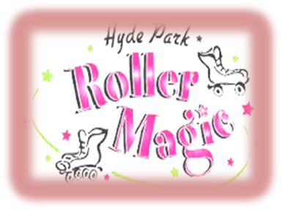http://hydeparkrollermagic.com/
In conclusion, Dutchess County has many recreational sites that are unique and special in their own way. Visitors and residents should take the time to visit these sites because they are worth seeing and they can learn and gain a lot of knowledge about these recreational sites by reading and looking at the graphics of these interpretative signs.

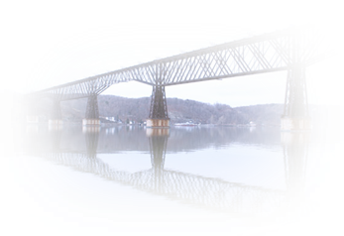
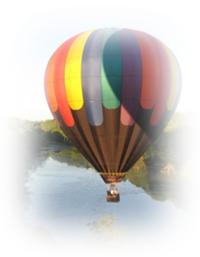
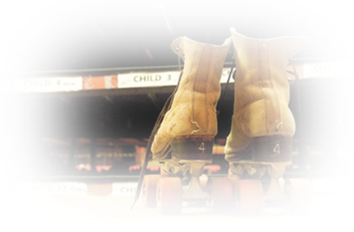
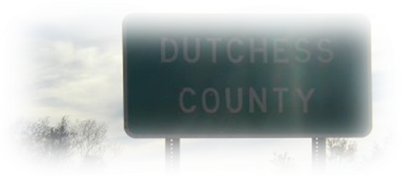
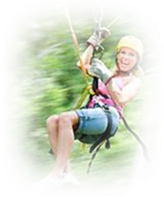

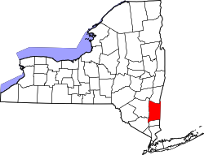
Dutchess County Key Recreational Sites
Katie Miller

The Hudson River Valley has been an important region of America even before the nation’s founding. From the moment Henry Hudson sailed up the river in 1609, it has influenced the region around it in many different ways. It has been used for transportation, shipping and other economic purposes for centuries; beginning with simple trade and bartering between the Native Americans and the European colonists. Later on, its strategic position made it an integral part of the American Revolution. However the importance of the Hudson River has by no means come to an end. It is a natural landmark that still bestows its impact upon the surrounding valley and country today; offering memories of the past through a multitude of historic sites; and other recreational activities that everyone can enjoy. The Hudson River in Dutchess County particularly truly bridges the gap between past and present; as it has flowed constantly through times of war and peace; and laid witness to iconic moments in time; as well as being the home of a number of key recreational sites today, such as: Big Bear Ziplines, Hyde Park Roller Magic, the Old Rhinebeck Aerodome and Blue Sky Balloons.
Big Bear Ziplines is a paradigm of the Hudson River valley’s continued relevance in today’s modern times. In the region of historic Hyde Park; home of one of history’s giants, Franklin Delano Roosevelt, families can enjoy a unique adventure experience through a zipline course; that will send them soaring at eighty feet high from tree to tree at speeds of up to 30 miles per hour. Big Bear Ziplines is easily accessible as it is the closest ziplining canopy course to New York City. Reservations must be made in advance; and a safety waiver must be signed, but after these preliminary details are out of the way, anyone weighing at least eighty pounds can be flying through the treetops for hours for only ninety nine dollars!
The Walkway over the Hudson spans the river at its mid-way point; and is owned today by New York State’s office of Parks, Recreation and Historic preservation. Originally a railroad bridge, it is now enjoyed by runners, bikers, pedestrians and families alike who are looking to get their excersice or take in the beautiful view! At 212 feet high and 1.28 miles long, the scenic walkway over the Hudson is the longest elevated pedestrian bridge in the world, and an experience everyone should enjoy!
Another site for those interested in having a lot of fun and a great workout is Hyde Park Roller Magic! Great for the entire family, Hyde Park Roller Magic is famous for giving memorable birthday parties, holiday skate parties, dances, private parties, fund-raising events and corporate events! With both roller and in-line skating options, Hyde Park Roller Magic makes it easy to rock out to a DJ under disco lights while you skate the night away.
Rhinebeck is home to another key historic site in Dutchess County; the Old Rhinebeck Aerodrome. The “aerodome” is a museum of aviation from year’s past- antique planes, engines, and memorabilia- brought to life in the present day through airshows done to show the public about the “golden years” of aviation. The weekend air shows are done from mid-June through October, weather permitting.
Finally, another key recreational site in Dutchess County is Blue Sky Balloons. Blue Sky Balloons is a hot air balloon launch over the beautiful Hudson River Valley, offering staggering scenic views of one of the most unique regions in America. The balloon rides are 3 hours long and are conducted by certified pilots that have been flying for over 20 years. If that wasn’t enough to ensure that your family will love this safe, amazing experience, the balloon rides are only, 225 dollars per person, a great value for this once in a life time experience!

Kathleen Clarke

Highway Route Markers

Duthess County is filled with excellent and unforgettable places to visit. Given its historic past, located in New York State, Dutchess County contains landmarks that are enjoyable for the entire family. Places such as the Big Bear Ziplines, The Walkway Over The Hudson, The Old Rhinebeck Aerodome, Hyde Park Roller Magic and Blue Sky Balloons, are all recreational places that should be visited while in Dutchess County. Given the importance of these places and the thrill that comes with visiting them, they would be nothing without the highway signs that lead to the location, making travel within Dutchess County so much easier. The strategic locations of these signs make the potentially confusing directions so much easier to follow.
Big Bear Ziplines is located at 817 Violet Avenue Route 9G, Hyde Park, New York, 12538. While traveling to Big Bear Ziplines there will be multiple signs strategically placed on the route to get there. The highway route marker signs for Big Bear Ziplines are white with a picture of a cartoon bear. On the bear it states the name in order for a clear understanding of what the sign is representing. The signs will be strategically placed as if the visitors are arriving from the Taconic State Parkway. The first sign will be placed on the Parkway that warns the driver the exit for Big Bear Ziplines is approaching. As the driver comes to exit 55W they will notice the sign and understand to exit here. You then continue straight on that road until you hit N Hamilton Street, about seven miles down where you will find the next route marker informing the driver to make a right. A short distance after that there will be another sign to letting the driver know to keep right onto Parker Avenue. There will be another sign located where Parker Avenue turns into Violet Avenue for lack of confusion. Big Bear Ziplines is located on the left about three miles down, where the last sign will be located.
The Walkway Over the Hudson has two entrances, one in Poughkeepsie of Dutchess County and another in Highland of Ulster County. The route marker sign for walkway is white with a picture of a portion of the bridge and “Walkway Over The Hudson” written on it for easy interpretation. The Poughkeepsie entrance is located on the east side of the river. The first highway route marker is located near exit 55 W on the Taconic State Parkway, where the tourists would exit the highway to come to Dutchess County. The tourists stay on that road for eight miles, so about halfway down (four miles) is the placement for the second route marker. The next sign will be placed on the right approaching Columbus Street because that is there drivers will turn right. The next sign is located at the right, approaching Parker Avenue. Lastly, there will be a sign at the destination to ensure that the tourists are at the right location.
The Old Rhinebeck Aerodome is located at 9 Norton Road, Redhook, New York, 12571. The highway route marker sign has a white background with and image of old airplanes that can be seen at the aerodome. “Old Rhinebeck Aerodome” is also written on the sign. There are multiple ways to arrive at the Aerodome. The first sign is located at exit 199 toward Pine Plains/ Red Hook on the Taconic State Parkway. The next sign is located before Oriole Mills Road in order to inform the driver that they need to make a right there. The next sign is located where Oriole Mills Road changes to Stone Church Road, in order to avoid confusion for the drivers. The last sign is located at the corner of Stone Church Road and Norton Road. This sign will make the tourists aware that they need to make a right and the destination will be right on the right.
Hyde Park Roller Magic is located at 4178 Albany Post Road, Hyde Park, New York, 12538. The first highway route marker sign will be placed on near exit 55 W in order to inform the driver to exit toward Poughkeepsie. The tourists will then be on this road for eight and a half miles, so in order for them not to doubt their travels there will be a sign about four miles or halfway down. The next sign will be located at the slight right onto Church Street/East-Wood Arterial. The next sign will then be placed on the corner of that street and U.S. 9, so the drivers know to make a right. The next sign will be about halfway down route 9, or two miles down. The last sign will be located at the Hyde Park Roller Magic Site.
Blue Sky Balloons is located at 34 Lauer Road, Poughkeepsie New York, 12603. The first highway route marker sign will be located at the exit toward Dutchess 21/Noxon Road. The next highway route marker sign will be located at the right turn in order to stay on Dutchess 21/ Noxon Road. Another route marker sign is located at the corner of Noxon Road and Lauer Road, which lets the driver know to make a right. The last sign is located at the destination.
Dutchess County is more than just a County in New York State; it contains more history than most people would expect. A visit to Dutchess County and touring the right locations is like taking a walk into the past. There are so many locations and sites that are worth seeing and enjoying. Attractions such as Big Bear Ziplines, The Walkway Over The Hudson, the Old Rhinebeck Aerodome, Hyde Park Roller Magic and Blue Sky Balloons are only a few of what makes Dutchess County unique and worth visiting.

Synthesis Essay
The Hudson River is a natural landmark that still bestows its impact upon the surrounding valley and country today; offering memories of the past through a multitude of historic sites; and other recreational activities that everyone can enjoy. The Hudson River in Dutchess County particularly, truly bridges the gap between past and present. This county is a great place to live or visit because of its many exciting recreational site such as: Big Bear Ziplines, Blue Sky Balloons, the Walkway Over the Hudson, the Old Rhinebeck Aerodome and the Hyde Park Roller Magic.
The Big Bear Ziplines are located in the region of historic Hyde Park; home of one of history’s giants, Franklin Delano Roosevelt, families can enjoy a unique adventure experience through a zipline course; that will send them soaring at eighty feet high from tree to tree at speeds of up to 30 miles per hour. To find out information about Big Bear Zipline, you can visit www.bigbearziplines.com. On the home page, on the top right corner there are some small icons, if you click on the first one, which is the icon for Youtube, you will be directed to a Big Bear Zipline video, where you can actually see people ziplining in action. The interpretative sign is a picture of one of the zipline courses. The visitors will be gliding through 50 acres of woodlands and hay fields.The zip line sign represents this site because these visitors will be gliding through eight of these through various speeds and heights. The visitors follow professional trained Zip pilots through the eight-obstacle zipline courses. Visitors climb fire truck ladders, swoop down turzon vines and look at breathtaking views while gliding through the course. The highway route marker signs for Big Bear Ziplines are white with a picture of a cartoon bear. On the bear it states the name in order for a clear understanding of what the sign is representing. The signs will be strategically placed as if the visitors are arriving from the Taconic State Parkway. The first sign will be placed on the Parkway that warns the driver the exit for Big Bear Ziplines is approaching. As the driver comes to exit 55W they will notice the sign and understand to exit here. You then continue straight on that road until you hit N Hamilton Street, about seven miles down where you will find the next route marker informing the driver to make a right. A short distance after that there will be another sign to letting the driver know to keep right onto Parker Avenue. There will be another sign located where Parker Avenue turns into Violet Avenue for lack of confusion. Big Bear Ziplines is located on the left about three miles down, where the last sign will be located.
Blue Sky Balloons is located in Poughkeepsie and is a great time for everyone. They have been up and running for thirty-six years opening in 1976, and Bill Hughes, a former Navy Pilot, has been running it himself for the past twenty five. A ride is $225 a person and they don’t take flight in the winter due to weather conditions. They have a website http://www.blueskyballoons.com/) where potential visitors can take a virtual flight, which is unique and exciting. Viewers can read about the pilot and book their flight right on the website. The interpretative sign I choose was their Blue Sky Hot Air Balloon that the visitor will be traveling in when having a scenic view of the Hudson River Valley. The visitors can see some many different views of the Hudson River Valley while gliding in the hot air balloon. Visitors may also ask for special flights such as birthday, anniversary or a special occasion like an engagement flight. The highway route marker sign is white with a picture of a hot air balloon for easy recognition. Blue Sky Balloons is located at 34 Lauer Road, Poughkeepsie New York, 12603. The first highway route marker sign will be located at the exit toward Dutchess 21/Noxon Road. The next highway route marker sign will be located at the right turn in order to stay on Dutchess 21/ Noxon Road. Another route marker sign is located at the corner of Noxon Road and Lauer Road, which lets the driver know to make a right. The last sign is located at the destination.
The Walkway over the Hudson is a key historical site in this county. Originally a railroad, the idea for this engineering achievement was sparked during the industrial revolution. Dutchess County was chosen for the location of this railroad over the Hudson because of its prime location in between New York City, and Albany. It is now enjoyed by runners, bikers, pedestrians and families alike who are looking to get their exercise. At 212 feet high and 1.28 miles long, the scenic walkway over the Hudson is the longest elevated pedestrian bridge in the world! The website for this bridge provides information on upcoming events, which is also a good strategy to get people excited about upcoming activities. On the bottom left corner of the page, are the Twitter and Facebook icons, where people can follow what is going on, trough social media. The interpretive sign I used is a picture of the bridge because it symbolizes how important and unique the bridge really is. Visitors can also use the audio tour guide on the interpretative signs around the bridge in which they can use their phones to dial a number to hear more information about that sign. The Walkway over the Hudson is a great recreational site to go visit and see the scenic views of the Hudson River Valley. The route marker sign for walkway is white with a picture of a portion of the bridge and “Walkway over the Hudson” written on it for easy interpretation. The Poughkeepsie entrance is located on the east side of the river. The first highway route marker is located near exit 55W on the Taconic State Parkway, where the tourists would exit the highway to come to Dutchess County. The tourists stay on that road for eight miles, so about halfway down (four miles) is the placement for the second route marker. The next sign will be placed on the right approaching Columbus Street because that is there drivers will turn right. The next sign is located at the right, approaching Parker Avenue. Lastly, there will be a sign at the destination to ensure that the tourists are at the right location.
Rhinebeck is home to another key historic site in Dutchess County; the Old Rhinebeck Aerodrome. The Aerodrome has one of the largest collections of early aeroplanes in the world, including, aeroplanes, automobiles, motorcycles, early engines and memorabilia from 1900-1935. Visitors can view the event schedule, read articles about the site and can check out the online store, and see all the wonderful and interesting souvenirs, on their website. The interpretative sign I choose is a picture of one of the aeroplanes a visitor would see flying in the air on the weekends. This recreational site features air shows from mid-June through mid-October where visitors have a chance at seeing the old aviation aeroplanes flying in the air depending on the weather. There are also different themes depending on if it is Saturday or Sunday. On Saturday, the Old Reinbeck Aerodrome shows the History of Flight showing Pioneer, WWI, and Linderberg era aircrafts flying in the sky. When winds are calm they also fly their oldest aircraft, which was built in 1909 called Bleriot. On Sunday, they feature World War I dogfight plus brainstorming aircrafts. Old Reinbeck Aerodrome also has early aviation brainstorm rides where visitors can experience themselves the thrill of early aviation while looking at the scenic views of the Hudson Valley from below in an Open Cockpit 1929 new standard biplane. The highway route marker sign has a white background with and image of old airplanes that can be seen at the aerodome. “Old Rhinebeck Aerodome” is also written on the sign. The first sign is located at exit 199 toward Pine Plains/ Red Hook on the Taconic State Parkway. The next sign is located before Oriole Mills Road in order to inform the driver that they need to make a right there. The next sign is located where Oriole Mills Road changes to Stone Church Road, in order to avoid confusion for the drivers. The last sign is located at the corner of Stone Church Road and Norton Road. This sign will make the tourists aware that they need to make a right and the destination will be right on the right.
Hyde Park Roller Magic is located in the Historic Hyde Park. This recreational site is great for families and is filled with plenty of activities such as roller skating, in-line skating, birthday parties, holiday skate parties, dances, private parties, fund-raising events and corporate events. This wholesome family site is great for all ages! Hyde Park Roller Magic has a website (http://www.hydeparkrollermagic.com/) that includes information on the various special events the rink hosts like, birthday parties, holiday parties, and fundraising events. They have a Facebook page which they update frequently. There is an announcement section so potential visitors can view upcoming events and plan their visit. The interpretative sign I choose is the sign in which you would see hanging outside the Hyde Park Roller Magic site. The actually building of this place does not look pretty at all but once you go in-doors the visitor would be amazed how much is going on and how much fun they are going to have. Hyde Park Roller Magic is located at 4178 Albany Post Road, Hyde Park, New York, 12538. The first highway route marker sign will be placed on near exit 55 W in order to inform the driver to exit toward Poughkeepsie. The tourists will then be on this road for eight and a half miles, so in order for them not to doubt their travels there will be a sign about four miles or halfway down. The next sign will be located at the slight right onto Church Street/East-Wood Arterial. The next sign will then be placed on the corner of that street and U.S. 9, so the drivers know to make a right. The next sign will be about halfway down route 9, or two miles down. The last sign will be located at the Hyde Park Roller Magic Site.
Dutchess County is filled with Recreational Sites that committees and groups have kept alive for people everywhere. These are just a few of this county’s historical sites, but they are all key examples as to why Dutchess is a great place to experience and visit. You will never be bored, and you will feel the history come to life all around you!
Annotated Bibliography
http://www.oldrhinebeck.org/
- History
- Directions
- “about section”
- Social media sites it provided
- Interpretative Panels
http://www.bigbearziplines.com/
- History
- Directions
- “about section”
- Social media sites it provided
- Interpretative Panels
http://www.walkway.org/
- History
- Directions
- “about section”
- Social media sites it provided
- Interpretative panels
http://dutchessny.gov/
- History
http://www.hydeparkrollermagic.com/
- Home
- Directions
- Hours and Pricing
- Interpretative panels
http://www.blueskyballoons.com/bsbvirtual.html
- About the Pilot
- Directions
- Policies
- Links
- Interpretative panels
http://www.nyspark.org/
- Interpretative panel

“Official website of Dutchess County Government NY” October 6 2012, http://www.co.dutchess.ny.us/Tourism/HistIndex.htm
Drake Creative, “Walkway over the Hudson,” http://www.walkway.org/, October 6 2012, http://www.walkway.org/walkway-friends.
“Blue Sky Balloons” http://www.blueskyballoons.com/. December 4, 2012, http://www.blueskyballoons.com/bsbpilot.html
“Hyde Park Roller Magic” http://www.hydeparkrollermagic.com/ December 4, 2012, http://www.hydeparkrollermagic.com/rink-hours-pricing/
Esydor Media LLC, “Cole Palen’s Old Rhinebeck Aerodome,” http://www.oldrhinebeck.org/, October 6 2012, http://www.oldrhinebeck.org/index.php?option=com_content&view=article&id=56&Itemid=140.
“Big Bear Ziplines,” October 6 2012, http://www.bigbearziplines.com/about-big-bear/.
“Big Bear Ziplines,” http://www.bigbearziplines.com/ (accessed October 5 2012)
Drake Creative, “Walkway Over the Hudson,” http://www.walkway.org/ (accessed October 5 2012)
“Hyde Park Roller Magic,” http://www.hydeparkrollermagic.com/ (accessed November 27 2012)
Esydor Media LLC, “Cole Palen’s Old Rhinebeck Aerodome,” http://www.oldrhinebeck.org/(accessed October 5 2012)
“Blue Sky Balloons,” http://www.blueskyballoons.com/index.htm (accessed November 27 2012)
“Big Bear Ziplines,” December 1, 2012, http://www.bigbearzipline.com/
“Big Bear Ziplines,” December 1,2012, http://www.bigbearzipline.com/
“ Walkway Over the Hudson,” December 1, 2012, http://walkway.org/
“ Walkway Over the Hudson,” December 1, 2012, http://walkway.org/
“Blue Sky Balloons,” December 1, 2012, http://www.blueskyballoons.com/
“Blue Sky Balloons,” December 1, 2012, http://www.blueskyballoons.com/
“Blue Sky Balloons,” December 1, 2012, http://www.blueskyballoons.com/
“Old Reinbeck Aerodrome,” December 1, 2012, http://www.oldrhinebeck.org/
“Old Reinbeck Aerodrome,” December 1, 2012, http://www.oldrhinebeck.org/
“Old Reinbeck Aerodrome,” December 1, 2012, http://www.oldrhinebeck.org/
“Hyde Park Roller Magic,” December 1, 2012, http://hydeparkrollermagic.com/
“Hyde Park Roller Magic,” December 1, 2012, http://hydeparkrollermagic.com/
“Big Bear Ziplines,” October 6 2012, http://www.bigbearziplines.com/about-big-bear/.
Drake Creative, “Walkway over the Hudson,” http://www.walkway.org/, October 6 2012, http://www.walkway.org/walkway-friends.
December 5, 2012. http://www.hydeparkrollermagic.com/.
Esydor Media LLC, “Cole Palen’s Old Rhinebeck Aerodome,” http://www.oldrhinebeck.org/, October 6 2012, http://www.oldrhinebeck.org/index.php?option=com_content&view=article&id=56&Itemid=140.
December 5, 2012. www.hydeparkrollermagic.com/.
“Big Bear Ziplines,” October 6 2012, http://www.bigbearziplines.com/explore-our-area/ecofriendly/directions/
Drake Creative, “Walkway Over The Hudson” October 6 2012, http://www.walkway.org/directions/item/directions
Esydor Media LLC, “Cole Palen’s Old Rhinebeck Aerodome,” October 6 2012, http://www.oldrhinebeck.org/index.php?option=com_content&view=article&id=57&Itemid=141
“Hyde Park Roller Magic” http://www.hydeparkrollermagic.com/directions/ December 3 2012.
“Blue Sky Balloons” http://www.blueskyballoons.com/bsbdirections.htm December 3 2012
“Big Bear Ziplines,” December 1, 2012, http://www.bigbearzipline.com/
2“Big Bear Ziplines,” http://www.bigbearziplines.com/ (accessed October 5 2012)
“Blue Sky Balloons” http://www.blueskyballoons.com December 3 2012
Drake Creative, “Walkway Over The Hudson” October 6 2012, http://www.walkway.org/directions/item/directions
“Old Reinbeck Aerodrome,” December 1, 2012, http://www.oldrhinebeck.org/
“Old Reinbeck Aerodrome,” December 1, 2012, http://www.oldrhinebeck.org/
Esydor Media LLC, “Cole Palen’s Old Rhinebeck Aerodome,” http://www.oldrhinebeck.org/(accessed October 5 2012)
“Hyde Park Roller Magic” http://www.hydeparkrollermagic.com/directions/ December 3 2012.

