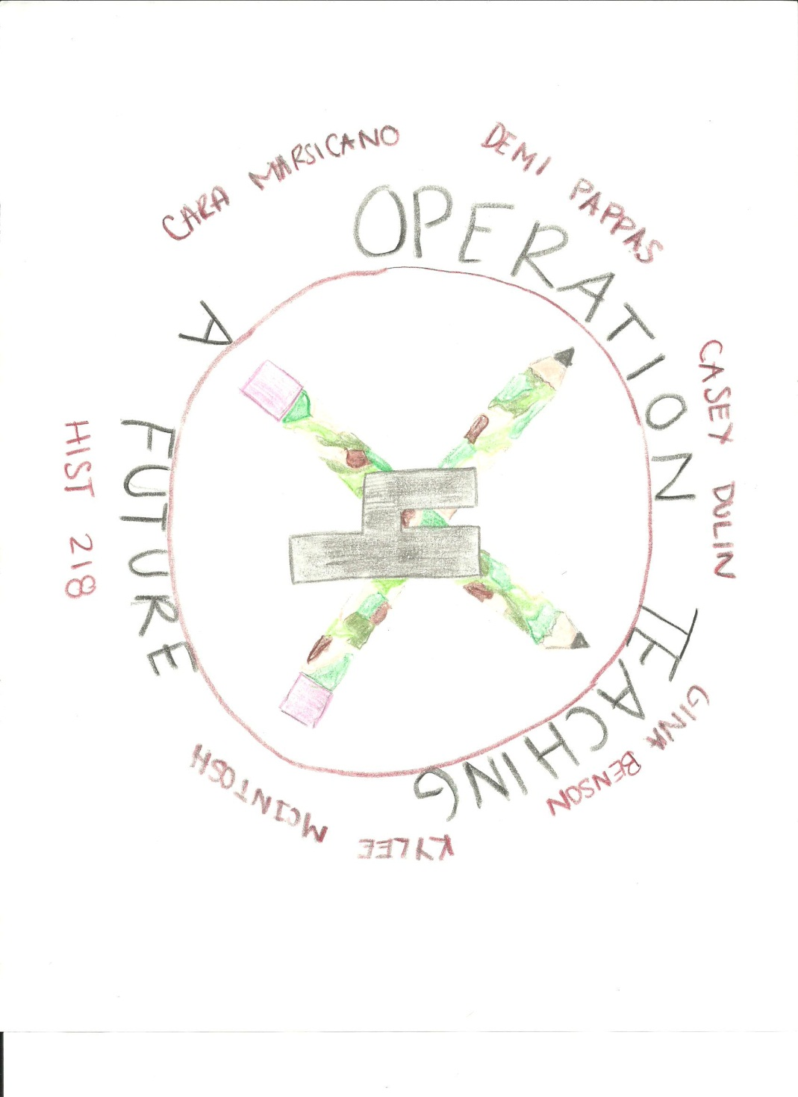

Rensselaer County

“Life looks good from Here”

BY: Operation: Teaching for a Future; Kylee McIntosh, Cara Marsicano, Gina Benson, Demi Pappas, and Casey Dulin

Table of Contents

History of Rensselaer County- Cara Marsicano
Historical, Industrial, and Cultural Sites- Kylee McIntosh
Interpretative Signs- Casey Dulin
Highway Markers- Gina Benson
Demographics of Rensselaer County- Demi Pappas
Overview of Rensselaer County
Lesson Plan for Rensselaer County-Demi Pappas
Rensselaer Itinerary-Kylee McIntosh
County Websites-Cara Marsicano
Works Cited

History of Rensselaer County
By: Cara Marsicano
On July 27, 1630, a subdivision of the original Albany County was made and given the name of the famous family of the State, Rensselaer. Kiliaen van Rensselaer was a Dutch jeweler and merchant, who jeweled and worked as a subscriber to the Dutch West India Company (Wikipedia). Rensselaer County was established where the Adirondacks and the Berkshires meet, heading up towards the eastern boundaries of New York-Vermont and New York- Massachusetts. This became a great cross route, because it became a great center of commerce and trade along the eastern and western border. The Hudson was located on the western side of the county but was still located on the trade path, which helped the explorers arrive. Man made another of these waterways to and from the west in the Barge Canal; its outlet being in this county. The Indians had their trails from the north and east through Rensselaer; their place was taken by the best of modern railroads and highways (HopeFarm).
In the beginning, the land was first settled only under lease, and upon the same rules of tenure in force at Albany and other parts of the Hudson territory. This led to the same difficulties in the collection of rents. The settlement of the county did not proceed without the hardships and dangers, which troubled all the outlying districts of the State. During the French and Indian War the northern part of the county was repeatedly wasted and the pioneers were driven from their homes. The Battle of Bennington, was fought in Rensselaer County, and led to the defeat of Burgoyne at Saratoga.
Besides the collection of rent, there were other inconveniences. Rensselaer County did not provide stores in the area until 1778. Prior to that time settlers had to make the long trip down to the Castleton Landing for manufactured goods. The paths were too small to admit wagons and so everything had to be carried (churchtree). One family was forced to leave its wagon in Cherry Plains for twelve years before they could finally get it to their farm. We often forget that the early settlers in the Eastern part of the United States faced a situation just as difficult as the men and women who later settled the West. (hopefarm)
It has been said, that during the Civil War the first troops from the North to tread the soil of Virginia were from this county; and it is said that no community, in proportion to its population, sent so many of its youth in the World War as did Troy, the principal city of Rensselaer(churchTree). Although it was a struggle for the county to hold on to its land and inhabitants, Rensselaer County in the ended thrived and provided for many of the countries wars.

Historical, Cultural, and Industrial Sites in Rensselaer County
By: Kylee McIntosh
In researching the area of Rensselaer County, New York, it was made apparent that there are many attractive sites that bring tourists to the area. Some of these places include Bennington Battlefield, Crailo State Historic Site, Burden Iron Works Museum, Goolds Orchard, Dyken Pond Environmental Education Center, and Knickerbocker Mansion.
Bennington Battlefield is located in the Grafton Lake State Park in Grafton, New York. May 1st until Labor Day the park is open daily from 10am to 7pm. From May 29th until September 6th hiking is allowed daily. The interpretative panels are working daily from 10am- 7pm. From Labor Day until Veterans Day the park is open weekends only from 10am- 7pm. Bennington Battlefield hosted a battle during August 1777 in the Revolutionary War. The British were trying to take over the storehouses in Bennington, Vermont to replace their depleting sources. The battle never made it to Vermont. British General Burgoyne and Colonel Baum underestimated the Americans lead by General Stark and Colonel Warner. The British lost many men and lost this battle. This park offers hiking, interpretive signs, picnic areas, and scenic views.
Crailo State Historic Site is a fortified brick manor house in Rensselaer, New York. It was originally a part of the vast landholding called Patroonship of Rensselaerwyck, named after Van Rensselaer’s estate in the Netherlands. Crailo was home to American soldiers during the American Revolution, mainly serving American militia. Crailo is a farm as well as a fort that has always been used to protect Americans from both the British and the Indians. Fort Crailo is where “Yankee Doodle” was composed. Crailo State Historic Site is open Wednesday- Sunday from mid-May through the end of October from 11am-4pm, when guided tours are offered. Crailo Fort is located on 9 ½ Riverside Avenue in Rensselaer, NY.
Burden Iron Works Museum is on One East Industrial Parkway in Troy, New York. It once was one to the Burden Water Wheel, which was the most powerful water wheel in history. The museum holds horseshoes and machinery for the Union that were manufactured in the city throughout the 19th Century.
Goold Orchards is located in Castleton, New York on 1297 Brookview Station Road. At the Orchard you can pick your own apples or enjoy the Farm Store. There is also an apple Festival in October or school tours. From September to October classes can learn how apples are harvested and picked their own.
Dyken Pond is in Corpseyville, New York on 475 Dyken Pond Road. Here there are summer camps, school programs, recreational programs, and field trips. Here you can hike, canoe, fish, camp, bird watch, and sight see. Here you can explore the ecology of the area and learn to identify specific species.
Knickerbocker Mansion is located in Schaghticoke, NY at 132 Knickerbocker Road. The Knickerbocker Mansion was built in the 1780's by Johannes and Elizabeth Knickerbocker. The Mansion presides over the remains of the historic Witenagenot Oak Tree which was planted in 1676 to commemorate a peace treaty between the Native Americans and European settlers. It offers tours from May-October on Sundays from 11 AM to 3 PM, for special events and by appointment for group tours and authentic colonial Dutch meals. The mansion is a great representation of the Dutch culture and the peace that was achieved between Native Americans and European Settlers.
In Rensselaer County there are many places to go to enjoy and learn. These sites teach you about the history, culture, and industry of the county as well as offer an enjoyable experience.

Interpretative Signs
By: Casey Dulin
Renssealaer County, New York is full of beautiful, eventful and eye catching sites. This caused a lot of attraction and brought tourists to this attractive place. It is located in the eastern part of New York. The name of the county is named after the family of Kiliaen van Rensselaer. He was a Dutch jeweler and merchant. It was inhabited by the Algonquian speaking Mohican Indian Tribe.
There are great places to visit in the Renssealaer County. For example, Bennington Battlefield, Fort Crailo, Burden Iron Museum, Goold Orchards, Dyken Pond and Knickerbocker Mansion are just six that I can tell you about.
The Bennington Battlefield is located in Grafton, New York. This battlefield hosted a battle in 1777 in the Revolutionary War. In this fight not only did the British loose, they lost a lot of men. At this location the American colonists had a store of food and weapons. British General Burgoyne knew this was critical in order to get restock for his troops. For a little under a century, this battle had been celebrated in the Old State Arms Hotel annually which is also located at this site.
Fort Crailo is located in Renssealaer, New York. It is a museum of Colonial New Netherland history in upper Hudson Valley. Crailo was the home to American soldiers during the American Revolution. This fort was used to protect the Americans from British and Indians. Originally, it was a part of the vast landholding. This was called the Manor or Partoonship of Renssealaerswyck. Crailo was built in the early 18th century by Hendrick Van Rensselaer, grandson of the First Patroon.
The Burden Iron Museum is in Troy, New York. It housed the Burden Water Wheel, which is the most powerful vertical water wheel in history. It grew out of the Troy Iron and Nail Factory, but Scotsman Henry Burden took it from a little local operation to one of the most important iron mills of its day. It most likely inspired George Washington Ferris to build the Ferris wheel.
The Goold Orchards is located in Castleton, New York. You can enjoy shopping at the farm store, apple picking, tours or the apple festival. Also, you can learn about harvesting apples. The farm has been in the Goold family since 1910. Recently, in 2010 they celebrated their 100th anniversary. Their mission is to grow and sell only the highest quality apples and freshest apple cider.
Dyken pond is in Cropseyville, New York. At the pond you can learn ecology of the area and learn to identify species. Also, you can enjoy some hiking, canoeing, fishing, bird watching and sightseeing. The park features over six miles of trails. There is no swimming, open fire or collecting of any sort. The Center offers activities and workshops dedicated to environmental education.
Knickerbocker Mansion is a historic log mansion stands proudly today as a reminder of the amazing William Edwin Knickerbocker. All Knickerbocker guests are welcome to share in the warmth and fun atmosphere of the living room of the main house. You can enjoy the extensive library, games and jigsaw puzzles, or relax on one of two covered verandas with forest and lake views. Outside activities include croquet on the lawn, a hike through the forest, or an afternoon nap in a hammock for two.
Rensselaer County is a very attractive and fun place to visit. There are many places to go. At each place you can learn a lot of interesting information. At each place there will be sure to be seen interpretive signs. Hopefully, you would find them worthy of information.

Highway Route Markers
By: Gina Benson
There are over thirty-six highway markers that indicate where the important historical sites are located. On these markers you find the name of the site, the important dates the site was established, and a possible mini description. In Rensselaer County, NY, these thirty-six, plus, highway markers are informative enough to give you incite on a site. In this county, some highway markers indicate school districts, which are numbered 6 and 7. The main highways in Rensselaer County are New York State Route 2 (also known as Brunswick Road), New York State Route 287 (also known as Brick Church Road), New York State Route 7, New york State Route 142 (also known as Gypsy Road), US Route 9, US Route 20, Columbia Turnpike, New York State Route 4, New York State Route 9J, New York State Route 67, US Route 40, New York State Route 43, and New York State Route 22. Along New York State Route 2, or Brunswick Road, in Eagle Mills is the home of a soldier that fought in the War of 1812. His name is Philip D. Dater and he lived from 1790 to 1868. This information is all found on the highway marker. The information on the markers is informative enough to describe the significance of the site. The schools and school districts I mentioned before are Garfield School, School District No. 6, and District 7. The Garfield School was a one-room schoolhouse that existed circa 1840 to 1881 in Brunswick on Garfield Road near New York State Route 2. The school was named after a teacher who taught there from 1854 to 1856. This teacher’s name was James A. Garfield, who later became the 20th president of the United States. He was a teacher while studying at Williams College. The School District No. 6 was built on land granted by Luther and Olive Eddy circa 1830 also in Brunswick on the corner of Buck Road and Brick Church Road, also known as New York State Route 287. The students later named the brick building the Lincoln School. The District 7 School, located on Gypsy Lane of New York State 142 near Lansingburgh in Brunswick was known as the “schoolhouse in the woods.” It was built circa 1829 to 1830. The school was built on land that was granted by Abraham Jacob Lansing in 1829. In 1840 a teacher named Herman Melville taught there. His home is a historical site in Troy. Many religious and historical churches in the Rensselaer County can be found along the major highways. In the town of Brunswick, a Lutheran church by the name of Gilead Church is found on New York State Route 7 at Haynersville. Reformed Protestant Dutch Church at Tiossiook is along New York State Route 67 in Hoosick. Other churches nearby in Hoosick are the Hoosick Baptist Church and St. Croix Church. The most important historical sites are ones that deal with war and battles that allowed the Hudson Valley and America for that matter to sustain their freedom. Fort Crailo in East Greenbush is where “Yankee Doodle” was written in 1758. Hoosick is where you will find Bennington Battlefield. Here, General Stark would win the battle in August 1777. Albert Pawling, a Second Lieutenant led forces to Quebec St. John’s, White Plains, and Monmouth. His tomb is found in the Old Mount Ida Cemetery along with many other soldiers who fought in the American Revolution, the War of 1812, and the Civil War. There are many more important markers giving great significance to the area but it the schools, churches, and battle sites have made the area what it is today.

Demographics of Rensselaer County
By: Demi Pappas
New York State’s total population in 1860 was 3,880,735 (1860 Census of Population and Housing). In 1860, the population of Rensselaer County in particular, was approximately 86,328 including individuals who were white, African American, and mulatto. The total white population was 85,270, the total African American population was just 727, and the total mulatto population was just 331. Of the 86, 328 individuals living in Rensselaer County, 41,870 of them were male, while 43,367 of them were female. Furthermore, there were a total of 70,891 housing units. In the 1860’s citizens of Rensselaer County had the same typical jobs that all of New York State had at that time. Amongst the most popular were farmers, farm laborers, tailors, merchants, laborers, carpenters, shoemakers, blacksmiths, and clerks. There were about 254,786 farmers in New York State and about 115,728 farm laborers (1860 Census of Population and Housing). From this we can gather that there were an abundance of farms, and therefore farmers in the county.
In 2010 the population of Rensselaer County increased drastically. The total New York State population was 18,976,457 people. In 2010, the population of Rensselaer County was approximately 158,629. The total white population was 140,335, the total African American population increased to 7,943, and the total mulatto population increased to 1,839. Of the 158,629 individuals now living in Rensselaer County, 78,169 of them were male, while 80,460 of them were female. Additionally, there were a total of 78,169 housing units. Occupations of citizens in Rensselaer County diverted to more modern day occupations. The total population that was over 16 and employed was 80, 598. There were 30,075 individuals were in occupations involving business, management, science, and arts. There were 12,597 individuals were in a service occupation. There were 22,781 individuals who were in sales and office occupations, 6,950 individuals who were in natural resources or maintenance occupations, and 8,195 individuals in production and transportation occupations.
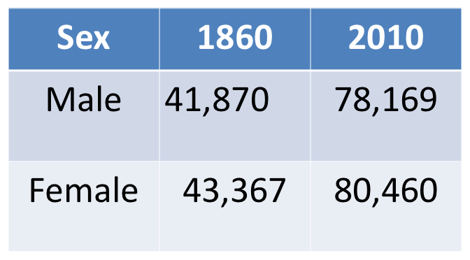
Race | 1860 | 2010
White (including Indians) | 85,270 | 140,335
African American | 727 | 7,943
Mulatto | 331 | 1,839
Total | 86,328 | 158,629
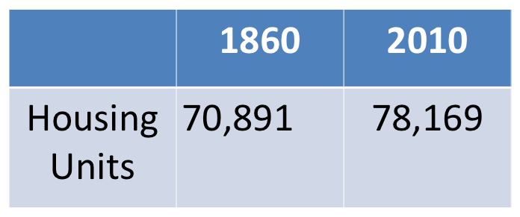
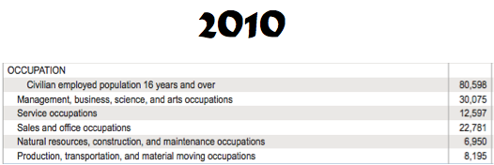

Rensselaer County Overview
Rensselaer County has a large industrial background as well has a large cultural background, thus creating a county that has been very helpful throughout history as well as a rousing place to visit. Rensselaer County’s History is similar to America’s History as whole. Prior to the arrival of the Dutch in in the early 1600’s Native Americans inhabited the land. In 1629 Kilean van Rensselaer established the county. Following the War for Independence many New Englanders migrated to the county. In 1791 the county officially was founded and named after its first settler. Rensselaer County was in an ideal location geographically which made the County one of the leading Industrial developers. This county also played a very important role in the Civil War, creating much of the wars supplies as well as sending many men to fight. Rensselaer County thrived and provided for many of the Country’s wars.
In researching the area of Rensselaer County, New York, it was made apparent that there are many attractive sites that bring tourists to the area. Some of these places include Bennington Battlefield, Crailo State Historic Site, Burden Iron Works Museum, Goolds Orchard, Dyken Pond Environmental Education Center, and Knickerbocker Mansion. Bennington Battlefield is in Grafton, New York and is a park that shows the area where the Bennington Battle was held during the Revolutionary War. Crailo State Historic Site is a fortified brick manor house in Rensselaer, New York that housed soldiers during the numerous wars throughout history and also the birth place of the song “Yankee Doodle”. Burden Iron Works Museum is in Troy, New York and housed the Burden Water Wheel, and also displays other industrial tools that had been made for numerous wars throughout history. Goold Orchards is located in Castleton, New York. At the Orchard you can pick your own apples, enjoy the Farm Store, or go on school tours. Dyken Pond is in Corpseyville, New York and has many educational programs to offer pertaining to the pond’s ecology. Knickerbocker Mansion is in Schaghticoke, NY. Here you can experience the Dutch culture and the peace treaty process on tours. These sites teach you about the history, culture, and industry of the county as well as offer an enjoyable experience.
The main highways in Rensselaer County are NYS Rt. 2, NYS Rt. 287, NYS Rt. 7, NYS Rt. 142, US 9, US 20, NYS Rt. 4, NYS Rt. 9J, NYS Rt. 67, US 40, NYS Rt. 43, and NYS Rt. 22. The most important historical sites are ones that involved war and battles that allowed the Hudson Valley and America for that matter to sustain their freedom. Fort Crailo in East Greenbush is where “Yankee Doodle” was written in 1758. Hoosick is where you will find Bennington Battlefield. His tomb is found in the Old Mount Ida Cemetery along with many other soldiers who fought in the American Revolution, the War of 1812, and the Civil War. There are many important markers giving great significance to the area, but its schools, churches, and battle sites have made the area what it is today.
In 1860, the population of Rensselaer County in particular, was 86,328. The white population was 85,270, the African American population was 727, and the mulatto population was 331. 41,870 individuals were male, while 43,367 of them were female. There were a total of 70,891 housing units. Amongst the most popular jobs in Rensselaer County were farmers, farm laborers, tailors, merchants, laborers, carpenters, shoemakers, blacksmiths, and clerks. In 2010, the population of Rensselaer County was 158,629. The white population was 140,335, the African American population was 7,943, and the mulatto population was 1,839. 78,169 individuals were male, and 80,460 individuals were female. There were a total of 78,169 housing units. The total population employed was 80, 598. There were 30,075 individuals were in occupations involving business, management, science, and arts, 12,597 individuals were in a service, 22,781 individuals who were in sales and office occupations, 6,950 individuals who were in natural resources or maintenance, and 8,195 individuals in production and transportation.
Throughout the years of Rensselaer County’s existence it has shown that it has proven itself reliable for our country in many wars as well as proven its reliability in both industry and agriculture.

Lesson Plan for Rensselaer County
By: Demi Pappas
Lesson plan on Agriculture- Field trip to Goold Orchard

Overview before the trip: Students will learn that agriculture was very important to Rensselaer County, which was seen through the many farms, and orchards. Students will discover agriculture in Rensselaer County, and learn how climate and environmental factors affect agriculture. Students will be broken up into groups, and each group will pretend they are farmers, and research the weather and environmental factors they would need to consider in order to successfully run their farms (Ex: drought).

Overview during the trip: On their field trip to Goold Orchard the next day, students will investigate what type of factors affected the apples and other fruit (Ex: bugs). Students must pay attention to the tour guide, as he or she will explain how the farmers of the orchard handle the environmental factors in order to grow the crops effectively (Ex: pesticides). Students will take notes on their trip, and use the knowledge they have gained to complete their report for the following day’s lesson. Students are allowed to pick their own apples, and other fruit, which they can examine further to determine what kind of factors have affected them.

Overview after the trip: Students will write a report on all of the information they have learned in the past two days. They must write a report on what environmental factors they need to take into consideration, and what they would do if they had to face these factors on their farms. Students must also create a poster, where they have drawn a picture of their farms, including what factors they have researched and learned solutions to on their field trip. For example, students may choose to write about droughts, and how sprinklers may be used to water crops. Students will draw a picture of a farm with sprinklers, and maybe draw a picture of a sun to indicate that it is a hot dry day.

Closing Activity: The teacher and students can have a discussion on how farmers would sell their crops to make a profit, and how their jobs depended upon the environment. Students can think about how much they would sell the crops on their farms for depending upon what environmental factor they have researched, and share their ideas in a class discussion.

Extension Activity: The teacher can distribute seeds to students and teach them how to grow their own plants. Having students actually attempt to grow their own plants will show them how hard it can be for farmers to grow plants for a living, because so many factors are taken into consideration.

New York State Standards: Social Studies 1-History of the United States and New York: use a variety of intellectual skills to demonstrate their understanding of major ideas, eras, themes, developments, and turning points in the history of the United States and New York. English Language Arts Learning 1-Students will read, write, listen, and speak for information and understanding. English Language Arts Learning 4-Students will read, write, listen, and speak for social interaction.

Learning Intelligences: Auditory learning- Students will be listening to their group members’ ideas, and other group’s presentations at the end of the lesson. They will also be participating in a group discussion at the end of the lesson. Verbal linguistic- Students will discuss the report with their group members, and be required to ask the tour guide on the field trip numerous questions. Bodily-kinesthetic- Students will be involved in the lesson with hands on activities such as picking their own fruit, and creating posters.
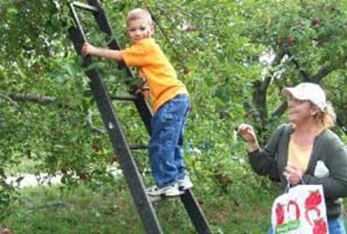

Rensselaer Itinerary
By: Kylee McIntosh

Day 1
Historic Barns at Nipmoose: The Historic Barns of Nipmoose provide a unique opportunity to step into the past and learn about the artistry of America’s early agricultural buildings. their exceptional architecture can be enjoyed by people of all ages and interests. Here you can view a Scottish barn, a German Barn, a corn crib and a farm house. This site displays 18th and 19th century farmers and earl American settlers. The Historic Barns of Nipmoose are located in a pastoral area called Buskirk in northeastern Rensselaer County, NY. Here you can experience the apple orchard, stream, farm fields and picnic lunches. Lunch should be eaten here.
Address: 59 Sherman Lane, Buskirk, NY 12028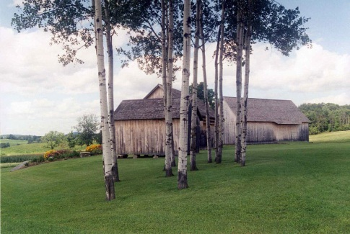
Directions
From the North
(Travel time from Saratoga Springs, NY, approximately 50 minutes)
Merge onto I-87 S. Take Exit 15 toward Rte. 29E/Schuylerville. Take NY Rte. 29/Gen. Philip Schuyler Commemorative Hwy. going East toward Wooley Road. Continue to follow NY Rte. 29 for 6.1 miles into Schuylerville. Turn right onto Broadway/US Rte.4/NY Rte. 29/NY Rte. 32 for 0.3 miles. Turn left onto Ferry St/NY Rte. 29. Continue to follow NY Rte. 29 for 5.1 miles into Greenwich. Stay straight to go onto Main St/NY Rte. 372. Continue to follow NY Rte. 372 for 8.9 miles into Cambridge. Turn right onto S. Park St/NY Rte. 22. Continue to follow NY Rte. 22 for 5.4 miles. Turn right onto NY Rte. 67 toward Eagle Bridge and go 3.2 miles. In Buskirk, turn left onto County Route 103. Go 2.5 miles. Turn right onto Nick Mush Road. Go 0.4 miles and turn left onto Sherman Lane. The Barns are at the top of the hill.

From the South
(Travel time from Hudson, NY, approximately 90 minutes)
Take NY Rte. 23B East 3.9 miles. NY Rte. 23B becomes NY Rte. 23. Merge onto the Taconic State Parkway N and go 14.5 miles to the last exit before the toll (Chatham/East Chatham Exit). Bear left on ramp and turn right onto Rte. 295 East. Go 4.4 miles. Turn left onto County Rte. 5. Go 4.2 miles. Turn right onto US Rte. 20/Columbia Turnpike. Go 2 miles through the village of New Lebanon. Turn slight left onto NY Rte. 22. Go 29 miles to a tee. Turn right onto NY Rte. 7 and take an almost immediate left onto Pine Valley Road (County Rte. 103). Rte. 103 has several turns, so watch signs. Go 7.5 miles. At sharp turn, stay straight onto Nick Mush Road. Go 0.4 miles and turn left onto Sherman Lane. The Barns are at the top of the hill.
From the East
(Travel time from Boston, MA, approximately 3 hours 20 minutes)
(Travel time from Bennington, VT, approximately 30 minutes)
From Rte. 67A turn left onto Rte. 67. Follow for 8.3 miles through Walloomsac and North Hoosick (here Rte. 67 will merge with Rte. 22). Stay straight on Rte. 67/Rte. 22. At blinking light near Benson's Restaurant, turn left onto Rte. 67 and go 3 miles, passing through Eagle Bridge. In Buskirk, turn left onto County Rte. 103. Go 2.5 miles. Turn right onto Nick Mush Road. Go 0.4 miles and turn left onto Sherman Lane. The Barns are at the top of the hill.
From the West
(Travel time from Clifton Park, NY, approximately 30 minutes)
At the intersection of Rte. 9 and NY-146, take NY-146 E/Clifton Park Blvd. for 5 miles. Turn left to stay on NY-146 E for 2.7 miles. NY-146 E becomes US-4 N/NY-32 N. In Mechanicville turn right onto Park Ave. for 0.1 miles and then turn left onto Main St. N for 0.3 miles. Turn right onto NY-67 and go 5.6 miles. Turn left onto NY-40/NY-67 for 1.5 miles passing through Schaghticoke. Turn right onto NY-67 for 1.4 miles. After crossing the bridge in Valley Falls, turn left to stay on NY-67 for 7.8 miles. In Buskirk, turn right onto County Route 103. Go 2.5 miles. Turn right onto Nick Mush Road. Go 0.4 miles and turn left onto Sherman Lane. The Barns are at the top of the hill.
Knickerbocker Mansion: 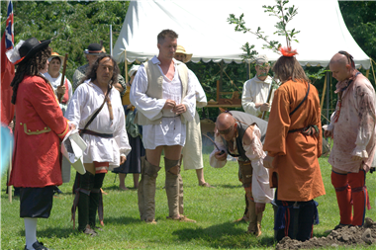
Directions from Historic Barn at Nipmoose:
Directions to Knickerbocker Mansion
132 Knickerbocker Road, Schaghticoke, NY 12154‎ - (518) 664-1700‎
17.2 mi – about 29 mins
Historic Barns of Nipmoose
59 Sherman Lane, Buskirk, NY 12028‎ - (518) 944-4414‎

 | 1. | Head northwest on Sherman Ln toward Nickmush Rd |  |  | go 0.2 mi  total 0.2 mi
 | 2. | Turn right onto Nickmush Rd  About 2 mins | go 0.4 mi  total 0.7 mi

 | 3. | Take the 1st left onto Buskirk-West Hoosick Rd/Co Rd 103  About 5 mins |  |  | go 2.5 mi  total 3.2 mi
 | 4. | Turn left onto NY-67 W  About 12 mins | go 9.2 mi  total 12.4 mi

 | 5. | Turn left onto NY-40 S/NY-67 W/State Route 40 S  About 3 mins | go 1.5 mi  total 13.9 mi
 | 6. | Turn right onto NY-67 W/Co Rd 118/Farm to Market Rd/Old Schaghticoke Rd  About 4 mins |  |  | go 2.7 mi  total 16.6 mi

 | 7. | Turn right onto Don Wier Rd/Knickerbocker Rd  Destination will be on the right  About 2 mins | go 0.7 mi  total 17.2 mi
Knickerbocker Mansion
132 Knickerbocker Road, Schaghticoke, NY 12154‎ - (518) 664-1700‎
Overview: The Knickerbocker Mansion was built in the 1780's by Johannes and Elizabeth Knickerbocker. Its architecture is a rare middle age style. The Mansion presides over the remains of the historic Witenagenot Oak Tree which was planted in 1676 to commemorate a peace treaty between the Native Americans and European settlers. The Mansion is open for tours from May-October, for special events and by appointment for group tours and authentic colonial Dutch meals. The Mansion is listed on the National Historic Register.
Hender’son’s Bar(dinner)
American Cuisine - Established 1997 - Serving fine foods and refreshments for the whole family.
Directions From Knickerbocker Mansion:
132 Knickerbocker Rd, Schaghticoke, NY 12154‎
1. | Head south on Don Wier Rd/Knickerbocker Rd toward NY-67 W/Co Rd 118/Farm to Market Rd/Old Schaghticoke Rd  About 2 mins | go 0.7 mi  total 0.7 mi

 | 2. | Turn left onto NY-67 E/Co Rd 118/Farm to Market Rd/Old Schaghticoke Rd  About 5 mins |  |  | go 2.7 mi  total 3.3 mi
 | 3. | Turn left onto NY-40 N/NY-67 E/State Route 40 N  About 2 mins | go 0.7 mi  total 4.1 mi

 | 4. | Take the 2nd right onto Main St  Destination will be on the left | go 449 ft  total 4.1 mi
Hender'son's Bar
188 Main Street, Schaghticoke, NY 12154‎ - (518) 753-7510‎
Old Judge Mansion:
Directions from Hender’son’s Bar:
Hender'son's Bar
188 Main Street, Schaghticoke, NY 12154‎ - (518) 753-7510‎

 | 1. | Head north on Main St/Valley Falls Ave toward 3rd St  Continue to follow Main St |  |  | go 449 ft  total 449 ft
 | 2. | Turn left onto NY-40 S/State Route 40 S  About 14 mins | go 8.7 mi  total 8.8 mi

 | 3. | Turn right onto Plank Rd/State Route 40 S  Continue to follow Plank Rd |  |  | go 0.1 mi  total 8.9 mi
 | 4. | Continue onto Northern Dr  About 1 min | go 0.8 mi  total 9.7 mi

 | 5. | Turn left onto 5th Ave  About 5 mins | go 2.3 mi  total 12.0 mi
 | 6. | Continue onto 6th Ave  Destination will be on the left |  |  | go 0.1 mi  total 12.1 mi
 | 3300 6th Ave, Troy, NY 12180‎
Overview: Old Judge Mansion, a beautiful, relaxing bed and breakfast located in the historic city of Troy, NY, the home of Uncle Sam.
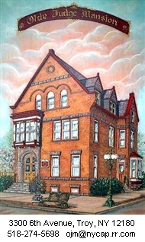This 1892 Victorian-Gothic Style home has five bedrooms: three have private baths while two smaller rooms, economically priced, share a full and a half bath. Each bedroom has a VCR, TV, phone and broadband Internet connection. There is a full hot breakfast in the morning, and we offer off-street parking. Free WIFI also available.
There are plenty of movies to fill your time, books on the history of Troy and surrounding area, a piano in the parlor to play and snacks in the evening. Come relax in the elegance of times gone by. Rates are from $55 to $95.
BREAKFAST WILL BE SERVED HERE

Day 2
Breakfast is served at the Bed and Breakfast.
Mount Ida Falls:
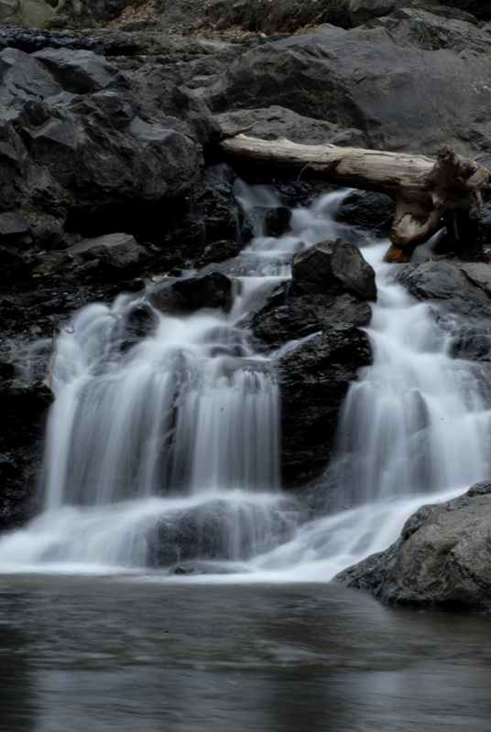
Directions from Old Judge Mansion:
3300 6th Ave, Troy, NY 12180‎

 | 1. | Head south on 6th Ave toward Glen Ave |  | go 49 ft  total 49 ft
 | 2. | Take the 1st right onto Glen Ave | go 338 ft  total 387 ft

 | 3. | Take the 1st left onto River St  About 3 mins |  | go 1.5 mi  total 1.5 mi
 | 4. | Continue onto 3rd St | go 0.3 mi  total 1.9 mi

 | 5. | Turn left onto Ferry St  About 2 mins | go 0.4 mi  total 2.2 mi
 | 6. | Continue onto Congress St  About 1 min |  | go 0.6 mi  total 2.9 mi

 | 7. | Turn right onto Pawling Ave |  | go 404 ft  total 3.0 mi
 | 8. | Take the 1st right onto Linden Ave |  |  | go 0.2 mi  total 3.2 mi
 | Linden Ave, Troy, NY 12180‎
There will be a large parking area on the right approximately .2 miles down the road. The trail leads to the base of the falls.
Overview: The waterfall collects in the Dyken Pond and then later empties into the Hudson River. The first drop is 85 feet and drops into a gorge of crumbly black shale then it continues to drop another 75 feet into a massive pol and finally ends its falls a little upstream with a 15 foot fall. Here you can walk the trails and take in the picturesque scenery.
Famous Lunch( lunch):
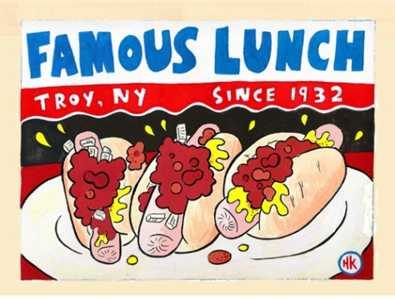
Directions from Mount Ida Falls:
Linden Ave, Troy, NY 12180‎

 | 1. | Head northeast on Linden Ave toward Sampson Ave |  |  | go 0.2 mi  total 0.2 mi
 | 2. | Turn left onto Pawling Ave  About 1 min | go 404 ft  total 0.3 mi

 | 3. | Turn left onto Congress St  Destination will be on the right  About 2 mins | go 0.9 mi  total 1.2 mi
Famous Lunch
111 Congress Street, Troy, NY 12180‎ - (518) 272-9481‎

Overview: “World famous hot dog”
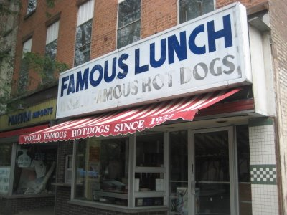

Troy Savings Bank Music Hall:
Directions from Famous Lunch:
Directions to Troy Savings Bank Music Hall
30 2nd Street, Troy, NY 12180‎ - (518) 273-8945‎
0.3 mi – about 2 mins
Famous Lunch
111 Congress Street, Troy, NY 12180‎ - (518) 272-9481‎

 | 1. | Head west on Congress St toward 4th St  About 2 mins |  | go 0.2 mi  total 0.2 mi
 | 2. | Turn right onto 2nd St  Destination will be on the right | go 0.1 mi  total 0.3 mi
Troy Savings Bank Music Hall
30 2nd Street, Troy, NY 12180‎ - (518) 273-8945‎
Overview: Acoustically perfect venue for an eclectic group of performers. Box Office Hours:10 a.m. to 5 p.m. Monday – Friday 12 p.m. to 5 p.m. Saturday 90 minutes before each show. http://www.troymusichall.org/ for show listings.
Captain JP Cruise Line (dinner):
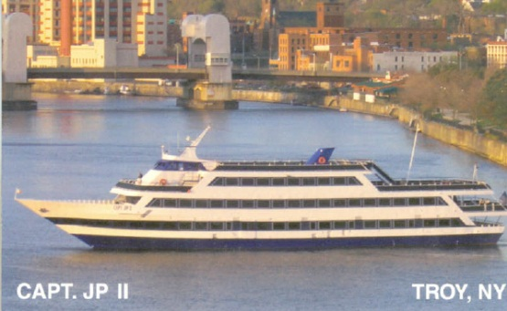
Directions from Troy Savings Bank Music Hall:
Directions to The Captain J.P. Cruise Line.
278 River Street, Troy, NY 12180‎ - (518) 270-1901‎
0.1 mi
Troy Savings Bank Music Hall
30 2nd Street, Troy, NY 12180‎ - (518) 273-8945‎

 | 1. | Head north on 2nd St toward Broadway |  | go 495 ft  total 495 ft
 | 2. | Slight right onto River St  Destination will be on the right | go 164 ft  total 0.1 mi
The Captain J.P. Cruise Line.
278 River Street, Troy, NY 12180‎ - (518) 270-1901‎
Overview: 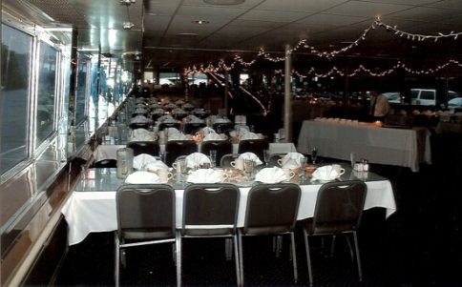
The Captain J.P. II is by far the largest and most lavish cruise vessel in the Capital Region of upstate New York. It is a four deck cruise ship, certified by the United States Coast Guard to accommodate 600 passengers and seat in excess of 500 people comfortably; air and heat, along with full service bars and a dance floor on each deck. Fully equipped to handle any occasion, from private parties, proms and weddings to quiet morning brunch cruises to trips to New York City, The Captain J.P. Cruise Line is your ticket to an entertaining morning, afternoon or evening.
Old Judge Mansion:
Directions from Captain JP Cruise Line:
Directions to Olde Judge Mansion Bed & Breakfast
3300 Sixth Avenue, Troy, NY 12180‎ - (518) 274-5698‎
1.6 mi – about 6 mins
The Captain J.P. Cruise Line.
278 River Street, Troy, NY 12180‎ - (518) 270-1901‎

 | 1. | Head northeast on River St toward Franklin St | go 282 ft  total 282 ft
 | 2. | River St turns slightly right and becomes Fulton St  About 1 min |  | go 318 ft  total 0.1 mi

 | 3. | Turn left onto 4th St  About 1 min | go 0.1 mi  total 0.2 mi
 | 4. | Continue onto River St |  | go 0.1 mi  total 0.3 mi

 | 5. | Continue onto King St | go 0.2 mi  total 0.5 mi
 | 6. | Continue onto River St  About 1 min |  | go 1.1 mi  total 1.5 mi

 | 7. | Turn right onto Glen Ave | go 338 ft  total 1.6 mi
 | 8. | Take the 1st left onto 6th Ave  Destination will be on the right |  | go 49 ft  total 1.6 mi
Olde Judge Mansion Bed & Breakfast
3300 Sixth Avenue, Troy, NY 12180‎ - (518) 274-5698‎
BREAKFAST WILL BE SERVERED AT THE BED AND BREAKFAST

Day 3
Crailo State Historic Site: 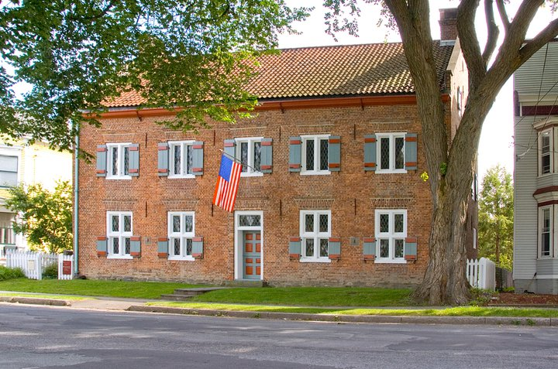
Directions from Old Judge Mansion:
Directions to Crailo
9 1/2 Riverside Ave, Rensselaer, NY 12144‎ - (518) 463-8738‎
10.5 mi – about 13 mins
Olde Judge Mansion Bed & Breakfast
3300 Sixth Avenue, Troy, NY 12180‎ - (518) 274-5698‎

 | 1. | Head south on 6th Ave toward Glen Ave  About 1 min | go 0.7 mi  total 0.7 mi
 | 2. | Turn left to merge onto NY-7 W toward I-787  About 1 min |  | go 0.7 mi  total 1.4 mi

 | 3. | Take the exit onto I-787 S toward Albany  About 8 mins | go 7.6 mi  total 9.0 mi
 | 4. | Take exit 3A to merge onto US-20 E/U.S. 9 S/Dunn Memorial Bridge toward Rensselaer  Continue to follow US-20 E/U.S. 9 S  About 2 mins |  |  | go 1.3 mi  total 10.3 mi

 | 5. | Turn right onto Broadway | go 0.1 mi  total 10.5 mi
 | 6. | Continue onto Riverside Ave  Destination will be on the left |  | go 354 ft  total 10.5 mi
Crailo
9 1/2 Riverside Ave, Rensselaer, NY 12144‎ - (518) 463-8738‎

Overview: 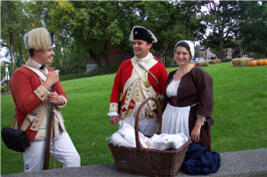Crailo State Historic Site is the museum of the Colonial Dutch in the Hudson River Valley. A new exhibit features engaging interactive components that help tell the fascinating story of the Dutch and their trade partners along the River in the 17th century. A recreated Dutch House room, a 17th century genre painting that comes to life, and a mural of Fort Orange with windows, doors and drawers to explore are highlights of the exhibit. A Museum Shop Marketplace offers books on the Dutch, Native Americans, the French and Indian War, and 17th century exploration as well as reproductions of beautiful 17th century trade items found in regional archaeological sites.
Hours: Group Tours & Individual Tours made by appointment year round. Mid-April thru October opened Wednesday & Sunday, 11:00am - 4:00 pm. June, July and August, also open on Tuesdays. Admission: $5/adults $4/students and adults 62 and over Free/children 12 and under.

Casey’s Restaurant (Lunch): 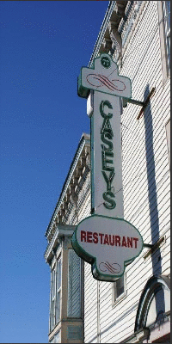

Directions from Crailo State Historic Site:
Directions to Caseys Restaurant
77-79 Washington Avenue, Rensselaer, NY 12144‎ - (518) 463-3318‎
2.1 mi – about 6 mins
Crailo
9 1/2 Riverside Ave, Rensselaer, NY 12144‎ - (518) 463-8738‎

 | 1. | Head north on Riverside Ave toward Aiken Ave |  |  | go 354 ft  total 354 ft
 | 2. | Continue onto Broadway  About 6 mins | go 1.7 mi  total 1.8 mi

 | 3. | Turn right onto Washington Ave  Destination will be on the left | go 0.2 mi  total 2.1 mi
Caseys Restaurant
77-79 Washington Avenue, Rensselaer, NY 12144‎ - (518) 463-3318‎

Overview: Jimmy Casey's Restaurant was established in 1995 in a building that has been a restaurant for the last 100 years. The cozy dining room and bar area is a perfect setting for lunch or dinner. We are located just down the street from the Doane Stuart School in Rensselaer which is just a few blocks off I-90 East Exit 7. The popular establishment is just a few minutes from downtown Albany and has plenty of off street parking for our patrons.

Cherry Plain State Park: 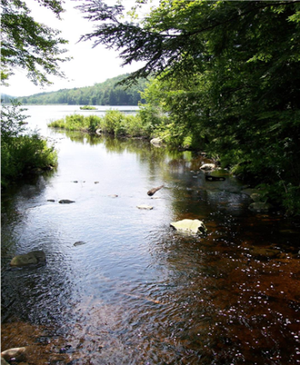
Directions from Casey’s Restaurant:
Directions to Cherry Plain State Park
26 State Park Road, Cherry Plain, New York 12040‎ - (518) 279-1155‎
20.5 mi – about 41 mins
Caseys Restaurant
77-79 Washington Avenue, Rensselaer, NY 12144‎ - (518) 463-3318‎

 | 1. | Head northeast on Washington Ave toward 7th St  About 3 mins |  | go 1.5 mi  total 1.5 mi
 | 2. | Continue onto Washington Avenue Extension | go 0.2 mi  total 1.6 mi

 | 3. | Turn left onto NY-43 E  About 16 mins | go 8.9 mi  total 10.5 mi
 | 4. | Continue onto Taborton Rd  About 16 mins |  | go 8.4 mi  total 18.9 mi

 | 5. | Turn right onto Dutch Church Rd |  | go 69 ft  total 18.9 mi
 | 6. | Slight right onto Miller Rd  About 6 mins | go 1.6 mi  total 20.5 mi
Cherry Plain State Park
26 State Park Road, Cherry Plain, New York 12040‎ - (518) 279-1155‎

Overview: 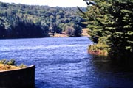 The Park offers a beach, picnic tables with pavilions, a playground, recreation programs, a nature trail, hiking and biking, a campground with tent and trailer sites, cross-country skiing, a boat launch with boat rentals, and a food concession.

ITINERARY OVERVIEW: This itinerary is a compilation of a three day long tour of Rensselaer County, which consists of historic sites, nature sites, art sites, and a plethora of restaurants. This itinerary is a simple guide that can be changed to accommodate the travelers’ needs or wants in Rensselaer County. Be sure to plan ahead and make reservations as needed.

County Websites
By: Cara Marsicano
- Welcome to Rensselaer County: here you will find all the important involving the community, the press and political views.
- Lifes good from here: Here you will find all of the county’s economic development and planning.
- History is Here: here is a perfect site to visit if you are interested in seeing what Rensselaer County has to offer.
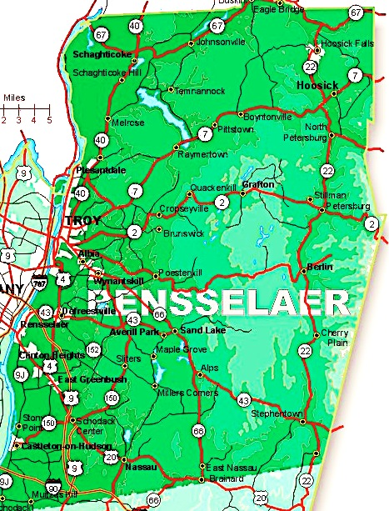

Works Cited
"Â ." Bennington Battlefield State Historic Site. Web. 01 Mar. 2012. <http://nysparks.com/historic-sites/12/details.aspx>.
"Â ." Crailo State Historic Site. Web. 01 Mar. 2012. <http://nysparks.com/historic-sites/30/details.aspx>.
"Â» Itâ€™s That Time Again â€“ Apple Picking at Good Orchards Sandra Foyt." Â» Itâ€™s That Time Again â€“ Apple Picking at Good Orchards Sandra Foyt. Web. 01 Mar. 2012.<http://www.sandrafoyt.com/2011/09/24/its-that-time-again-apple-picking-at-good-orchards/>.
"About the Gateway." Hudson Mohawk Industrial Gateway. Web. 01 Mar. 2012. <http://hudsonmohawkgateway.org/3_about.html>.
"All Over Albany." The Burden Ironworks Museum. Web. 01 Mar. 2012. <http://alloveralbany.com/archive/2009/07/13/the-burden-ironworks-museum>.
"Apples from Goold Orchards." Apples from Goold Orchards. Web. 01 Mar. 2012. <http://www.goold.com/>.
"Background of Settlement in Petersburgh and Rensselaer County, NY." Background of Settlement in Rensselaer County. Web. 03 Mar. 2012. <http://churchtree.tripod.com/rensshistory.html>.
Baker Anderson, George. "History of Brunswick, New York." History Files at Rays-place.com. D. Mason & CO. Publishers, Syracuse, NY 1897. Web. 02 Mar. 2012. <http://history.rays- place.com/ny/ren-brunswick-ny.htm>.
"Battle of Bennington." Wikipedia. Wikimedia Foundation, 03 Apr. 2012. Web. 04 Mar. 2012. <http://en.wikipedia.org/wiki/Battle_of_Bennington>.
"Dyken Pond Environmental Education Center." Dyken Pond Environmental Education Center. Web. 01 Mar. 2012. <http://dykenpond.org/>.
"Fort Crailo." 301 Moved Permanently. Web. 01 Mar. 2012. <http://dmna.ny.gov/forts/fortsA_D/crailoFort.htm>.
Nysm.nysed.gov. Web. 29 Feb. 2012. <http://www.nysm.nysed.gov/historicmarkers/hisaction.cfm>.
Profile for Rensselaer County, New York, NY. Photograph Rensselaer County, New York County Information. Epondunk - the Power of Place, 2007. Web. 04 Mar. 2012. <http://www.epodunk.com/cgi-bin/genInfo.php?locIndex=22497>.
"Rensselaer County History." New York and New York State Books on History Genealogy and Regional Interest for Sale from Hope Farm Press. Web. 03 Mar. 2012. <http://www.hopefarm.com/rensseny.htm>.
"Rensselaer County." Home. Web. 01 Mar. 2012. <http://www.renscotourism.com/Home.aspx>.
"Rensselaer County - Life Looks Good from Here." Knickerbocker Mansion. Web. 05 Mar. 2012.<http://www.renscotourism.com/Details.aspx?sid=61e10489-7f89-4151-82a5-1cf181bdbe0c>
"Rensselaer County - The Upstate N.Y. Roads Site." The Upstate N.Y. Roads Site. Web. 01 Mar. 2012. <http://www.upstatenyroads.com/counties/rensselaer.shtml>.
Rittner, Don. "Knickerbocker Mansion A Must Visit." Blog. Time Union. Don Rittner, May 2009. Web.
"The Hudson." Bath-On-Hudson (Rensselaer, NY). Web.
Whiteford, Noble E. "Hudson." History.rochester. Bill Carr, 8 Dec. 1999. Web.
Tps.cr.nps.gov. Web. 29 Feb. 2012. <http://tps.cr.nps.gov/nhl/detail.cfm?ResourceId=407&ResourceType=Site>.

Works Cited (annotated)
"Â ." Cherry Plain State Park. Web. 02 May 2012. <http://nysparks.com/parks/173/details.aspx>. Used for the itinerary to find out activities and address.
"Â ." Crailo State Historic Site. Web. 02 May 2012. <http://nysparks.com/historic-sites/30/details.aspx>. Used for the itinerary to find out activities and the address.
Baker Anderson, George. "History of Brunswick, New York." History Files at Rays-place.com. D. Mason & CO. Publishers, Syracuse, NY 1897. Web. 02 Mar. 2012. <http://history.rays- place.com/ny/ren-brunswick-ny.htm>. This website was used in order to find historical sites as well as for history.
"Battle of Bennington." Wikipedia. Wikimedia Foundation, 03 Apr. 2012. Web. 04 Mar. 2012. <http://en.wikipedia.org/wiki/Battle_of_Bennington>.This website was used to understand the importance of the battle that took place in Rensselaer County.
"Bennington Vermont, Old Bennington Walking Tour - Bennington Museum." Bennington Vermont, Old Bennington Walking Tour - Bennington Museum. Web. 09 May 2012. <http://www.bennington.com/chamber/walking/monumentdescription.html>. This website spilled out a ton of information about Bennington Battlefield. You can go on walking tours here and also learn about all the history. It was built in the late 1880’s. This battle took place during the Revolutionary war in 1777. In 1877, a local historical society was formed and they started planning the monument.
"The Captain J.P. Cruise Line." The Captain J.P. Cruise Line. Web. 02 May 2012. <http://www.captainjp.com/>. Used for Itinerary to find the address, the type of cuisine and how to go about making reservations.
“Census of Population and Housing.” 1860 Census. United States Census Bureau, 22 Dec. 2011. Web. 4 Mar. 2012. <http://www.census.gov//ww///‌.html>.This source was valuable in helping me discover demographics of Rensselaer County in 2010 and 1860. In particular, it had information regarding race, sex, and housing units for both 1860 and 2010, however it only had information regarding occupations for 2010. This provided the exact information that I needed to complete my portion of the presentation regarding demographics.
"Fort Crailo." 301 Moved Permanently. Web. 29 Feb. 2012. <http://dmna.ny.gov/forts/fortsA_D/crailoFort.htm>. Used to find the site Fort Crailo, it provided information for the highway marker.
"Garfield School." Garfield School. Web. 09 May 2012. <http://www.townofbrunswick.org/history/garfield.asp>. The Garfield School was very interesting to learn about. I found out when it was built and by whom on this website. This school district served School District #2 for about 80 years. The restoration and adaptive reuse of the Garfield School has earned the recognition of the Preservation League of New York State.
Goold Orchards. N.p., n.d. Web. 7 May 2012. <http://www.goold.com/>The website for Goold Orchards helped me discover what type of activities individuals could participate in when visiting. In particular, I searched for what children could do so that I could make a successful lesson plan for my students. I discovered that there are tour guides which take students through the Orchard and teach them about agriculture and how the crops are grown, and what climate effects them. From this information, I decided to make a lesson plan on agriculture, since it was so important to Rensselaer County. I believe the field trip to Goold Orchards would be extremely beneficial for students to see first-hand how crops are grown.
"Greenbush Cantonment." Greenbush Cantonment. Web. 09 May 2012. <http://dmna.ny.gov/forts/fortsE_L/greenbushCantonment.htm>. This website was very useful. It had a lot of helpful information about the Greenbush Cantonment. It spoke about what the place was made of (how many rooms, how big, what each room had in each, how many barracks, etc). The one Officer Barracks still remains standing and the Red Mill School occupies the former grand parade grounds. Also, on this website it had a map of the Cantonment. The map labeled each part of it and told you what it was. It also had other visuals such as the place itself and signs that are there.
"Hender'Son's Bar & Grill." Hender'Son's Bar & Grill. Web. 02 May 2012. <http://www.hender-son-s.com/>. Used for the itinerary, menu and address.
"Historic Barns of Nipmoose." Historic Barns of Nipmoose. Web. 02 May 2012. <http://www.nipmoosebarns.org/>. Used for the itinerary, activities, events and the address.
"Home Page." Knickmansion. Web. 02 May 2012. <http://www.knickmansion.com/>. Used for the itinerary to get the address and activities.
"The Hudson." Bath-On-Hudson (Rensselaer, NY). Web.
"Jimmy Casey's Restaurant." Jimmy Casey's Restaurant. Web. 02 May 2012. <http://jimmycaseys.com/>. Used for itinerary the menu and the address.
“NYS P-12 Common Core Learning Standards.” NYSED.gov. N.p., 23 Oct. 2009. Web. 7 May 2012. <http://www.p12.nysed.gov///>.On this website, I found the New York State Learning Standards for Social Studies, which is necessary to include when creating a lesson plan. In order for a lesson plan to be beneficial to students, it must cover learning standards for the particular subject, and from this website I found learning standards that were associated with my lesson plan.
Nysm.nysed.gov. Web. 29 Feb. 2012. <http://www.nysm.nysed.gov/historicmarkers/hisaction.cfm>. The site was very helpful in finding historical markers that were already in place.
"Old Mount Ida Cemetery - Troy, NY - Worldwide Cemeteries on Waymarking.com." Old Mount Ida Cemetery - Troy, NY - Worldwide Cemeteries on Waymarking.com. Web. 09 May 2012. <http://www.waymarking.com/waymarks/WM5KCG_Old_Mount_Ida_Cemetery__Troy_NY>. I had a hard time finding useful and factual information on Mount Ida Cemetery but this website gave me a lot of help. It told me about other names for this cemetery and let me know that it no longer exists and was completely vandalized and destroyed. Also, this cemetery has many signs that give information that they had pictures of on the website.
"Olde Judge Mansion." - Historic Bed and Breakfast in Troy, New York. Web. 02 May 2012. <http://oldejudgemansion.com/>. Used for itinerary this is where the tourists would stay. It provided address and nearby locations.
"Poestenkill Falls - Waterfalls of the Northeastern United States." Waterfalls of the Northeastern United States. Web. 02 May 2012. <http://www.northeastwaterfalls.com/waterfall.php?num=1064>. Used for itinerary to find the address and for pictures.
Profile for Rensselaer County, New York, NY. Photograph Rensselaer County, New York County Information. Epondunk - the Power of Place, 2007. Web. 04 Mar. 2012. <http://www.epodunk.com/cgi-bin/genInfo.php?locIndex=22497>. This website was used to have a picturesque view of Rensselaer County.
Rensselaer County Census Records. New York American Local History Network, n.d. Web. 9 May 2012. <http://www.rootsweb.ancestry.com/‌~nyrenss2//>.On this website, I discovered what occupations citizens in Rensselaer County participated in. While it did not have specific numbers regarding how many individuals participated in which occupation, I did find out valuable information. Some occupations were farmers, farm laborers, tailors, merchants, laborers, carpenters, shoemakers, blacksmiths, and clerks.
"Rensselaer County, New York." Wikipedia. Wikimedia Foundation, 05 Sept. 2012. Web. 09 May 2012. <http://en.wikipedia.org/wiki/Rensselaer_County,_New_York>. Although this website was Wikipedia it had very good information for me to understand more about Renssealaer County. The population as of 2010 census was 159,429. It had helpful pictures and facts all throughout the website that helped me on other parts of this project. There are 14 towns and 6 villages.
Rittner, Don. "Knickerbocker Mansion A Must Visit." Blog. Time Union. Don Rittner, May 2009. Web.This website was used to have a clearer understanding of the resources and economical efforts used in Rensselaer County.
Tps.cr.nps.gov. Web. 29 Feb. 2012. <http://tps.cr.nps.gov/nhl/detail.cfm?ResourceId=407&Resourc eType=Site>. This site was helpful in finding historical site and highway marker information.
"Troy Savings Bank Music Hall." Troy Savings Bank Music Hall. Web. 02 May 2012. <http://www.troymusichall.org/>. Used for the itinerary in order to find the address and different events.
"Welcome." Web. 02 May 2012. <http://www.famouslunch.org/Welcome.html>. Used this in my itinerary to find the address and menu.
Whiteford, Noble E. "Hudson." History.rochester. Bill Carr, 8 Dec. 1999. Web.This website is just a broad understanding of how the Hudson has impacted Rensselaer County

