Final Paper

The Native Americans first settled Ulster County, they called this land “esepu” meaning “the high banks”. In 1652 the first European Dutch settlers came, calling the land “Esopus”. The Duke of York officially founded the County on November 1st 1683.
Ulster County is located in the Mid-Hudson region of the Hudson Valley. It currently consists of 14 towns. It’s surrounded on three sides by water. To the East there is the Hudson River. On the West there is the Wallkill River. And on the Northern side is the Rondout River. The known mountain of this region is the Shawangunk Mountain. This mountain runs for thirty miles.
When comparing the demographic of Ulster County from 1860 to 2010, it’s interesting to notice the drastic changes. There was a total of 76,408 people living in Ulster County in 1860. 74, 7999 were white, majority being male. 1,609 were African-American, majority being female. In 2010 the census results were drastically different from 1860. The population of Ulster County in 2010 was 182,493. 89% of the population was white and 7% was African-American. 1% was American Indian, 2% were Asian, and 3% percent were identified as “other.” This shows that Ulster County has grown drastically since 1860.
Ulster County is the home of many significant historical sites. Some key places to see in Ulster County include Perrine’s Bridge, Byrdcliffe, Tuthillhouse Gristmill, Catskill Mountain Railroad and the Ulster County Courthouse. These sites all contributed to the culture and importance of this county. The second oldest bridge, built in 1834, Perrine’s Bridge, in the state of New York, is in Ulster County. It is situated in the modern day town of Esopus Rosendale, and crosses the Walkill River. Another site is The Ulster County Courthouse it was originally constructed in 1864 in Kingston. This is where the New York State Constitution was written and approved in April of 1777 by the Patriots to establish a New York system of government. The courthouse was burned to the ground in October of 1777 by British troops. The courthouse was reconstructed and held the crucial court case of Sojourner Truth, an African American abolitionist who successfully fought to free her son from slavery.
To show the importance of the Ulster County Courthouse a sign has been created to show the events that have occurred at this location. In the right hand corner of the sign there is the Ulster County seal. Within the synopsis is the thesis for our county as well which is, “The county is rich in history and has played a pivotal role in the establishment and evolution of New York through government, recreation, and culture.” which will be proven through the sites and information that each member presents to the class. The bottom right corner of the sign features a picture of the courthouse present day and a picture of the location of Ulster County within New York, which appears on each sign.
Ulster County is rich in history and has contributed to the development of New York and the United States through recreation, government and culture. Through the work of my teammates and myself, the contributions of Ulster County and its influences will be emphasized and; therefore, support the thesis that Ulster County has played a pivotal role in establishing New York State.

The History of Ulster County
Ashley Mast
March 2, 2012
The Native Americans first settled Ulster County, they called this land “esepu” meaning “the high banks” (www.ulstercountyalive.com). But in 1616 the first European settlers came to “Esepu”. The Europeans were Dutch and had arrived in 1652. They then called the land they has settled “Esopus”(www.wikipedia.org). After the Dutch has become comfortable with their new land they began trading. Thomas Chambers was the first Dutch settler to start the trade business with in Ulster County (www.wikipedia.org).
When the Dutch started trading the Native Americans began to become frustrated, they felt that they were losing their land and the Europeans were taking over. Ulster County is said to have suffered more from Indian hostilities than any other part of the county at this time that was under Dutch rule (www.usgennet.org). Traditions say that the tension between the Dutch and the Native Americans originally began when an Indian woman stole a peach from a Dutch families garden. The family later killed the women to teach the Native Americans a lesson (www.usgennet.org).
Although people had occupied Ulster County from 1616 and possibly before, the county itself was officially founded on November 1st 1683. The Duke of York created twelve counties one of which was Ulster. After creating the counties they choose the first capital of New York, which was Kingston, a town with in Ulster County (www.wikipedia.org). Later affluent families of Ulster County were recruited for the American Civil War to help form the 139th New York Volunteer Infantry Regiment. Ulster County has grown significantly over the years. Today it has a population of 182,493 people with in fourteen towns: Esopus, Marbletown, New Paltz, Hurley, Marlborough, Olive, Kingston, Rochester, PLattekill, Saugerties, Shandaken, Shawangunk, Wawarsing, and Woodstock (www.usgennet.org). Compared to the 29,370 people in 1790 (www.wikipedia.org). Ulster County will continue to grow.
Ulster County is surrounded on three sides by three different bodies of water (www.ulstercountyalive.com). To the East there is the Hudson River. On the West there is the Wallkill River. In 1835 a covered wooden bride was built to go over the Wallkill River in Rifton. It was called Perrine’s Bridge and still stands today (www.ulstercountyalive.com). And on the Northern side is the Rondout River. The Rondout River runs through the county and is named after a fort originally built by the early Dutch settlers. Ulster County is also known for it mountainous landscape. The known mountain of this region is the Shawangunk Mountain (www.usgennet.org). It starts by Orange County and ends near Kingston, in Ulster. This mountain runs for thirty miles, and was one of the reasons that the Native Americans deemed this region “the high banks” (www.usgennet.org).

Lauren Neeson
Ulster County is situated in southeast New York in the historic Mid-Hudson Valley. Located throughout the county are numerous key historical, industrial, and cultural sites that have contributed to the development of New York as well as the US.
To show the importance of the Ulster County Courthouse ,an interpretive sign has been created to showcase the important events that have occurred at this location. In the right hand corner of the interpretive sign there is the Ulster County seal followed by a very brief synopsis of the history and location of the county. Within the synopsis is the thesis for our county as well which is,” The county is rich in history and has played a pivotal role in the establishment and evolution of New York through government, recreation, and culture.” which will be proven through the sites and information that each member of the team presents to the class. The seal, synopsis of history and thesis will appear on each sign. The bottom right corner of the sign features a picture of the courthouse present day and a picture of the location of Ulster County within New York, which will appear on each sign as well.
To show the individual contributions of the courthouse, the sign includes a title and an image of the Ulster County Courthouse followed by a brief summary of events that have occurred there since its construction in 1684.
Ulster County is rich in history and has contributed to the development of New York and the United States through recreation, government and culture. Through the work of my teammates and myself, the contributions of Ulster County and its influences will be emphasized and; therefore, support the thesis that Ulster County has played a pivotal role in establishing New York State.

Nicole Roderman
Ulster County is located in the Mid-Hudson region of the Hudson Valley. When first created, there were twelve towns in Ulster County but today there are now fourteen. Ulster County lies on the Hudson River and is made up of many beautiful mountains. It has taken an enormous amount of time and hard work for Ulster County to become what it is today. In order to track the changes made in Ulster County, historians use documents such as the Census, which collects data on the populations in specific increments of time.
When comparing the demographic of Ulster County from 1860 to 2010, it is very interesting to note the drastic changes. There was an estimated total of 76,408 people living in Ulster County in 1860. 74, 7999 of those people were white, a majority of them were males. 1609 of them were African-American, majority being females. The census reported very specific occupations that the people of 1860 had such as bakers, agents, hunters, nurses, teachers, students, and even servants. The highest populated “occupation” was a servant, which 155,282 people were in Ulster County. There were 4904 students, 18,628 teachers, 50 hunters, and 5516 bakers. In 2010, the census results were recorded very differently than they were in 1860. The categories were much more broad so some comparisons were hard to draw. The total population of Ulster County in 2010 was 182, 493. Eighty-nine percent of the population was white and seven percent was African-American. One percent was American Indian while two percent were Asian, and three percent were identified as “other.” This shows that Ulster County has not only grown significantly in population but it has also grown in diversity since 1860.
All of these statistics shows a significant increase in population in Ulster County, an increase of 106,085 people. Among those people, many cultures have found their way in calling Ulster County their home. There was increase in the African-American population, as well as cultures that weren’t present in 1860 such as Hispanics, Asians, and Native Americans. With the diffusion of new cultures as well as an increase in the “minority”, an acceptance of these different cultures has been instilled in the residents of Ulster County. Other inferences that can be drawn from the statistics provided from the Census would be about the change in occupations held in Ulster County. The most prevalent occupation of 1860 was being a servant. There was also a high prevalence in the nurses/healthcare population, bakers, and surprisingly teachers. Although all of those occupations remain active today, except for being a servant, there are many more fields that weren’t around during 1860 such as technical support, or automotive repair. There has also been an extreme decrease in occupations such as shoemakers, cobblers, and lumberman that work in individual counties rather than nationally.
With a time span of 150 years, considerable changes in a community are bound to happen. All of the changes, whether it was an increase or decrease, represent Ulster County. The people have made significant changes as well as the community as a whole.

Bibliography
1. 1860 Census of Population and Housing. Census Bureau Homepage. Retrieved February 20, 2012, from http://www.census.gov/prod/www/abs/decennial/1860.html
2. Ulster County QuickFacts from the US Census Bureau. State and County QuickFacts. Retrieved February 20, 2012, from http://quickfacts.census.gov/qfd/states/36/36111.html

Pictures:
Thesis- http://ulstercountynyrealestate.com/wp-content/uploads/2010/07/catskill-mountains-ulster-county.jpg
Map- http://4.bp.blogspot.com/-ly8ebgGHJCE/TaJQFDEV7GI/AAAAAAAABIY/V_cPSz-poMg/s1600/ulster+map.gif

Brianna LaFontaine
Professor Johnson
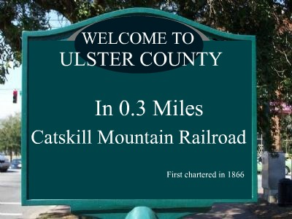
2/3/12
Group #5
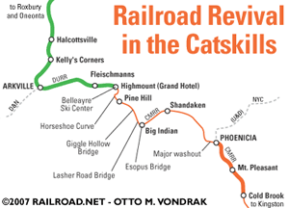
Ulster County is rich in history and has played a pivotal role in the establishment and evolution of New York through government, recreation and culture. There are five historical landmarks in particular which contributed the most to Ulster’s success in becoming well established and culturally developed as a County.
The Catskill Mountain Railroad is one of Ulster County’s many historical landmarks. It has contributed greatly to the growth and development in Ulster County. This railroad was established in 1866 and was originally used for the import and export of goods. The railroad started off local and as years past it eventually became known as the Ulster & Delaware Railroad.
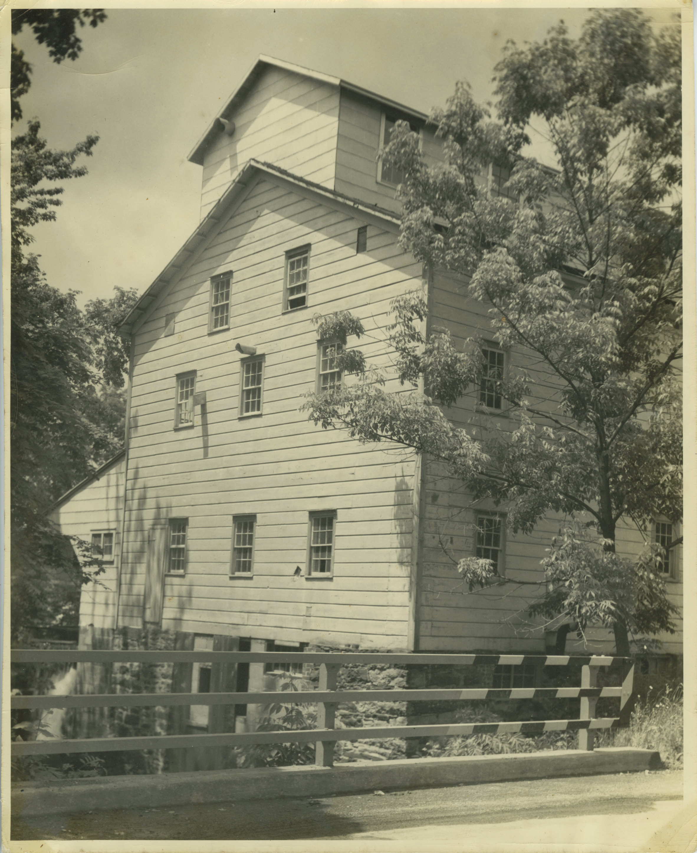
In 1788 Selah Tuthill, when he was only eighteen, established the Tuthilltown Gristmill. Today, the building is a well-known restaurant renovated and changed over numerous times by the Gabriello Family, but this historical site did not start off as a restaurant. It is considered the oldest water operated gristmill in New York State. (catskillmtn.org) From the 1980’s until the early 2000’s the mill produced much of the state’s kosher flour. Although the mass production of kosher flour is no longer produced out of the Tuthilltown Gristmill, for tourist attraction the mill is still occasionally powered.


Ralph Radcliffe Whitehead founded Byrdcliffe back in 1902. The Byrdcliffe mission statement is as follows: “Byrdcliffe provides opportunities for excellence in all the arts. It is a locus for creative collaboration and encounters for artists, students, arts professionals, and the public gathered in community for inspiration.” (Can be found on Byrdcliffe website, woodstockguild.org) Located in Woodstock, this well-known historical site has prevailed in teaching arts to gifted students. Byrdcliffe has been a non-profit organization since 1938, collecting income specifically from “individual memberships, bequests, foundation grants, government agency grants, income from our endowment, and corporate and individual contributions. Byrdcliffe receives earned income from rentals, tuitions, sales, and tickets.”(Woodstockguild.org)
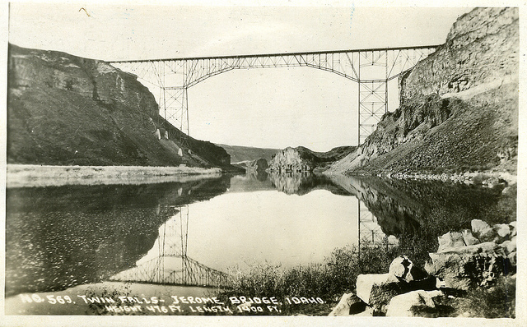
Perrine’s Bridge is another extremely important historical landmark in Ulster County that started off contributing to trade being made between Rifton and Rosendale in 1834. Back in the 19th century, much of New York’s economy was based on the import and export of smaller communities reliant on the agricultural and water powered industries as their main source of income. (nycoveredbridges.org) This bridge was essential and important in providing easier access when linking trading portals together. Today, Perrine’s bridge is known as New York’s second oldest bridge still standing and is located in Esopus Rosendale. The Perrine’s bridge was a huge contribution to New York’s economy in the mid 1800’s into the mid 1900’s.

Originally constructed in 1684
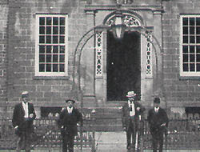
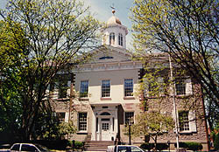
Opened in 1789 Still Active, Present Day

Ulster County Courthouse is located in Kingston New York. This courthouse played a key role in developing Ulster County’s government. Research of this particular courthouse seems to result in endless amounts of history and important events that bring us to where our government is today, not only because this building alone holds over 300 years of history. The famous trial of Sojourner Truth was held in this same courthouse as well as several others.

Works Cited:

Photographs:
http://www.nps.gov/nr/travel/kingston/k7.htm
http://www.woodstockguild.org/about-byrdcliffe
http://www.tuthillhouse.com/

Information:
http://www.nycoveredbridges.org/page6.html
http://www.woodstockguild.org/about-byrdcliffe
http://www.railroad.net/articles/railfanning/cmrr/index.php
http://www.catskillmtn.org/guide-magazine/articles/2004-06-the-tuthilltown-gristmill.html

Nicole Bischoff
March 4, 2012
Midterm Essay

History of Ulster County

Ulster County is located in the Mid-Hudson Region of New York and is the home of many significant historical sites. The county is in the southeast part of the state, south of Albany and west of the Hudson. Some key places to see in Ulster County include Perrine’s Bridge, Byrdcliffe, Tuthillhouse Gristmill, Catskill Mountain Railroad and the Ulster County Courthouse. These sites all contributed to the culture and importance of this county.
The second oldest bridge in the state of New York is in Ulster County. Perrine’s Bridge was built in 1834 by a man named Benjamin West. It is situated in the modern day town of Esopus Rosendale, New York and crosses the Walkill River. The length of the bridge is 154 feet and it is almost 20 feet wide. There is only one lane and it is closed to vehicular traffic. Perrine’s Bridge was originally built to aid the trade between the towns of Rifton and Rosendale. This special bridge got its name from James W. Perrine, a French Huguenot immigrant who owned a tavern on the east side of the bridge. Perrine’s son was hired as the “snower” which means he would spread snow across the bridge so horse-drawn sleighs could cross. Perrine’s Bridge is a beautiful historical landmark that played an important role in the trade throughout towns of Ulster County.
Byrdcliffe is a community near Woodstock founded by Ralph Radcliffe Whitehead in 1902. The estate was created as a result of the Arts and Crafts Movement and is surrounded by the beautiful Catskill Mountains on 1,500 acres of land. Guests from across the county came to stay at the estate including writers, painters, social reformers and musicians. Some notable visitors include singer Bob Dylan and actor Chevy Chase. Byrdcliffe was referred to as a “textbook example” of a utopian Arts and Crafts community. Teachers and students there were dedicated to their pottery, furniture making, photography, painting and weaving. Twice a week there would be dance in the Studio and White Pines lawn. The Woodstock Byrdcliffe Guild (WBG), a non-profit organization now owns the community. Byrdcliffe is the oldest continuing arts colony not only in Ulster County, but also in the whole United States.
The Ulster County Courthouse was originally constructed in 1864 on Wall Street in Kingston, New York. This is where the New York State Constitution was written and approved in April of 1777 by the Patriots to establish a New York system of government. The courthouse was burned to the ground in October of 1777 by British troops. The courthouse was reconstructed and held the crucial court case of Sojourner Truth, an African American abolitionist who successfully fought to free her son from slavery.
Until recently, the Tuthilltown Gristmill was the oldest operating gristmill in the state of New York. It is located in the town of Gardiner, right off of Albany Post Road. The original power source of the mill was an undershot wheel, later replaced by an overshot wheel. In 2006, the Mill was converted into a restaurant and is a National Historic Landmark.
The Catskill Mountain Railroad was licensed in the year 1866 and was completed between Oneonta and Kingston in 1900. People would use the train to get to the hotels and lodges in the Catskills. Freight traffic included coal and lumber along with dairy products. During the Great Depression, the railroad saw less and less passengers and business really suffered after people began owning automobiles. New York Central bought out the company and then conservationists restored it in 1977. This railroad was a main form of transportation for the people of Ulster County. These historical sites are all noteworthy in their own way and helped Ulster County become a key place in the Mid-Hudson Valley.

